EXAM # 1
PROTEIN STRUCTURES AND NMR
SPECIAL TOPICS IN PHYSICAL CHEMISTRY
CHEM 991A, Spring 2007
Wednesday February 28th, 2007

NAME_____________________________________

1) The Verify3D program is often used to help evaluate the quality of a protein structure. Describe in detail the structural parameters that Verify3D uses to analysis a structure and how this might be used as an XPLOR potential energy function. (15)

Verify3D measures the packing of a protein by identifying which of 18 categories that each amino acid falls within. These packing categories are based on the area buried, the fraction polar and the secondary structure of each amino acid. Using high-quality X-ray structures, the probability of finding each of the 20 amino-acids within each of the 18 categories was determined. Verify3D then determines a scoring function for each amino-acid in the target protein structure by simply assigning a packing category and a corresponding probability:
Total 3D-1D score =
In principal, this scoring function can be used as an XPLOR energy function, similar to the application of the Ramachandran target function:
$$E\text{DB}(i)=−k\text{DB}\sum_{m=1}^{N\text{restra}\text{int}s}{(\text{log}Pi)}$$
A “look-up” table containing bins based on the 18 packing categories with the corresponding probabilities for each amino acid is used to calculate energies in the same manner as the Ramachandran target function. The challenge is quickly measuring the area buried and fraction polar for each amino-acid to assign a packing category. The secondary structure assignment can be obtained easily from the φ, ψ torsional angles.

2) Determining an XPLOR NOE energy requires measuring a distance between the atoms defined in an NOE assign statement. XPLOR provides multiple approaches to calculating a distance between sets of atoms using the averaging definition. Describe the differences between how SUM and CENT calculate a distance and how they are used. (10)

SUM calculates a distance between all the atoms defined in an NOE assign statement by simply summing all the distances raised to -6 power:
$$R=({\sum_{\text{ij}}{R_{\text{ij}}^{−6}}}/n\text{mono})^{{−1}/6}$$
CENT only calculates a single distance, where a pseudo-atom is used to represent the geometric center for a group of magnetically equivalent atoms (single NMR assignment). The use of CENT and pseudo-atoms requires corrections to both the upper and lower bound distances in the NOE constraint definition to compensate for the difference relative positions between the pseudo-atoms and the actual atom locations.

3) A first-year graduate student comes to you for an opinion on an idea he has. He wants to use molecular modeling and experimental K_{D} values for known MEK kinase ATP inhibitors to predict the K_{D}s for other test compounds:

Drug | Observed K_{D}
AG 957 | 10 nM
Adaphostin | 1 mM
Erbstatin | 100 uM
Itaconic acid | 10 uM
Tyrphostin | 50 nM

His plan is to dock each compound into the ATP binding site of MEK kinase and calculate a minimum structure. He then plans to plot a ΔE (relative to the undocked MEK kinase structure) against the measured K_{D}s. He can then use this plot to predict the K_{D} for other compounds. What is your opinion? (10)

As we discussed at length in class, the calculated energy for a minimized structure has no correlation or relationship to anything biologically meaningful. Any relationship found in such analysis is strictly serendipitous. The observed energy simply measures how well the structure matches the specifics of the various energy target functions. Three other problems: (1) the results of a minimization is directly dependent on the starting structure → how each compound is docked to generate an initial structure will impact the results. (2) correct parameterization (charges, atom types, h-bonds, van der waals, etc) of the drug will have a huge impact on the calculated energies (3) A number of drugs bind by an induced fit i.e. the ATP binding site changes to accommodate the drug. The energies do not reflect the inherent stability/instability of the protein-drug complex only the incompatibility/compatibility of the constraint between the free and docked structures.

A proper analysis is more complicated then quickly minimizing a handful of structures. He would need to do a ~100 ps or longer dynamic simulation for each structure starting at the free conformation, for the free protein and each complex. He would also have to do extensive ab initio calculations to properly define the small molecules. Experimental NMR data would help and a better result would be obtained calculating the dynamics in a bath of water. The energies for each structure can then be compared after each dynamics run has reached equilibrium. While the absolute ΔE is still probably not meaningful, the relative trends would be expected to be consistent.

4) Identify an amino acid that is likely to be in (a) active site, (b) salt-bridge, (c) α-helix, (d) β-strand, (e) turn. (5)

- His, Ser, Cys, etc
- Arg, Lys, Glu, Asp
- Ala, Glu, Met, etc
- Val, Ile, Tyr, etc
- Gly, Asn. Asp, etc

5) How can you use NMR to determine the protonation state of His or if Cys is involved in a disulphide bond? (5)

The relative Cα and Cβ chemical shifts for His and Cys are indicators of the protonation state and the oxidized/reduced state.
His Cys
- Unprotonated: Reduced:
  - Cα 54.3 ppm Cα 56.9 ppm
  - Cβ 30.7 ppm Cβ 28.9 ppm
- Protonated: Oxidized:
  - Cα 53.3 ppm Cα 54.05 ppm
  - Cβ 28.5 ppm Cβ 42.25 ppm

6) Under what circumstance would you expect an Arg to be in the core of the protein and a Phe on the surface? (5)

Burying a charged residue such as Arg would require the residue to be involved in a salt-bridge.
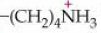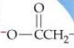

Conversely, a hydrophobic residue on the surface would probably be part of a hydrophobic patch that may be involved in the biological activity of the protein.

7) (a) What are the important structural factors that identify an α-helical region and a β-sheet? (b) What macroscopic structural feature is present in an α-helix, but absent in a β-sheet? Why? (c) How does this affect the amino-acid distribution in an α-helix? (d) What are the main differences between a β-turn and a γ-turn? (12)

(a) α-helix has φ, ψ torsional angles of -57º & -47º and a hydrogen-bonding pattern of I, I+4. A β-sheet has φ, ψ torsional angles of -119-135º & 113-135º and a hydrogen-bonding pattern across strands.

(b) α-helix has a dipole moment parallel to the helix axis. This occurs because all the hydrogen bonds of the helix align in the same direction with the helix axis allowing the individual dipole moments to add together.

(c) The α-helix dipole moment results in an effective positive charge at the C-terminus and negative charge at the N-terminus. The α-helix is further stabilized by the addition of a complimentary “capping” residue at the termini. (Asn at N-terminus and Glu at the C-terminus).

(d) A β-turn contains four consecutive residues while a γ-turn only contains three consecutive residues. Both contain a single H-bond between the residues at each end of the turn. A β-turn has a range of φ, ψ torsional angles for residues I+1 and I+2 (9 types). Conversely, a γ-turn has a limited φ, ψ torsional angles for residue I+1 (70-85,-60 - -70). A γ-turn is tighter.

8) An X-ray structure from the PDB was subjected to 100 steps of minimization followed by 100 ps of dynamics. Comparing the minimized structure to the original X-ray structures resulted in only a 0.16 Å rmsd. An average structure calculated from the entire dynamics run resulted in a 2.3 Å rmsd compared to the X-ray structure. Based on your understanding of minimization and dynamics, please explain these observations. (15)

Energy minimization results in a structure with near zero potential energy and zero temperature. This occurs by making small steps in Cartesian space along the negative potential energy gradient (first derivative of the potential energy). Only small changes atom positions are possible in minimization, so the final structure is very similar to the initial structure consistent with the small change in rmsd.
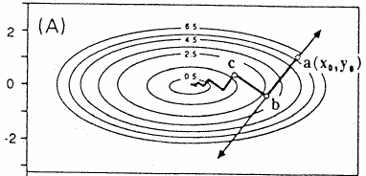

In molecular dynamics, Newton’s laws of motion are applied to follow the trajectory of each atom during a defined time period (100 ps). Again, the force for each atom is generated from the potential energy function and initial velocities are calculated using a random Maxwell-Boltzmann distribution at the given temperature. A New position for each atom is calculated after a “time-step”, where the total distance traveled will depend on the forces and velocities of the atom. In this manner, relatively large motions (compared to minimization can be made). All the structures in the dynamic run are effectively equivalent and simply demonstrate the range of motions/conformation available to the protein. Again, relatively large changes in conformations with a dynamics run are expected and consistent with the observed 2.3 Å rmsd.

9) You want to solve the structure of a protein that contains an uncommon amino-acid (L-carnitine) in your primary sequence. What do you need to do, in general, to calculate an XPLOR PSF file? (10)
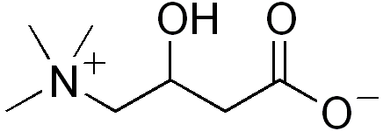

The standard XPLOR topology and parameter files do not include the necessary descriptors for this uncommon amino acid. This information will need to be included. Specifically, in the topology file you will need to identify a residue CAR, where the atom names, types and charges are identified. You will need to identify which atoms are bonded to each other. You will need to identify any improper angles to maintain planarity. The challenging part is identifying the expected bond lengths, bond angles and dihedral angle values and associated force constants for each unique bond, bond angle and dihedral angle present in the structure. You can use parameters for parts of the L-carnitine that are common to other amino-acids, but you may need to run some ab initio calculations to calculate other expected values.

10) (a) What is meant by local minima? (b) Why doesn’t distant geometry calculate a correct structure? (c) What is the main difference between steepest decent and conjugate gradient? (13)

(a) The energy-structure landscape for a protein is very complex containing many peaks and valleys. A local minima refers to an energetic minimum nearest a given conformer. A local minima is not the global minimum (lowest energy conformer for the structure).
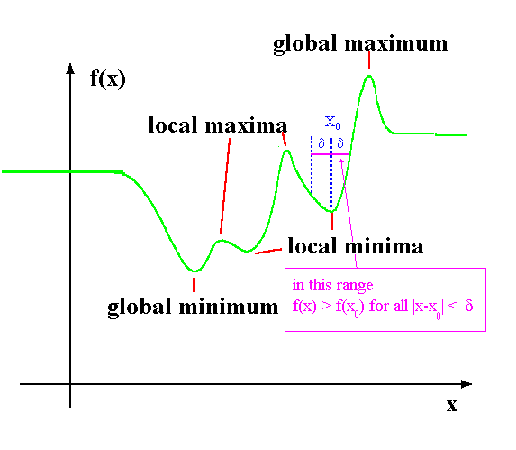

(b) The distance matrix is neither complete or 100% accurate.

(c) Steepest decent follows the force gradients by moving in trajectories that are 90º from the previous directory. Conjugate gradient decent is not directly dependent only on the prior trajectory, but uses the knowledge of all previous trajectories to identify the next path (not limited to 90º trajectories). Steepest decent slows as it gets closer to the minima, but is better for structures further from the minima. Conjugate gradient is generally faster, fewer steps.

