FINAL EXAM
PROTEIN STRUCTURES AND NMR
SPECIAL TOPICS IN PHYSICAL CHEMISTRY
CHEM 991, Fall 2004
Friday December 17th, 2004

NAME_____________________________________

- State the result of the operator I₊ acting on the states (0 1) and (1 0). Which of the two results is a consequence of the fact that I₊ is not Hermitian?

I₊ (0 1) -> (1 0); I₊ (1 0) -> (0 0). Hermitian operators can’t change the norm of a state; but clearly I₊ annihilates (1 0)

(2) Calculate the ratio of populations of the spin-down state relative to the spin up state for an NMR nucleus with a frequency of 900 MHz at a temperature of 300 K.
(k = 1.380650 × 10⁻²³ J/K; h = 6.6260693 × 10⁻³⁴ J.s)

$$\frac{p_{¯}}{p_{­}}=\text{exp}\left(\frac{−DE}{\text{kT}}\right)=\text{exp}\left(−\frac{\text{900}´{\text{10}}^{6}´6\text{.}\text{6260693}´{\text{10}}^{−\text{34}}}{\text{300}´1\text{.}\text{380650}´{\text{10}}^{−\text{23}}}\right)=0\text{.}\text{9985603}$$

(3) Consider the pulse sequence element shown below:

If the Hamiltonian is the standard weakly-coupled two-spin Hamiltonian, and the magnetization at the beginning of the sequence is I_{x}, what will be the magnetization at the end of the sequence, assuming that t₁ has been set to 1/2J, and the I and S spin chemical shifts are δ and δ_{S} respectively ?

I_{x} cos ω_{Ι}δ_{Ι}t₁ + I_{y} sinω_{Ι}δ_{Ι}t₁

(4) Express the operator I_{z}S_{z} in a 4 × 4 product basis.

$$\frac{1}{4}\left(\begin{matrix}1 & 0 & 0 & 0 \\ 0 & −1 & 0 & 0 \\ 0 & 0 & −1 & 0 \\ 0 & 0 & 0 & 1\end{matrix}\right)$$

- You wish to introduce an element in a pulse sequence which causes transverse I spin magnetization (e.g. I_{x}) to evolve into antiphase magnetization of the form I_{y}S_{z}, without acquiring any phase from the I or S spin chemical shift, or any modulation from a third spin T. Draw a pulse sequence element, showing the I, S and T spin channels, that accomplishes your goal. If the IS J coupling is 100 Hz, give the length of any time delay in your sequence.

This would work. Δ should be 1/4J = 2.5 ms

(6) Say briefly what we mean by a secular term in a high-field NMR Hamiltonian.

A secular term is one that commutes with the Zeeman Hamiltonian

(7) Describe some major advantages/disadvantages or limitations of multidimensional NMR experiments as it relates to protein structures. What are some ways to overcome these problems? (Hint: think in terms of data acquisition & processing).

- Advantages:
  - increased resolution (spread peaks out in 3D and 4D)
  - increased information content (correlation of 3 or 4 chemical shifts)

Disadvantages:
- require longer acquisition times
- reduced digital resolution
- reduced sensitivity (signal loss due to T2 relaxation during each evolution period)
- MW upper limit due to T2 relaxation

- i) reduce acquisition times with increased sample concentrations and lower number of data points in indirect dimensions.
ii) increase resolution by linear prediction and zero-filling
iii) increase sensitivity and MW upper limit by using deuterium labeling,
TROSY based experiments, higher temperature, etc.

(8) Describe the information content related to obtaining the assignments and structure for a protein that can be obtained from the following experiments. Please not that the experiments provide more that one type of information. Be specific.

Example: HNHB i) provides intra-residue correlation (i) between backbone HN and side-chain HBs. Used for both sequential and side-chain assignments.
- Relative intensity of HB1 and HB2 cross-peaks can be used to determine stereospecific assignments of HBs and determine χ₁ torsion angle.

- 3D ¹⁵N-edited NOESY
i. confirm backbone assignments from sequential i to i-1 NOEs
ii. identify regions of secondary structure from sequential i to i-1,i-2,i-3,i- 4
and across strand i to j NOEs
iii. determine tertiary fold from long range NOEs
iv. identify through space (≤ 5Å) interaction to backbone NHs

- HNHA
i. provides intra-residue correlation HNi to Hαi for backbone
assignments.
ii. relative intensity of Hα cross-peak to HN diagonal identifies ³J_{HNCα} coupling constant which in turn defines phi dihedral angle.

- HNCO
i. provides inter-residue correlation HNi to COi-1 for backbone
assignments.
ii. HNCO is most sensitive triple resonance experiment and identifies the number of peaks and the NH “root” chemical shifts expected in the
remainder of the experiments

- CBCANH
i. provides inter-residue correlations HNi to Cαi-1 and Cβi-1 for backbone assignments.
ii. provides intra-residue correlations HNi to Cαi and Cβi for backbone assignments.
iii. Cα and Cβ chemicals shifts are used to identify amino acid residue types.
iv. Cα and Cβ chemicals shifts are used to identify secondary structure.

(9) (a) Three-bond ¹H coupling constants are used to determine what two related structural parameters as part of a final refinement of a protein structure?
(b) Coupling constants are typically measured by peak separation, how are they measured for protein structures?
(c) What limitation in multidimensional NMR data requires this approach?

(a) χ angle and stereospecific assignments
(b) from the relative intensity of the cross-peak and diagonal peak
(c) digital resolution, a digital resolution of 0.02ppm → 12Hz for 600 MHz dataset.

(10) As we have seen through-out the lectures that the 2D HSQC experiment is a very versatile experiment. Describe (4) applications or variants of the 2D HSQC experiment for the analysis of protein structures and dynamics.

i. measure slow exchanging amides by collecting 2D ¹H-¹⁵N HSQC after transferring protein to D₂O.

ii. measure T₁, T₂ and ¹H-¹⁵N NOEs with 2D ¹H-¹⁵N HSQC experiments that contain T1 and T2 relaxation delays or ¹H presaturation.

iii. measure ligand binding by chemical shift changes in 2D ¹H-¹⁵N HSQC in absence and presence of ligand

iv. used to evaluate the quality of protein for NMR structure determination, line-shape, dispersion of chemical shifts, number of peaks

other possible examples:

v. used as the bases for backbone assignments by identifying all the NH and 15N chemical shifts expected in the remainder of the triple-resonance experiments.

vi. used to measure RDCs by collecting spectra coupled in the presence and absence of media to restrict isotopic tumbling

(11) The first step towards determining the protein structure after the NMR assignments are complete is the identification of regions of secondary structure. Describe how various type of NMR data assist in identifying regions of α-helix and β-sheet. Be specific.

α-helix can be identified by a combination of:
i) slow exchanging NHs
ii) small (3-4 Hz) ³J_{NHCα} coupling constants
ii) ΔCα ~ 3-4 ppm & ΔCβ ~ -1 ppm
iv) sequential NOEs:
a) NHi to Hαi-1,i-2,i-3,i-4
b) NHi to NHi-1
c) Hαi to Hβi+3

β-strand can be identified by a combination of:
i) slow exchanging NHs
ii) large (8-10 Hz) ³J_{NHCα} coupling constants
ii) ΔCα ~ -2 ppm & ΔCβ ~ 3 ppm
iv) across-strand NOEs (no sequential NOEs:
a) NHi to Hαj
b) NHi to NHj

(12) We spent a number of lectures summarizing general features of protein structures. This information is used to both calculate and verify a protein structure determined by NMR. Besides the primary sequence, name (4) pieces of information that is available at the start of an NMR analysis. How this information used to calculate a protein structure?

Multiple Possible answers, a few obvious choices:

1) carbon chemical shifts for random coil amino acids
- used to identify amino acid types during NMR assignment process
- used to identify regions of secondary structure based on differences.
2) connectivity information for each amino acid i.e. atom types, partial charges, bond
lengths, bond angles, etc.
- used to build the primary connectivity of the protein and provide starting structures.
- used to verify quality of structure by consistency with expected parameters
3) φ,ψ,χ1,χ2 Ramachandran maps
- used to refine a protein structure by keeping dihedral angles in expected regions of the Ramachandran maps.
- used to verify quality of structure by consistency with expected parameters
4) Definition of Secondary Structures (α-helix, β-sheet, turns)
- used to predict/determine NMR experimental results that are consistent with
identifying secondary structures present in the protein structure (see question #5).
5) Types of tertiary folds.
- used to verify quality of NMR structure by consistency with existing fold topology.
6) Amino acid propensities
- used to verify relative locations of amino acid types within a structure
i.e. location on surface or core, location within α-helix, β-sheet or turn
- participation in hydrogen bond, salt-bridge or disulphide bond

(13) Describe: (a) a one-dimensional NMR experiment and (b) a two-dimensional NMR experiment for the analysis of protein-ligand interaction. (c) Describe one way to determine a protein-ligand co-structure.

(a) monitor NMR spectra for ligand to observe either i) change in line-width, ii) transfer of saturation from protein or iii) change in diffusion coefficient.

(b) monitor either chemical shift changes in 2D 1H-15N HSQC or the sign change of an NOE in a transfer-NOE experiment.

(c) a high-quality structure can be obtained by indentifying intermolecular NOEs between the protein and ligand. These NOEs can be observed by using a 3D ¹³C-edited,filtered experiment where NOEs are only observed between ¹H attached to ¹³C and a ¹H attached to ¹²C.

(14) Given the following structural statistic tables for two different protein structures determined by NMR. Which of the two structures is a higher quality and better defined structure? Why?
A) residues 4-224 for Gankyrin
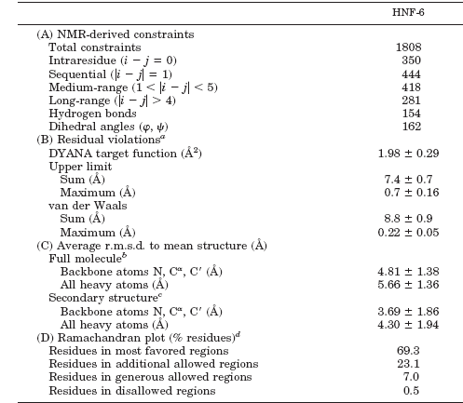
B) residues 6-152 for HNF-6

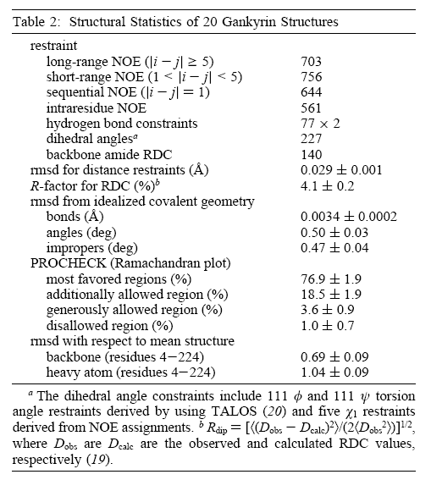

(a) The structure for gankyrin appears better defined.

(b) i. lower rmsd 0.69 vs. 4.81
ii. slightly better PRocheck values 76.9% vs. 69.3%
iii. higher constraints per residue 3189/220 (14.5) vs. 1808/146 (12.4)

(15) Given the NMR dynamic data for sinefungin binding to the enzyme thiopurine methyltransferase. What can you say about the dynamics of the protein in the absence and presence of the ligand? Free protein is blue circles, complex is red circles. ΔS² is S²(protein-ligand)-S²(free protein).

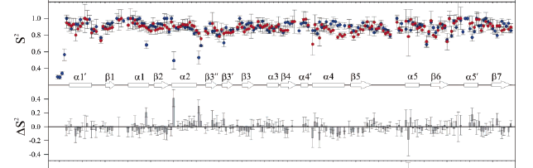
(a)
(b)
The addition of sinefungin to the enzyme results in regions of the protein that experience both a decrease and an increase in mobility as apparent by the box ΔS². Region (a) around β2 and α2 experiences a decrease in mobility with the addition of sinefungin. This indicates that this region is also more mobile in the apo-form of the protein and is probably the ligand binding site. Region (b) around α4 and α5 experiences an increase in mobility with the addition of the ligand. One potential explanation is the binding of the ligand in the active site results in a conformational re-arrangement that destabilizes interactions in the α4 and α5 region increasing mobility i.e. interaction(s) from region (b) are transferred to (a).
(16) Given the partial protein sequence: L71-G72-L73-V74-T75-G76 and the hypothetical NMR data, complete as much of the backbone NMR assignments as possible.

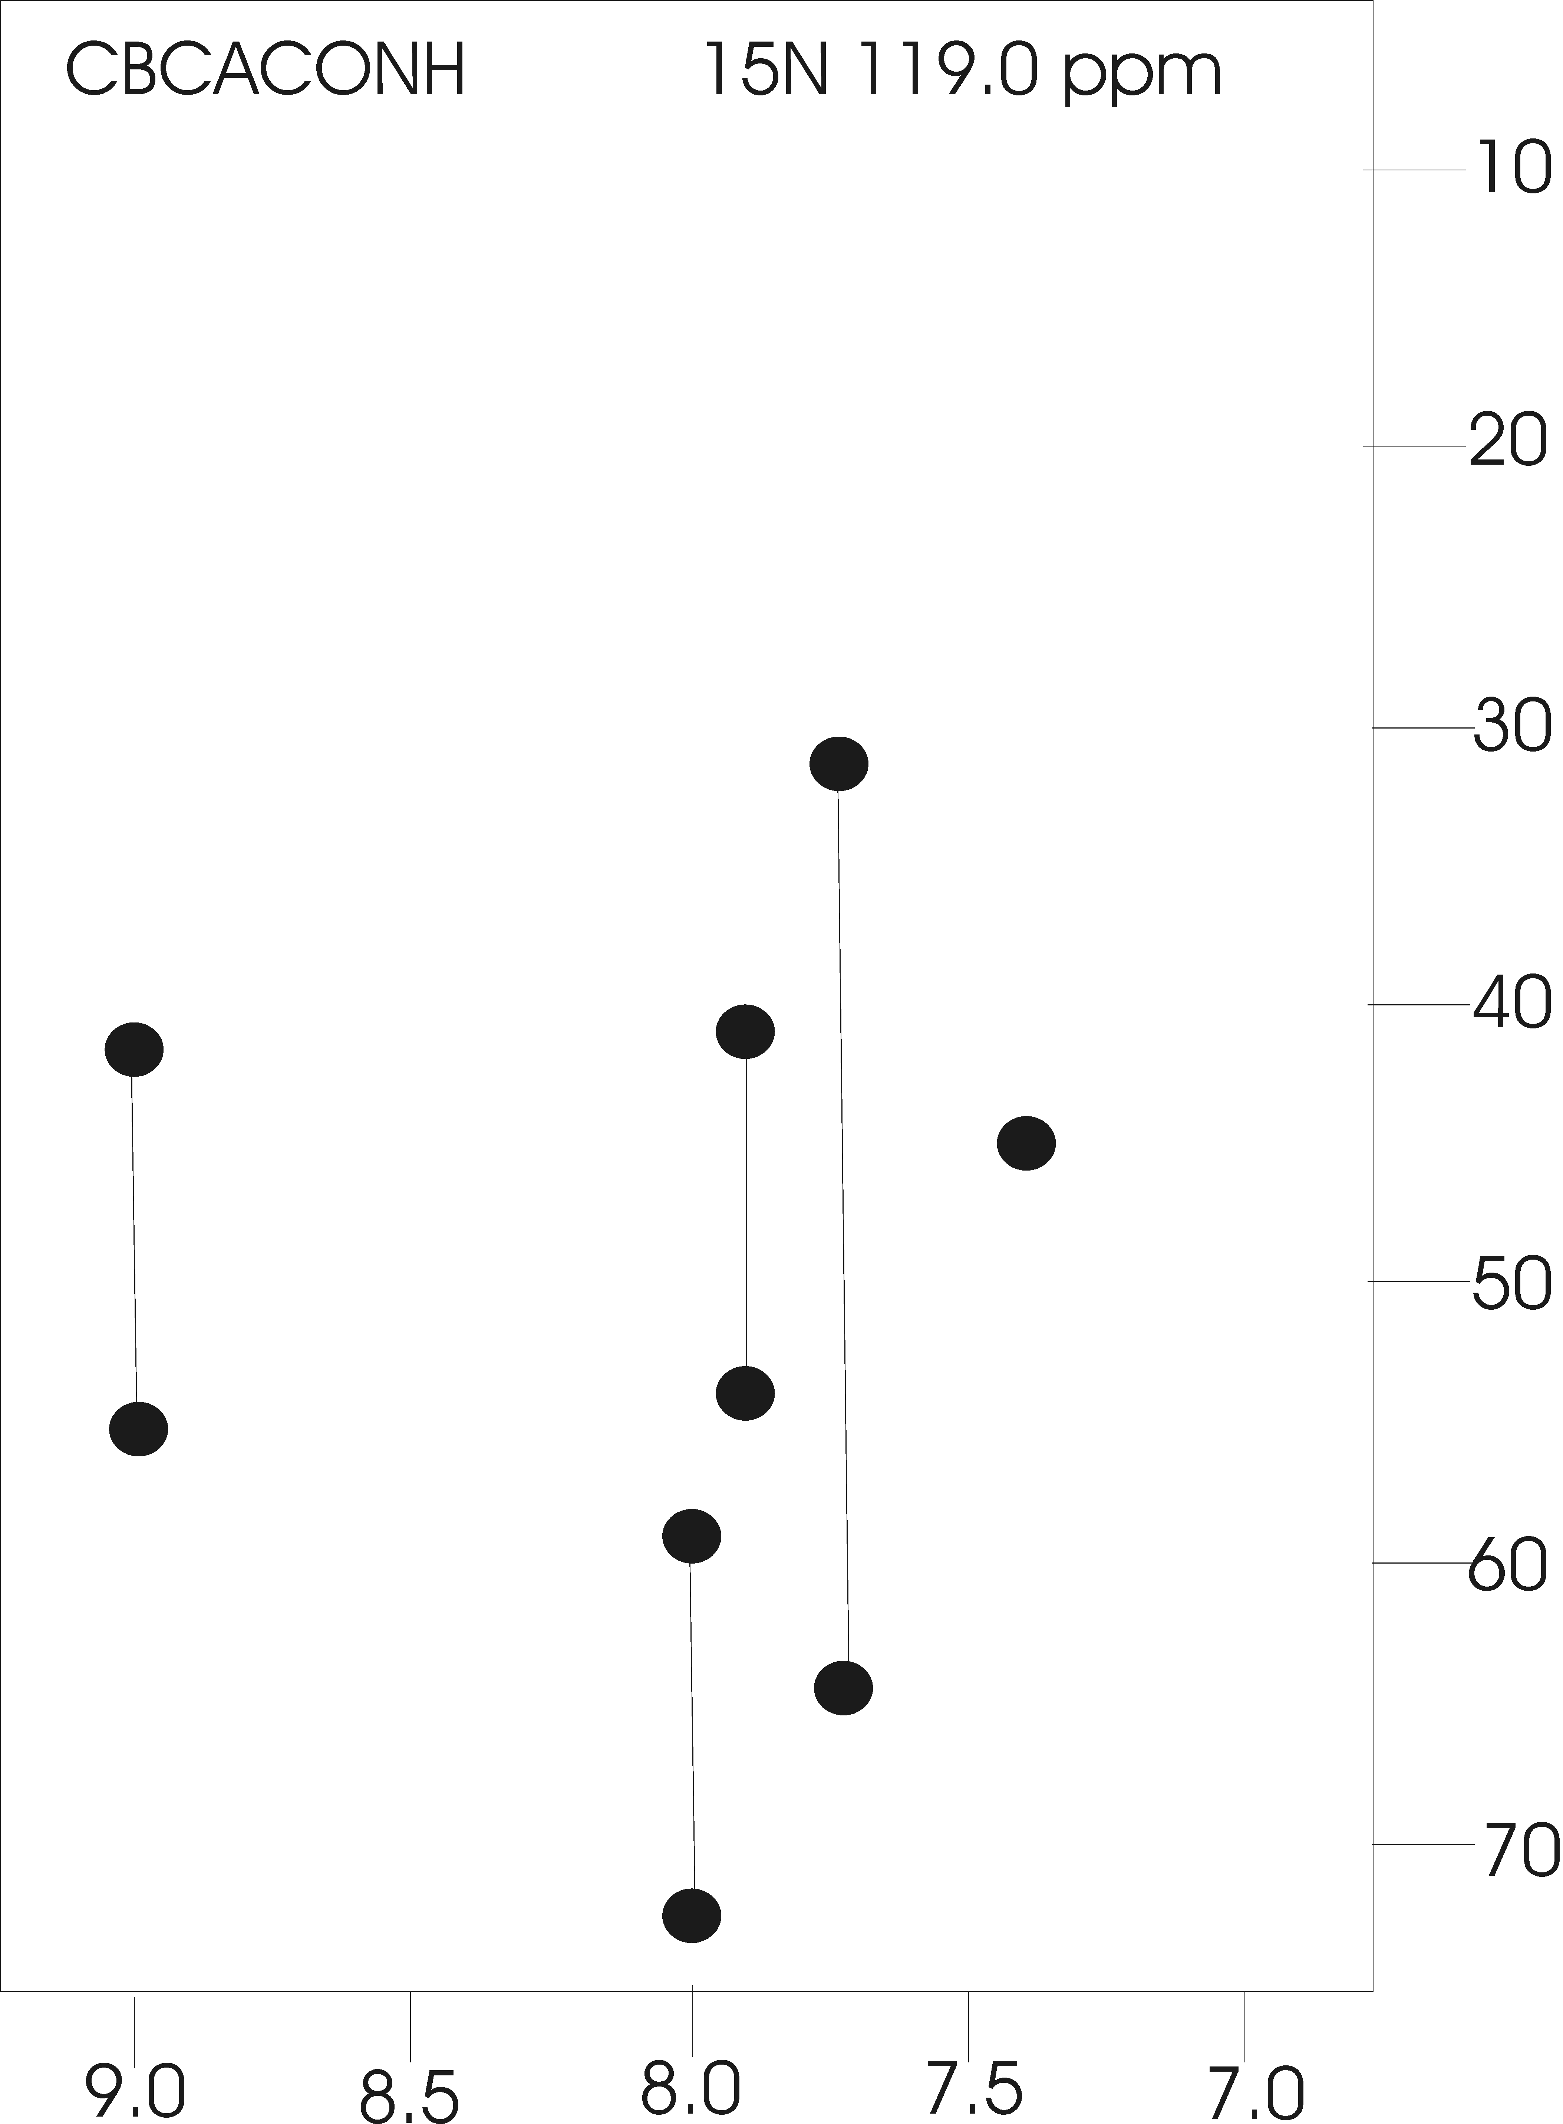
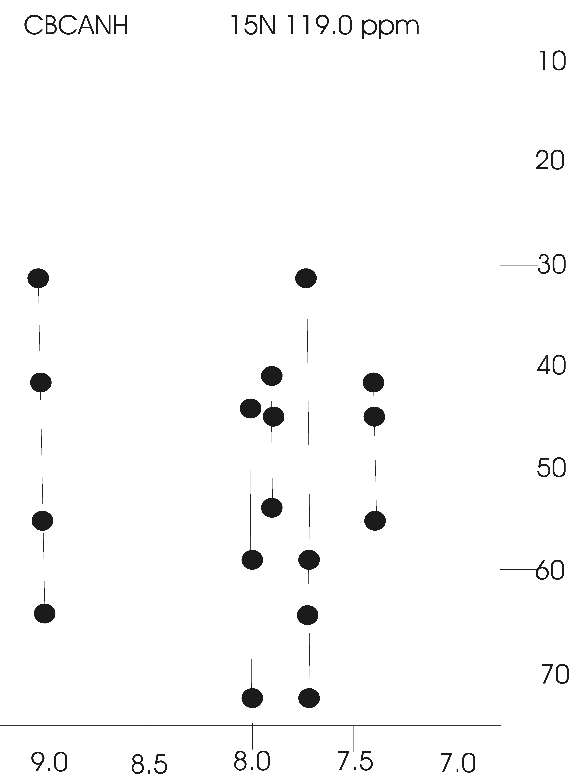

G72)

V74)
L71)
V74)

T75)

L71 55 43
G72 119.0 7.90 46
L73 119.0 7.40 54 43
V74 119.0 9.00 64. 32
T75 119.0 7.75 59 73
G76 119.0 8.00 45

(17) A common problem with determining the tertiary fold of a protein structure by NMR is ambiguous NOE assignments. Explain how this problem is resolved.

Ambiguous NOEs can be assigned by using an iterative structure calculation approach. An initial structure of the protein is calculated using all available experimental structural constraints (unambiguous NOE based distance constraints, hydrogen-bond constraints, dihedral angles, carbon chemical shifts, coupling constants, etc) and database targets (Ramachandran, hydrogen-bond, etc). The structure is than used as a “distance filter” to aid in the assignment of ambiguous NOEs. An assignment is made if one of the multiple possible assignments consistent with chemical shift assignments is also consistent with the current structure, the protons identified by the NOE are < 6 Å apart. The process is repeated until all the remaining NOEs are assigned to a pair of protons with a distance separation consistent with the structure.

(18) What is spin-diffusion? Why is this a problem? Describe one approach to resolve this issue.

(a) transfer of magnetization between two spins by an indirect relaxation mechanism

C-H1 H2 H3-C an NOE is observed between H1 and H3 through
| the mutual interaction with H2
C

(b) spin-diffusion results in two general observations:
i.) the relative distortion of the intensity of an NOE either lower or higher
ii.) observation of NOE between two protons that are not structurally close
The result is the inclusion of incorrect NOE based distance constraints in the structure calculation process. The distance constraint is either too short (tight) or should not be present.

(c) one approach is to simulate the complete relaxation matrix for the entire protein based on the experimentally observed NOE volumes and an existing structure (MORASS, Mardigras) to account for spin diffusion. The output is a predicted distance constraint for each NOE that accounts for spin diffusion.

13) Given the summary of NMR secondary structure information, what is the predicted regions secondary structure for the protein? What secondary structures are present?

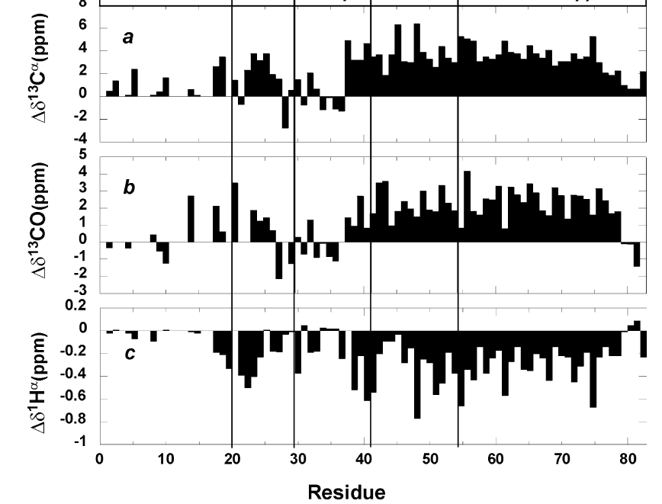
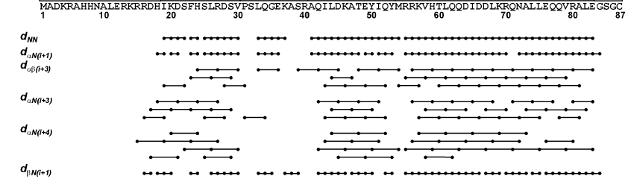

Helix 1 between residues 20-30, helix 2 between residues 40-55, helix 3 (actually Leu zipper) between residues 55-78. A disordered N-terminus residues 1-20, and C-terminus, 78-87 and a loop between residues 30-40

