Structure Problem Sets
SPECIAL TOPICS IN ANALYTICAL CHEMISTRY
CHEM 921, Fall 2005

Problem Set A: C₉H₁₁NO₂ Benzocaine in CDCl₃

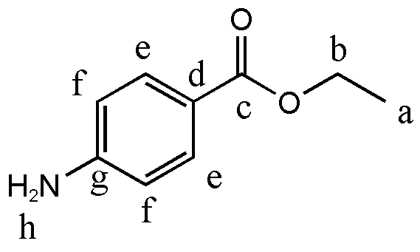
nuclei¹H (ppm)¹³C (ppm)a1.3714.4b4.3260.37c167.0d119.4e7.86131.5f6.64113.7g151.4h4.07

Problem Set B: C₁₂H₂₂O₁₁ Sucrose in D₂O

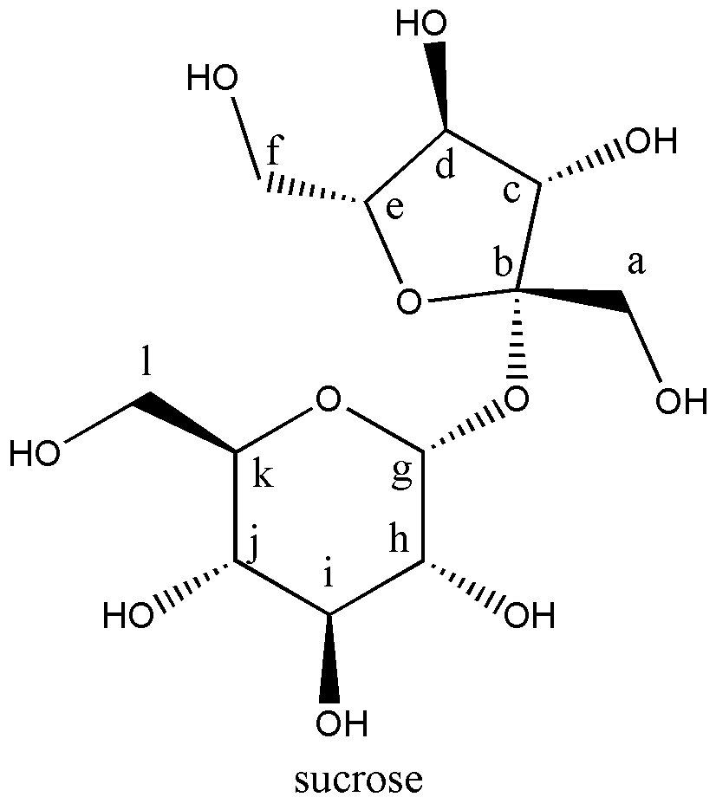
nuclei¹H (ppm)¹³C (ppm)a3.8162.5b103c4.0474.0d4.2076.5e3.8781.0f3.6661.0g5.4092.0h3.5472.5i3.7572.5j3.8469.0k3.4471.0l3.8172.5
Problem Set C: C₉H₈O Cinnamaldehyde in DMSO
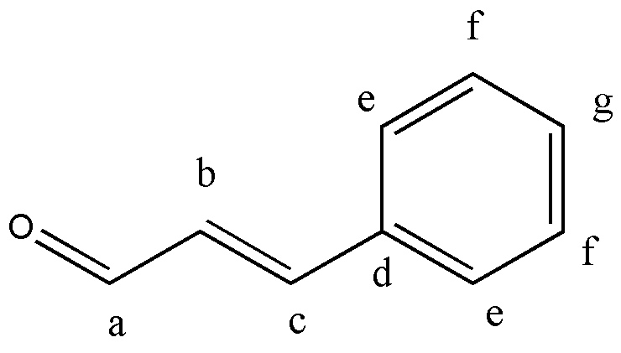
nuclei¹H (ppm)¹³C (ppm)a9.67194.2b6.86134.0c7.67152.9d131-128e7.75131-128f7.47131-128g7.40131-128

Problem Set E: C₁₄H₁₂O₂ Benzoin in CDCl₃
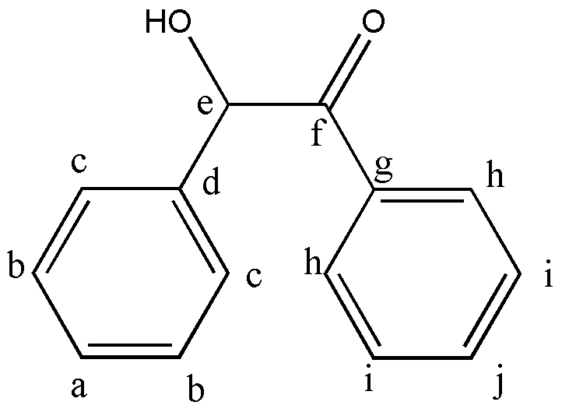
nuclei¹H (ppm)¹³C (ppm)a7.27128.6b7.33129-128c7.33129-128d134.0e5.9793.7f199.0g139.0h7.93129-128i7.41129-128j7.53133.5OH4.57
Problem Set F: C₉H₁₃NO₂ Phenylephrine in DMSO
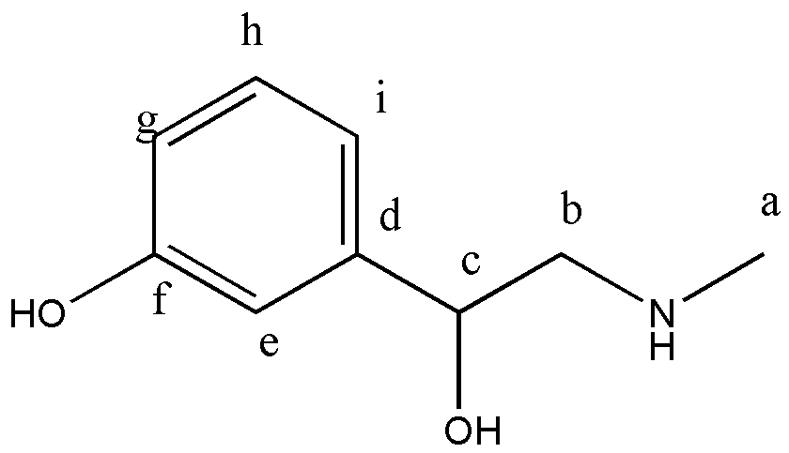
nuclei¹H (ppm)¹³C (ppm)a2.4732.6b3.01,2.9154.9c4.8567.9d143.0e6.80112.6f157.4g7.14116.1h6.77129.1i6.71114.5OH3.41

