Nuclear Magnetic Resonance (NMR)
Problem Set

1. Determine the structure for compound: C₇H₇OBr
NMR Solvent: CDCl_{3.}
Relative Intensity of ¹H NMR integrals are indicated

¹H NMR Spectra

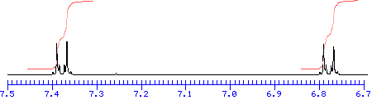

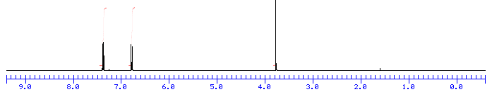
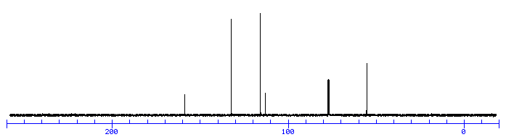
1
1
3
¹³C NMR Spectra

2. Determine the structure for compound: C₅H₁₄OSi
NMR Solvent: CDCl_{3.}
Relative Intensity of ¹H NMR integrals are indicated
¹H NMR Spectra
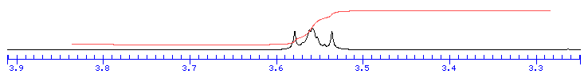
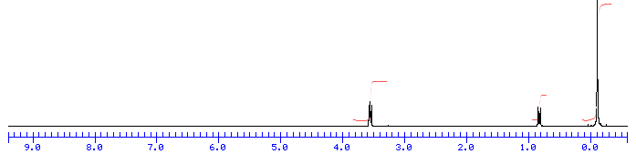
3
2
9

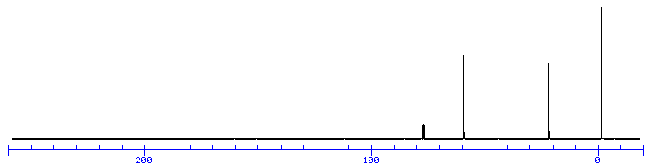
¹³C NMR Spectra

3. Determine the structure for compound: C₆H₁₃NO
NMR Solvent: CDCl₃
Relative Intensity of ¹H NMR integrals are indicated
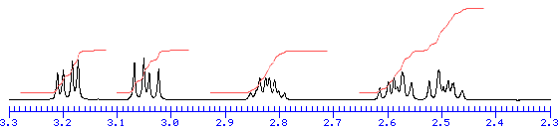
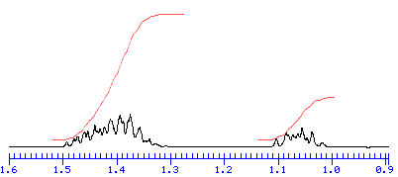
¹H NMR Spectra
1
1
1
3

4

1

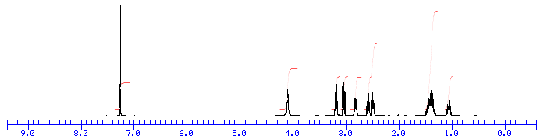
¹³C NMR Spectra
1
1
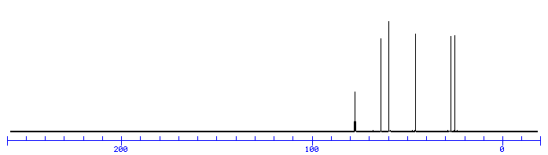

4. A 500 MHz NMR spectrometer costs approximately $500,000 a corresponding 800 MHz NMR spectrometer costs approximately $2 million dollars. Why would you want to buy a 800 MHz NMR?

5. At what frequency do the following nuclei give NMR absorption for a magnetic field of 11.7T : ¹H, ¹²C, ¹⁵N, and ³¹P?

6. Describe the splitting patterns for the ¹H NMR spectra (assuming first order) of the following:
a) CH₃CHClCH₃ b)

7. The ¹³C spectrum of CHCl₃ shows two peaks separated by 200 Hz. Draw a spin vector diagram to show the location of these two components in the xy-plane immediately after a 90º x-pulse a times 0, 1, 2.5, 5 and 20 msec. Assume T₁ and T₂ are ~ 20 sec. (a) the transmitter is placed in the center of the multiplet (b) the transmitter is placed 200 Hz to high field of the high field line.

8. The ¹³C NMR spectra of d6-benzene has a line-width of 3 Hz. What is the minimum delay between 90º pulses to obtain an accurate signal to noise measurement in a multiple pulse experiment?

9. The “correct” analysis of NMR data for the structure of cyclohexane may result in a planar structure. Explain why this may occur and why it would be wrong.

10. From the handouts, calculate the ¹³C shifts of (CH₃CH₂)₂CHCH₃ and the ¹H shifts of (assume rings behave as Ph):

11. If it takes 1 sec to collect a single FID. How long would it take to double the signal-to-noise? How many FIDs need to be collected? Explain.

12. If two chemical species are in fast-exchange on the NMR time-scale where species A has a chemical shift of 7.15 ppm and is twice as abundant as species B with a chemical shift of 6.89 ppm. What is the observed NMR resonance?

13. An NMR spectra is scanned (in CW mode) at time t=0 using a high-power radio-frequency magnetic field. It is then scanned repetitively at intervals of 5 seconds with a low-power radio frequency magnetic field. The maximum signal height, S, of each signal is given as follows:

t/s 5 10 15 20 25 30 1000
S/cm 4.6 6.8 8.4 9.8 10.9 11.8 14.9

Explain the physical process occurring and derive a numerical value for the parameter which determines the rate of this process.

