Nuclear Magnetic Resonance (NMR)
Problem Set Answers

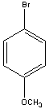
1.

2.

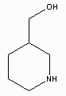
3.

4. Increase in both sensitivity and resolution as a result of the field increase (B_{o}). Also, TROSY effect. Field dependency of T2 for high molecular-weight proteins.
Sensitivity (S)  γ⁴ B_{o}²NB₁g(ν)/T
Frequency (ν) = | γ/2π|B_{o}

5. ν = | γ/2π|B_{o}, 11.7T

¹H γ = 26.7519 x 10⁷ rad T⁻¹ s⁻¹
ν = |26.7519 x 10⁷ rad T⁻¹ s⁻¹/2π| 11.7T = 498 MHz
¹²C γ = 0

¹⁵N γ = -2.712 x 10⁷ rad T⁻¹ s⁻¹
³¹P γ = 10.841 x 10⁷ rad T⁻¹ s⁻¹

¹H/¹⁵N = 9.865, 498/9.865 = 50.5 MHz
¹H/³¹P = 2.468, 498/2.468 = 201.8 MHz

6. (a) CH₃CHClCH₃
HB HA HB CH₃ are magnetically equivalent

HA (septet) HB (doublet)
| |
1 : 6 : 15 : 20 : 15 : 6 : 1
1 : 1

(b)
B
C

A

HA (doublet of doublet)
Split by HB

Split by HC
1 : 1 : 1 : 1

HB (doublet of triplets)
Split by HC

Split by HA
1: 2 :1 : 1:2 :1

HC (doublet of triplets)

Split by HB

Split by HA
1: 2 :1 : 1:2 :1

7. T₁ = T₂ = 20 sec., so no significant decay during time scale.

(a) ω = 2π(ν-ν_{o}) = 2π(± 100 Hz) = ± 3600º/sec

t =0 t = 1 msec, 36º

x
y
x
y
36⁰
36⁰

t= 2.5 msec, 90º t = 5 msec, 180º

x
y
x
y

t= 20 msec, 2x360º
x
y
(b)
transmitter
200 Hz
200 Hz
ω₁ = 2π(ν-ν_{o}) = 2π(200 Hz) = 7200º/sec
ω₂ = 2π(ν-ν_{o}) = 2π(400 Hz) = 14400º/sec

t =0 t = 1 msec, 72º, 144º

x
y
x
y
72⁰
144⁰

t= 2.5 msec, 180º, 360º t = 5 msec, 360º, 720º

x
y
x
y

t= 20 msec, 4x360º, 8x360º
x
y

8. wait ~ 5T₁, T₁ ≈ T₂
3Hz = 1/πT₂ T₂ = 0.106 sec, wait 0.530 sec.

9. NMR data is time-averaged. The low-energy conformation of cyclohexane is the chair conformation. But at room-temperature the structure inter-converts rapidly between multiple conformations that exchange axial and equatorial proton position (above and below the plane). By ‘averaging” these conformations, a planar structure may result.

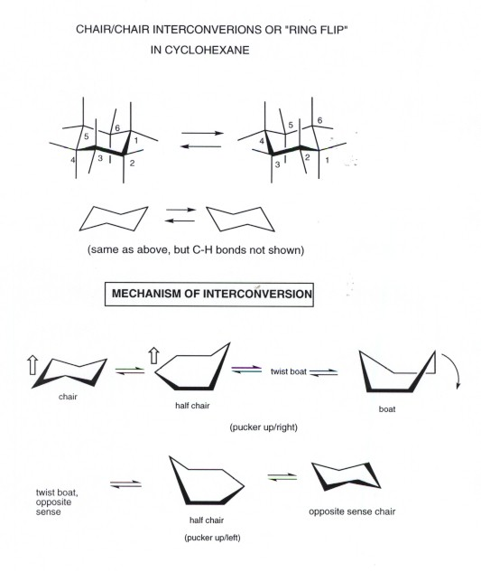

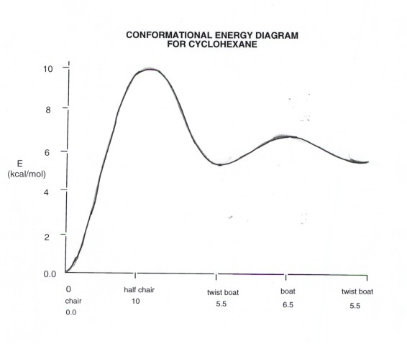

10. (a)
CH₃-CH₂
(A) (B)
CH –CH₃
- (D)

CH₃-CH₂
(A) (B)

From Table in Handout:
B₁ A₁₂ γ₁ Δ₁
δ_{a} = 6.80 + 1(9.56) + 2(-2.99) + 1(0.49) = 10.87 ppm

B₂ A₂₃ γ₂ Δ₂
δ_{b} =15.34 + 1(16.70) +1(-2.69) +0(0.25) = 29.35 ppm

B₃ A₃₂ γ₃ Δ₃
δ_{c} =23.46 + 2(6.60) + 0(-2.67) +0(0.68) = 36.66 ppm

B₁ A₁₃ γ₁ Δ₁
δ_{D} =6.80 + 1(17.83) + 2(-2.39) +0(0.49) = 18.65 ppm
A
B
(b)
A
B
C
D
E
F

Benzene Shift F effect Ph effect OH effect Total

δa 7.27 0.30 0.08 N.A. 7.65 ppm
δb 7.27 0.02 -0.18 N.A 7.11 ppm
δc 7.27 N.A -0.18 0.50 7.59 ppm
δd 7.27 N.A -0.18 0.4 7.49 ppm
δe 7.27 N.A. 0.00 0.14 7.41 ppm
δf 7.27 N.A. -0.08 0.50 7.69 ppm

11. S/N   number of scans

So, to double the S/N 4x number of scans need to be collected.
4 scans with a time of 4secs.

12. δ_{obs} = f₁δ₁ + f₂δ₂; f₁ +f₂ =1

δ_{obs} = 0.67(7.15) + 0.33(6.89) = 7.06

13. T₁ relaxation process: M_{z} = M₀(1-exp(-t/T₁))
T₁ = 17.2 s

