FINAL EXAM
ANALYTICAL CHEMISTRY
CHEM 421/821, Spring 2006
Monday May 1st, 2006

NAME_____________________________________

Some useful constants: h = 6.63x10⁻³⁴J.s
c = 3.00 x 10⁸ m/s
k = 1.38066 x 10⁻²³ JK⁻¹
F = 96485.31 C mol⁻¹
e = -1.602177 x 10⁻¹⁹C

SECTION I (Electrochemistry, MS and NMR)

1) (a) Calculate the theoretical potential of the following cell:
Pt,H₂(0.100 atm)|HCl(4.50x10⁻⁴ M), AgCl(saturated)|Ag

AgCl(s) + e⁻ → Ag (s) + Cl⁻ Eº = +0.222
E_{cathode} = +0.222 – (0.0592/1) log ((4.50x10⁻⁴)(1)/1) = 0.420

2H⁺ + 2e⁻ → H₂(g) Eº = 0.00
E_{anode} = 0.000 – (0.0592/2) log (0.100/4.50x10⁻⁴) = -0.169

E_{cell} = 0.420 – (-0.169) = 0.589

(b) Will the reaction proceed spontaneously as written?

Yes, E_{cell} is positive.

(c) The experimentally observed potential differs from the theoretical potential. List three reasons for this difference.

- Concentrations used instead of activities.
- Presence of ohmic potential or IR drop – E_{cell} = E_{cathode} – E_{anode} –IR
- Liquid junction potential
- Polarization of electrode

2) (a) Briefly, explain how a glass electrode measures pH.

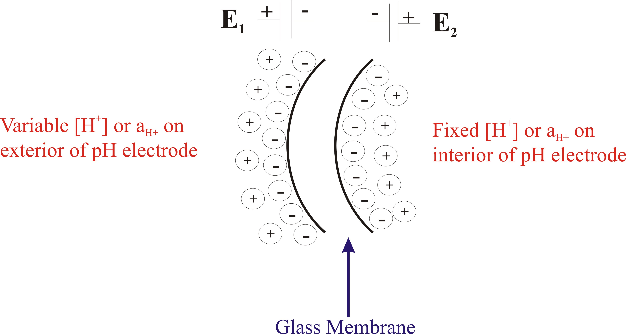

At each membrane-solvent interface, a small local potential develops due to the preferential adsorption of H⁺ onto the glass surface. Based on the Nernst equation, the observed potential is directly related to [H⁺] on the exterior of the electrode.
E_{b} = c – 0.592pH

(b) Identify another electrode that works similar to the glass electrode.

A number of electrode types relate a potential difference to a concentration difference across a membrane due to a specific interaction of an analyte with the electrode. Crystalline Membrane Electrode, Liquid Membrane Electrode or Enzyme electrodes are common examples

(c) What does pH stand for?

-log[H⁺]

(d) Why is a reference electrode needed?

Provides the other half-cell reaction (reference) to complete the cell, which is reversible, obeys Nernst equation, and a constant potential that is independent of the concentration of the detected analyte.

(e) What is the source of error at high pH with a glass electrode?

High pH → low [H⁺], so other ions beside H+ may interact with the glass electrode resulting in a lower pH value than actual.

4) A 0.0809 g sample of a purified organic acid was dissolved in an alcohol/water mixture and titrated with coulometrically generated hydroxide ions. With a current of 0.0324 A. 251 seconds were required to reach a phenolphthalein end point. Calculate the equivalent weight of the acid (weight that contains one mole of titratable H⁺).

0.0324 A x 251 s x $\frac{1 C}{A⋅S}$ x $\frac{\text{1F}}{\text{96485}}$x $\frac{1 \text{equiv} \text{HA}}{F}$= 8.429x10⁻⁵ equiv/HA

$\frac{0\text{.}\text{0809g} \text{HA}}{8\text{.}{\text{429x10}}^{−4} \text{equiv} \text{HA}}$= 960g/equiv

5) Explain one distinct applications of a magnetic field in mass spectrometry.

(i) mass analyzer – the amount an ion’s path is deflected or curved in a magnetic field is directly proportional to its mass to charge ratio.

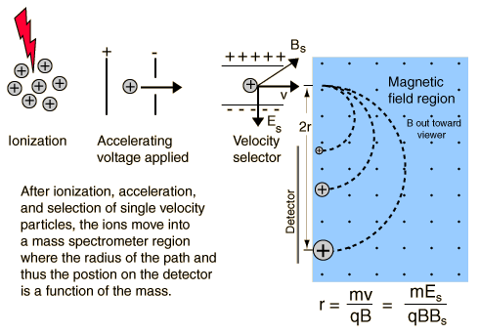

(ii) ion trap – ions will circulate about a perpendicular magnetic field vector effectively trapping the ion for further analysis (FT-MS or enhanced signal intensity).

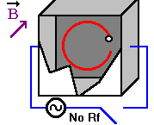

6) (a) What is the difference between soft and hard ionization?

Hard ionization - sufficient energy such that excited analyte relaxes by rupture of bonds.

Soft ionization – little to no fragmentation occurs

(b) Give an example of a soft and hard ionization method.

Hard ionization:
Electron-Impact Source (EI)
Soft Ionization:
Chemical Ionization Source
Matrix-Assisted Laser Desorption/Ionization (MALDI)
Electrospray Ionization (ESI)
Fast Atom Bombardment Sources (FAB)

7) (a) Calculate the Nominal and Average Molecular weight for glucose (C₆H₁₂O₆), as it pertains to mass spectrometry.
Nominal MW = (6 x 12) + (12 x 1) + (6 x 16) = 180
Average MW = (6 x 12.0107) + (12 x 1.00794) + (6 x 15.9994 )= 180.1559

(b) How do the molecular-weights support the Nitrogen Rule?
Even mass if the compound contains an even number of nitrogen atoms, including zero.

8) Which of the following compounds would be expected to show spin-spin splitting in their ¹H NMR spectra?

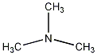
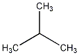
a) or

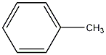
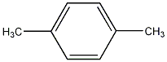
b) or

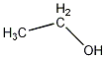
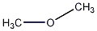
c) or

9) (a) In NMR, what are two experimental observables that provide direct evidence about the three-dimensional structure of the compound?

J-coupling – torsion or dihedral angle
NOE –intra or inter molecular distance

(b) What is the primary source of the chemical shift difference for the two types of protons in ethanol?

The chemical shift differences are due to the differences in local magnetic field caused by differences in electron density around the two nuclei due to the electronegativity of oxygen.

10) Given a molecular formula of C₆H₆OS and the following MS and NMR data determine the structure of the compound. Please label important features of the MS (fragment ions) and NMR (chemical shifts assignments) that support your identification. Peak integrals, splitting patterns and ion molecular weights are labeled on the spectra.

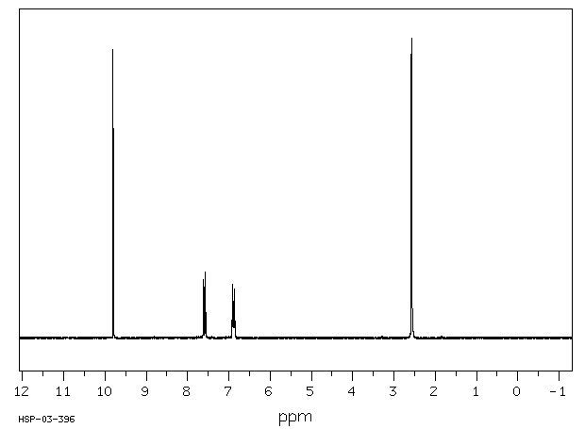
3
1
1
1
doublets
singlet
singlet

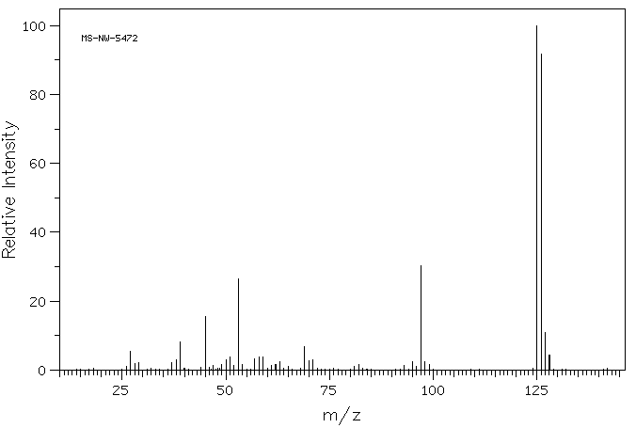
126
97
53
45

MW 126 = parent structure
MW 97 = loss of COH (-29)
MW 53 = C₄H₅⁺
Two fragments from ring split
MW 45 = CS+

SECTION II (Review)

1) (a) What detectors used in mass spectrometry and UV/vis spectroscopy function similarly?

Photomultiplier tube (PMT) and Electron Multiplier

(b) Briefly, describe how the MS detector works.

Ions strike surface of Cu/Be or lead near entrance that ejects electrons. Electrons then skip along surface ejecting more electrons with each impact. Typical current gain of 10⁵ to 10⁸.
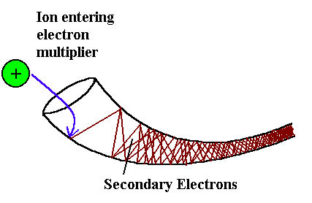

2) What are the major components of a spectrometer? Provide an example for each.

(i) Light source: deuterium lamp, tungsten lamp, globar, Hollow cathode lamp, etc.

(ii) Monochromator/filters: prism, Czerney-Turner (reflective) Grating, absorption filters, interference filters, etc.

(iii) Detector: PMT, thermocouple, silicon diode, bolometer, etc.

3) What is the source of absorption in:
(a) UV/vis, fluorescence, phosphorescence
Bonding electron transitions (σ, π, n, etc)

(b) NMR
Nuclei spin

(c) IR
Bond and angle vibrations

(d) Atomic Spectroscopy
Transitions of outer shell electrons

4) How can mass spectrometry and atomic emission spectroscopy be used to determine the molecular formula of an unknown?

AES can monitor the presence of up to 55 elements in an unknown sample by the observation of the presence/absence of the unique pattern of atomic emission bands for each element. Since AES follows Beer’s law, the relative intensity of the bands indicate the relative concentration of each element in the unknown.

Similarly, in MS the relative abundance and mass of each isotope is known. By determining a highly accurate molecular-weight (at least 4 decimal places), only one combination of elements will be consistent with the observed molecular-weight.

- What is the relationship between precision and signal-to-noise?

Precision is directly dependent on S/N. Precision is a measure of the reproducibility of the experimental results, where S/N quantifies the magnitude of the analyte signal relative to the background noise. Clearly as S/N increases, the reliability of accurately measuring the analyte signal increases, this correspondingly increases the reproducibility between repeat measurements.

- Line-shape, band-width or peak-width is an important experimental parameter that affects sensitivity and resolution. Briefly, describe or identify one factor that contributes to peak or band width in the following methods.

(a) UV/vis spectroscopy
Superposition of vibrational, rotational and vibrational transitions on the observed electronic transitions.

(b) Liquid chromatography
Factors that differential affect the travel time of a solute through a column: eddy diffusion, mobile phase mass transfer, stagnant mobile phase mass transfer, stationary phase mass transfer, longitudinal diffusion.

(c) NMR
NMR line-widths are related to magnetic field homogeneity, T₂ relaxation time (related to molecular weight), and exchange dynamics.

(d) Atomic Spectroscopy
Lines are broadened by Heisenberg uncertainty principal, pressure broadening, Doppler effect and electric/magnetic fields.

7) (a) How is resolution calculated in mass spectrometry and chromatography?
MS: ratio of the sum of the masses and mass differences $R=\frac{(m_{1}+m_{2})2}{Δm}$
m₁,m₂ = mass of the two ions, and Δm is the mass difference.

LC: ratio of the differences in retention time and differences in line-width $\frac{t_{r2}−t_{r1}}{(W_{b1}−W_{b2})2}$
t_{r1}, W_{b1} = retention time and baseline width for the first eluting peak
t_{r2}, W_{b2} = retention time and baseline width for the second eluting peak

(b) Describe one approach to increase resolution in NMR and chromatography.

NMR: increase in magnetic field strength, increase in NMR data size (zero-filling), increase in temperature.

LC: change mobile phase composition or gradient elution, change stationary phase, increase column length, change flow rate, pore or particle size, etc

8) Throughout the course, we have discussed how various techniques take advantage of the property of light to monitor a sample. Give a specific example of an approach that takes advantage of:
(a) Particle property of light

Any absorption spectroscopy technique or NMR utilizes the particle property of light through the absorbance of a photon to excite the analyte. The methods are distinguished by the wavelength or frequency of the photon that is absorbed and by process of absorbance.

(b) Diffraction property of light

Diffraction is the bending of light as it passes through a slit which results in constructive and destructive interference. This is either used to select frequencies from polychromatic light as a Monochromator in UV/vis, IR, fluorescence, etc. It is also the underlying principal in FT-IR, where the distance difference between two mirrors creates a different diffraction pattern. Thus, the observed absorbance is pattern is dependent on this distance, where FT of the interferograms generates an absorbance spectrum.

9) The IR spectrum for acetylene (C₂H₂) contains a strong absorbance at 3423 cm⁻¹, but the Raman spectrum contains absorbance at 3476 cm⁻¹ and 2181 cm⁻¹. Explain, in detail, the source of the differences in the IR and Raman spectra.

H-C=C-H C-H symmetric stretch is Raman active (symmetry, change in polarization) and occurs at 3476 cm⁻¹, IR inactive no change in dipole moment.
H-C=C-H C-C symmetric stretch is Raman active (symmetry, change in polarization) and occurs at 2181 cm⁻¹, IR inactive no change in dipole moment.

H-C=C-H C-H asymmetric stretch is IR active because of a change in dipole moment (asymmetric) and occurs at 3423 cm⁻¹. This stretch is Raman inactive because of no change in polarization
10) Below is a list of analytical techniques that we have covered during the semester and six analytical “problems” that might be solved using one of these techniques. Match each problem with one technique that you think would best address the problem. Use each technique only once.

1. Cyclic voltammetry 2. Gas Chromatography
3. NMR Spectroscopy 4. Inductively Coupled Plasma Emission
Spectroscopy
5. Matrix-Assisted laser Desorption/Ionization 6. Infrared Absorption Spectroscopy
with Time-of-Flight Mass Spectrometry MALDI-TOF

7. HPLC with UV/VIS Absorbance Detection 8. gel electrophoresis

Technique Problem
Selected
- A. __7__ You want to follow the concentration of a new drug and its degradation products in blood serum obtained from patients as a function of time.
B. __6__ You are carrying out a chemical synthesis that involves the dehydration of an alcohol to form an alkene and you want to determine if the proper product has been formed.
C. __4__ A local community is experiencing cancer rates well-above the national average and believe their drinking water has been contaminated with chromium. You want to determine if Cr(VI) exceeds the < 2 ppb average chromium concentration in drinking water.
D. __5__ A common problem with expressing a protein in yeast is the potential for heterogeneous glycosylation of the protein (addition of different lengths and branches of sugar-chains to the protein). You want to determine if a protein has been glycosolated.

- E. __3___You have synthesized a new natural product. You would like to confirm the structure of this compound.
F. __2__ You want to measure the relative air quality in Lincoln by monitoring the concentration of ozone and NO₂ at various locations in the city.

G. __1__ You want to monitor the enzyme mechanism involved in a redox reaction

H. __8__ You want to compare DNA fragments collected at two distinct crime scenes.

