EXAM # 2
ANALYTICAL CHEMISTRY
CHEM 421/821, Spring 2006
Monday March 6th, 2006

NAME_____________________________________

Some useful constants: h = 6.63x10⁻³⁴J.s
c = 3.00 x 10⁸ m/s
k = 1.38066 x 10⁻²³ JK⁻¹

1) A student was adjusting the path of light from a Hollow Cathode lamp through the sample-flame and noticed that the intensity of the elemental lines changed. Provide two explanations for this observation.

AAS sensitivity follows Beer’s law (A=bεc), where any factor that effects the atoms concentration will affect the signal intensity. The optimal sensitivity for an element in AAS is dependent on its position in the flame primarily due to differences in flame temperature. These temperature differences can affect the ratio of atoms to ions (higher temperature higher number of ions), or the concentration of atoms in the flame by the efficiency of the atomization process (lower temperature higher number of molecules).

Additionally, Beer’s law is additive (A_{obs} =A₁ +A₂ … + A_{n}), so the presence of molecules from incomplete atomization or oxide/hydride formation will also affect the observed intensities. Also, oxide/hydride formation increases in the outer cone of the flame because of lower temperatures and contact with atmospheric oxygen.

2) (a) Why can’t you use a thermal detector in FTIR?

Too slow

(b) Identify one light source used in UV/vis spectroscopy and one light source used in IR spectroscopy that operate based on a similar physical principal. What is this principal?

IR: globar, nernst glower, incandescent wire
UV/vis: tungsten filament lamp

Black body radiation: heat solid filament to glowing

(c) What are the basic differences between the operation of typical IR and UV/vis detectors?

UV/vis detectors generate a current from a photon striking photoemission material that emits an electron. IR detectors respond to an induced temperature change from IR radiation that typically result in a change in resistance of a metal wire that causes a change in potential or current.

(d) What is the major difference in the design of an atomic emission spectrometer relative to all the other spectroscopy techniques we have discussed so far? Why?

AES does not have a light source. The high temperature of the flame is used to excite the element and the emission spectrum is monitored when the element relaxes back to the ground state.
3) Match the Structures with the IR Spectra. Label key absorbance on the spectra consistent with the assigned structure.

(3)
(2)
(1)
(a)
(b)
(c)

(1)

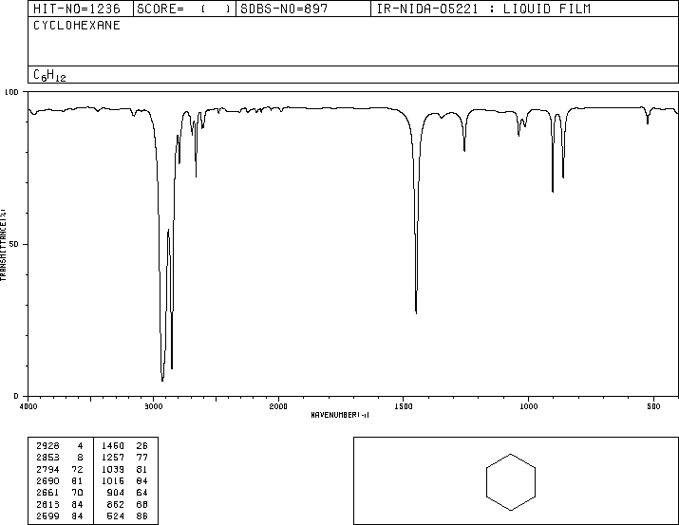
4000 3000 2000
1500 1000 500
C-H
C-H
(2)

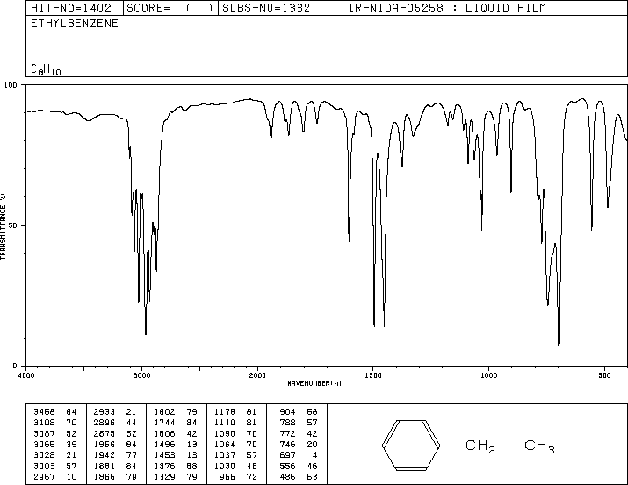
4000 3000 2000
1500 1000 500
C=C-H
C-H
C=C
C-H

(3)
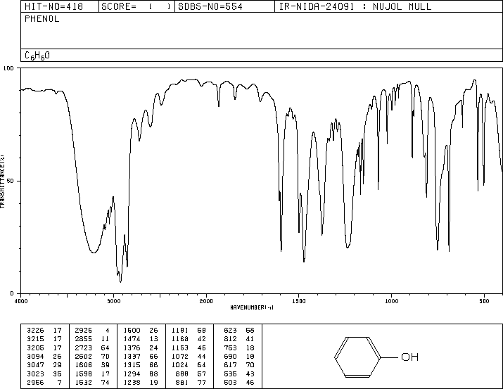
4000 3000 2000
1500 1000 500
O-H
C=C
C-H

3) Use energy diagrams to explain the mechanistic differences in generating an absorbance spectrum for IR and Raman Spectroscopy.

An IR spectrum results in the absorbance of light based on energy gaps between various ground and excited vibrational states. These vibrational states result from the bending, stretching and other asymmetrical motions of chemical bonds resulting in a dipole change.

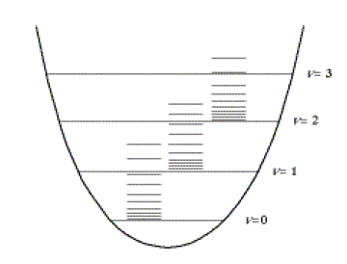
Interatomic Distance (r)
Potential Energy
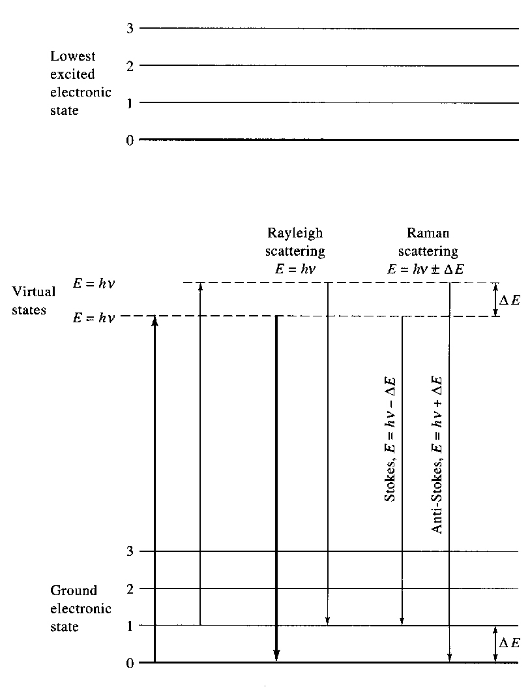

A Raman spectrum is also dependent on transitions between ground and excited vibrational states, but unlike IR this does not result from a direct absorption between these vibrational states. Instead, Raman spectroscopy measures a frequency shift that is identical to the energy gap between the vibrational states. First, an absorption occurs to a virtual state that is below the lowest excited electronic state but significantly larger than typical vibrational excited states. Like UV/vis, there are a number of excited vibrational states associated with each virtual state. The vast majority of these excited virtual states relax back to the ground state without any change in energy (Rayleigh scattering). But some relax back to the ground state with a change in energy by relaxing back to either a higher vibrational state (Stokes, lower energy) or lower vibrational energy state (Anti-stokes, higher energy). The Stokes and Anti-stokes transitions have a low probability requiring an intense light source (laser) to observe. Also, since Raman spectroscopy is measuring a frequency shift, the light source does not have to be in the IR frequency range.

Active Raman vibrations require a change in polarization, which are symmetric stretches.
- Given the IR and Raman spectrum for acetic acid (C₂H₄O₂):

(IR)
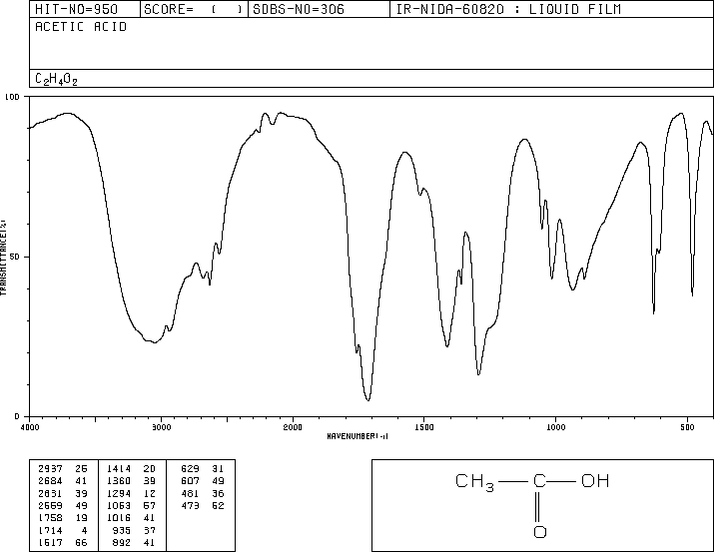
4000 3000 2000
1500 1000 500
(Raman)

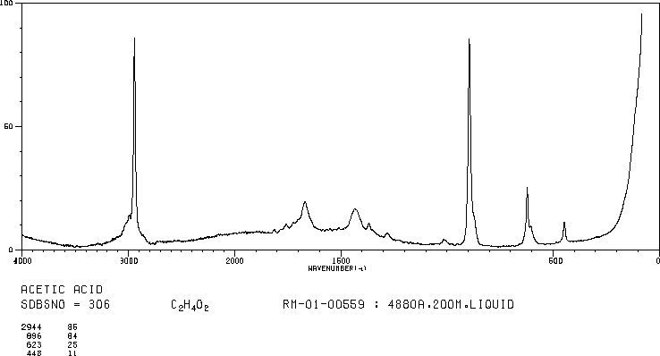
4000 3000 2000
1500 500

(a) What is the number of vibrational modes for acetic acid? (b) Why are the O-H and C=O stretches significantly weaker in the Raman spectrum?

- non-linear molecules, number of types of vibrations: 3N-6: 3(8)-6=18
- IR measures asymmetric stretches where a change in dipole occurs. As a result IR emphasizes polar functional groups. Conversely, Raman active stretches are symmetric where a change in polarizability occurs. Raman emphasizes aromatic and carbon backbones

5) Given the following chromatogram and a column length of 25 cm:
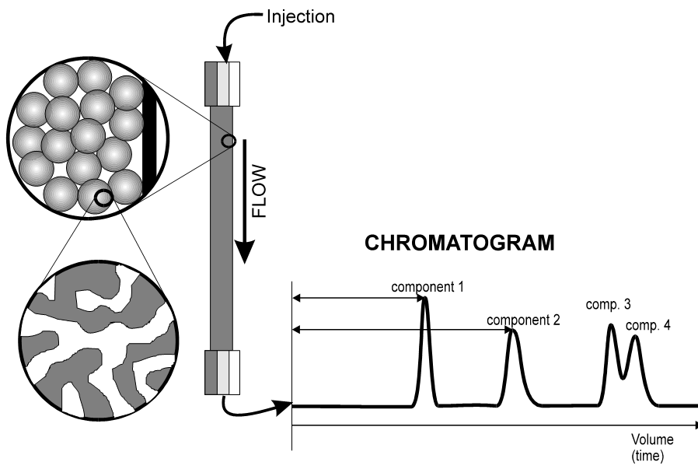
100
Seconds
150
225
Void
50
240
Calculate:
- Capacity factor for compounds 1 to 4.

k’ = (tR –tM)/tM
cmpd 1: k’ = (100-50)/50 = 1
cmpd 2: k’ = (150-50)/50 = 2
cmpd 3: k’ = (225-50)/50 = 3.5
cmpd 4: k’ = (240-50)/50 = 3.8

- How would you classify the performance of the column for compounds 1 and 2? For compounds 3 and 4?

The capacity factors in general indicate the separation is optimal, which is true for compounds 1 and 2 that are baseline separated. But, this is not the case for compounds 3 and 4, where there is significant overlap.

- Describe how you could use the capacity factor to quantify the quality of separation for compounds 1 and 2 relative to compounds 3 and 4.

The ratio of the capacity factor would indicate the relative separation between the peaks.

For k’_{2,1} = 2/1 = 2, which we know is a baseline separation.

For k’_{4,3} = 3.8/3.5 = 1.09, which we know results in peak overlap.

- Given that compound 1 has a peak-width (W_{H}) of 5 secs. and compound 2 has a peak-width of 10 secs. Calculate the number of theoretical plates and the plate height.

N = 5.54 (t_{R}/W_{h})² H = L/N

N₁ = 5.54(100/5)² = 2216 H₁ = 25 cm / 2216 = 1.1e⁻² cm
N₂ = 5.54(150/10)² = 1246.5 H₂ = 25 cm / 1246.5 = 2.0e⁻² cm

6) Why are peak widths or shapes more important in IR, Raman, AES and liquid chromatography than in UV/vis and AAS?

In IR, Raman, AES and liquid chromatography, we use the relative peak position to determine the structure, composition or separation of the analyte. This analysis becomes complicated or ambiguous when peaks overlap. Peak overlap is directly proportional to peak width. Conversely, UV/vis and AAS are primarily used to measure concentration, which typically does not require resolving peaks

7) The relative ranking of energy gaps between the electronic, vibration and rotation ground and excited states is:
a) rotation > vibration > electronic
b) vibration > rotation > electronic
c) electronic > rotation > vibration
d) electronic > vibration > rotation

8) The “fingerprint” region of an IR spectrum is routinely used to:
a) identify the functional groups present in the structure
b) identify a compound through a database search
c) measure anharmonic vibrations
d) determine force constants

9) A laser is typically used for Raman spectroscopy because:
a) vibrational transitions have a large ΔE
b) requires an IR light source
c) low intensity of the stokes and anti-stokes transitions
d) monochromators used for Raman spectroscopy absorb IR

10) Oxide and hydroxide formation in AAS can be avoided by:
a) placing the light source in the outer cone of the flame
b) increasing the oxidant/fuel ratio
c) increasing the temperature
d) changing the hollow cathode lamp

11) An advantage of FTIR is:
a) multiple compounds can be analyzed simultaneously
b) increase in speed, S/N and resolution
c) can use a photomultiplier detector
d) temperature independent

12) Releasing agents in atomic spectroscopy are effective because they:
a) lower the flame temperature
b) bind to analyte, but are volatile
c) form preferential compounds with interfering ions
d) produce an excess of electrons

13) The Two-line method, Source Modulation method and the Zeeman effect are important in atomic absorption spectroscopy because it:
a) correct for absorbance from molecular species
b) correct for the background created by the flame
c) allow for the measurement of a small signal against a large background
d) all of the above

14) In chromatography, the capacity factor is related to:
a) equilibrium constant between the mobile and stationary phase
b) column length
c) flow rate
d) all of the above

15) Hollow cathode lamps are important in Atomic Absorption Spectroscopy because:
a) provide a broad bandwidth of UV/Vis radiation
b) provide rapid sample atomization
c) provide a narrow bandwidth of light matching an element’s emission spectra
d) provide a source of sputtering

