EXAM # 1
ANALYTICAL CHEMISTRY
CHEM 421/821, Spring 2006
Monday February 6th, 2006

NAME_____________________________________

Some useful constants: h = 6.63x10⁻³⁴J.s
c = 3.00 x 10⁸ m/s

1) Compare and contrast the operation and use of a photomultiplier tube (PMT) and silicon diodes (photodiode) detectors.

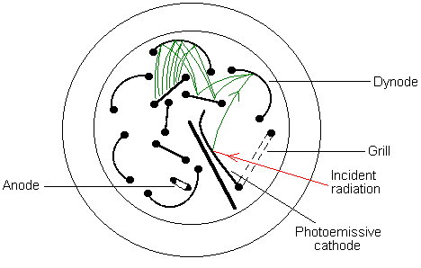
A current is generated proportional to the intensity of light that strikes the cathode coated with photoemissive material (Cs₂O). A series of nine dynodes where each dynode is covered with a and a 90V potential is applied between each dynode. This greatly amplifies the signal. When light hits cathode, an electron is emitted and attracted to dynode #1. This collision causes more electrons to be emitted and attracted towards dynode #2. Process continues until e- are collected at anode after amplification at 9 dynodes. Very sensitive to low light sensitive, but needs large external power supply (900V). PMT is easily damaged by intense light.
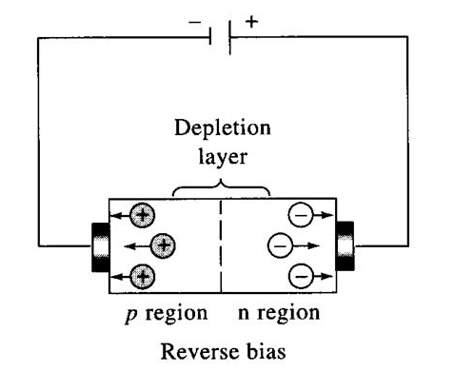
Conversely, a current is not generated with the silicon diodes (photodiode) detectors. Semiconducting material only conducts current under certain conditions. A semiconductor contains a stable p region (electron holes) and an n region (additional electrons). The electrons are impeded from traveling from the n region towards the p region by the repulsion of the p-region acceptor atoms. A photon of light provides enough energy to overcome this barrier and allow electrons to flow and complete a circuit. The observed current is proportional to the intensity of light. Not very sensitive, but can place multiple silicon diodes in a 1D or 2D array to measure positional changes in absorption.

2) Noise is an inevitable part of the operation of a UV/vis spectrometry. Explain in detail one noise or other factor associated with the standard operation of a UV/vis spectrometry that affects:

(a) accuracy

Factors that contribute to deviations from Beer’s law will negatively impact the accuracy of the measured analyte sample concentration (A=εbc). Factors include: i. errors in the geometry or surface contamination of sample cells, ii. measurements at low/high ends of the absorbance region, iii. additional analytes in sample with similar absorbance spectra, iv. broad bandwidth with large variations in ε, v. systematic error in calibration of 100%T and/or 0%T.

(b) precision

Factors that contribute to random fluctuations in repeat measurements of absorbance will include: i. fluctuation in light intensity/powers, ii. Shot noise → random thermal expulsion of e⁻ that generates current, iii. reading meters, iv. 0%T noise → current fluctuation in the absence of light.

(c) Why is systematic error more difficult to detect than random error?

Systematic error is a constant deviation from the true or accepted value. Thus, to identify a systematic error, some knowledge of the true value is necessary. This requires obtaining a calibration curve against known standards. Conversely, random error is a fluctuation about the true value and can simply be determined by the variability in a set of repeated data points (standard deviation).

3) (a) What is the source of absorption in UV/Vis and fluorescence spectroscopy?

Bonding electrons

(b) What is a common transition observed in UV/Vis spectroscopy and fluorescence?

π → π*

4) Draw a compound that you would predict to be:
(a) UV/vis active but not fluorescent

any compound with a double bond (π-π* transitions):

(b) fluorescent

any fused aromatic ring system (fluorescence favored for rigid structures):

(c) both UV/vis and fluorescent inactive.

any compound that lacks double bond, aromatic, or non-bonded characteristics, typically solvents for UV/vis spectroscopy (opposite above).

Water, ethanol, n-heptane, etc

5) An echellette grating that contains 3500 blazes/mm is used in a UV/vis spectrometer where the incident angle of the polychromatic beam is 60º.
(a) At what angle from the grating would you be able to observe light with a wavelength of 300nm?

nλ = d(sin β + sin γ)

d = 1 mm/3500 blazes x 10⁶nm/mm = 286 nm/blaze
300 nm = 286 nm(sin r + sin 60)
sin r = 300 nm/286nm - sin 60
sin r = 0.183
r = sin⁻¹ 0.183 = 105º

(b) What is the energy of a photon of this light?

E = hν = hc/λ = (6.63x10⁻³⁴J.s x 3.00 x 10⁸ m/s) / (300 nm x 10⁻⁹ nm/m)
= 1.989x10⁻²⁵ J.m / 3.0x10⁻⁷ m
= 6.63 x 10⁻¹⁹ J

(c) If an analyte exhibited a percent transmission of 25% at 300nm, what is its absorbance?

A = -log(%T/100)
A = -log(25%/100)
A = -log(0.25) = 0.60

6) You are designing an experiment to monitor the activity of an enzyme (DNase) using a compound that only absorbs at 550 nm when bound to a double-stranded DNA molecule. DNase degrades double-stranded DNA. The compound has a binding affinity (K_{D}) of 10 μM and a molar absorptivity of 3.91 x 10³ L cm⁻¹ mol ⁻¹.
$K_{D}=\frac{1}{K_{a}}=\frac{[\text{compound}][\text{DNA}]}{[\text{DNA}:\text{compound}]}$

What concentration of the compound needs to be added to an equal concentration of DNA to produce an absorbance of 0.1 in a 1.00 cm cell?

Concentration of [DNA:compound] needed for 0.1 absorbance is:

A= εbc
0.1 = (3.91 x 10³ L cm⁻¹ mol ⁻¹)(1.00 cm)(c)
c = 0.1/((3.91 x 10³ L cm⁻¹ mol ⁻¹)(1.00 cm))
c = 2.56 x10⁻⁵ M = 25.6 μM

Free compound concentration from K_{D}:

[DNA]=[compound] = x

K_{D} = x²/25.6 μM
x = √(25.6 * 10 μM) = 16 μM

Total compound concentration is the sum of the free and DNA complex:

Total [compound] = 25.6 + 16 = 41.6 μM

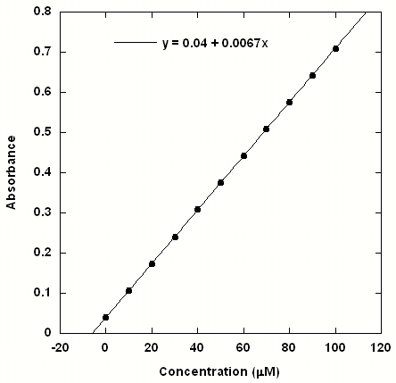
7) From the Following Calibration Data Calculate:
Conc. (μM) | Mean (A) | Std. Dev. (μM)
0.0 | 0.04000 | 0.003
10.0 | 0.10700 | 0.003
20.0 | 0.17400 | 0.002
30.0 | 0.24100 | 0.003
40.0 | 0.30800 | 0.004
50.0 | 0.37500 | 0.005
60.0 | 0.44200 | 0.004
70.0 | 0.50900 | 0.005
80.0 | 0.57600 | 0.006
90.0 | 0.64300 | 0.006
100.0 | 0.71000 | 0.005
- calibration sensitivity

calibration sensitivity = slope (m) = 0.0067

- analytical sensitivity (only for 50.0 μM)

analytical sensitivity (γ) = m/S_{s} = 0.0067/0.005 = 1.34

- limit of detection

S_{m} = S_{bl} + ks_{bl}
S_{m} = 0.040 + 3 . 0.003 = 0.049
limit of detection = c_{m} = (S_{m}-S_{bl})/m
c_{m}= (0.049-0.040)/0.0067 = 1.34 μM

8) Using energy diagrams explain one factor that affects the quantum yield of fluorescence?

Any process (vibrational relaxation, internal conversion, intersystem crossing) that results in a loss of energy prior to the transition from the excited singlet state to the ground singlet state will decrease the intensity of fluorescence.

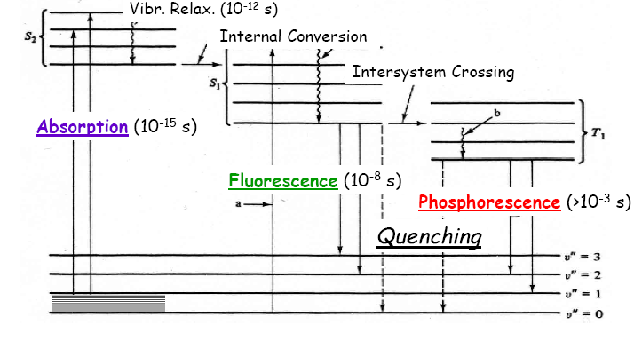

9) Describe one difference in the construction between a UV/vis spectrometer and a fluorescence spectrometer.

Delay between excitation and emission spectra, detector 90º from source (monitor emission), reference beam intensity truncated → fluorescence lower intensity.

10) What is a primary difference in the relaxation process associated with UV/vis, fluorescence and phosphorescence?

Significant difference in the rate of relaxation, phosphorescence >> fluorescence > UV/vis.

