FINAL EXAM
ANALYTICAL CHEMISTRY
CHEM 421/821, Spring 2005
Friday May 6th, 2005

NAME_____________________________________

Some useful constants: h = 6.63x10⁻³⁴J.s
c = 3.00 x 10⁸ m/s
k = 1.38066 x 10⁻²³ JK⁻¹
F = 96485.31 C mol⁻¹
e = -1.602177 x 10⁻¹⁹C

SECTION I (Electrochemistry, MS and NMR)

1) (a) Calculate the theoretical potential of the following cell:
Pt|Cr³⁺(2.00x10⁻⁴ M), Cr²⁺(1.00x10⁻³ M||Pb²⁺ (6.50x10⁻² M)|Pb

Pb²⁺ + 2e⁻ → Pb(s)
E_{cathode} = -0.126 – 0.0592/2 log (1/6.5x10⁻²) = -0.161

Cr³⁺ + e⁻ → Cr²⁺
E_{anode} = -0.408 -0.0592 log (1.00x10⁻³/2.00x10⁻⁴) = -0.449

E_{cell} = -0.161 – (-0.449) = 0.288

b) Would you expect the experimental potential to be lower or higher? Explain (hint: there are multiple factors to consider)

The experimental potential would be lower because of (1) concentration vs. activity (2) liquid-junction potential, (3) resistance of the cell and (4) polarization of electrode.

Standard electrode potentials are based on activity (a) not concentrations, where a_{X}=γ_{X}[X] and γ_{X} < 1.

Liquid junction potential develops whenever two electrolytes of different ionic composition come into contact. It is due to the unequal distribution of cations and anions across a boundary as a result of the differences in rates at which ions migrate. Junction potential can be 30 ≥ mV.

Flow of ions (current) through solution (resistance) gives a potential across cell according to Ohm’s law.
E_{cell} = E_{cathode} – E_{anode} –IR

Polarization of electrode is caused by slow mass transfer, slow intermediate reactions and slow transfer of electron between electrode and species. Polarization always reduces the electrode potential.

2) Traces of aniline can be determined by reaction with an excess of electrolytically generated Br₂:
C₆H₅NH₂ + 3Br₂ → C₆H₂Br₃NH₂ + 3H⁺ + 3Br⁻

The polarity of the working electrode is then reversed, and the excess bromine is determined by coulometric titration involving the generation of Cu(I):
Br₂ + 2Cu⁺ → 2Br⁻ + 2Cu²⁺
Suitable quantities of KBr and copper(II) sulfate were added.

(a) Calculate the micrograms of C₆H₅NH₂ in the sample if a current of 1.00 mA was applied for 3.76 minutes at the anode followed by a current of 1.00 mA for 0.270 minutes at the cathode.

1 mol C₆H₅NH₂ = 3 mol Br₂ = 6 mol e⁻

(3.76-0.27) min x (60s/min) x (1.00x10⁻³ C/s) x (mol e⁻/96485 C) x 1 mol C₆H₅NH₂/ 6 mol e⁻

(3.617x10⁻⁷ mol C₆H₅NH₂) x (93.128g C₆H₅NH₂/mol C₆H₅NH₂) x 10⁶μg/g = 33.7 μg C₆H₅NH₂

(b) What are the main requirements or assumptions for this calculation to be accurate?

100% current efficiency, all e⁻ go to participate in the desired electrochemical process.

- What is the difference between a metallic electrode of the first kind and a metallic electrode of the third kind?

Metallic electrodes of the first kind involves a single reaction where detection of the cathode is derived from the metal used in the electrode i.e. use of copper electrode to detect Cu²⁺ in solution.

Metallic electrodes of the third kind involves a metal electrode responds to a different cation than the metal used in the electrode where the cation is linked by an intermediate reaction i.e. a Hg electrode detects Ca²⁺ when it forms a complex with EDTA.

- In voltammetry, what is the significance of the midpoint (Y) and maximum current (Z) in the following plot?
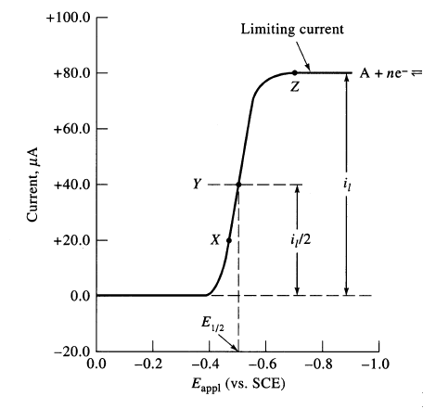

The midpoint (Y) is equal to E_{1/2} which is directly related to the standard half-cell potential (E^{O}). E_{1/2} = E^{O}-E_{ref}

The limiting current (Z) is related to the concentration of the analyte.

5) Given a molecular formula of C4H8O and the following MS and NMR data determine the structure of the compound. Please label important features of the MS (fragment ions) and NMR (chemical shifts assignments) that support your identification. Peak integrals and ion molecular weights are labeled on the spectra.

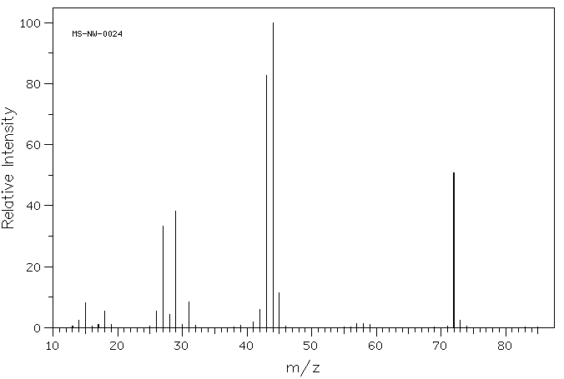
44
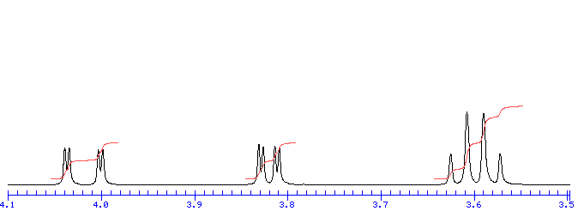
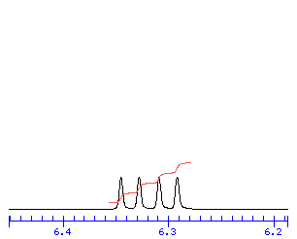
29
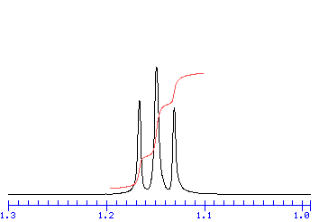
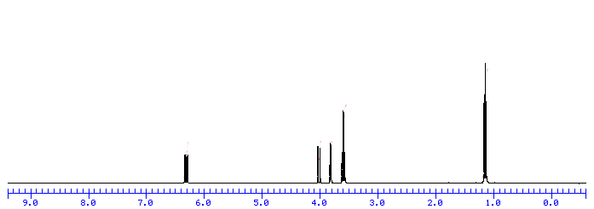
72
1
3
2
1
1

MW 72 = parent structure
MW 44 = loss of CH₂CH₃ (-28)
MW 28 = CH₂CH₃

6) The ¹H chemical shift for aromatic protons occur in the 7-8 ppm range, but protons directly attached to a carbon triple bond occur upfield at 2-3 ppm. Why?

The chemical shifts for both the aromatic and acetylene protons are affected by the local magnetic fields created by the motion of the π-electrons. The differences in the chemical shifts are attributed to the different orientations of the protons relative to the orientation of the local magnetic field. The aromatic protons are in the de-shielding region of the local magnetic field and “see” an effective decrease in the magnetic field. The opposite occurs for the acetylene protons.

7) In NMR, what is the purpose of:
  - An NMR lock signal

Compensates for the small continuous drift of the external magnetic field by maintaining a constant frequency for the solvent deuterium signal

  - Zero-filling

Mathematically improves the digital resolution of an NMR signal by adding an equal number of zero data points as experimentally collected to the end of the FID.

8) In NMR, what is the difference between T1 and T2 relaxation?

T1: relaxation of the net magnetization from the X,Y-plane back to alignment along the Z-axis. Primarily occurs through energy exchange with the solvent.

T2: randomization of the spins in the X,Y plane. Occurs through the exchange of energy between low and high energy spins.

- Briefly describe one of the following mass spectrometry ion sources:
  - Electron ionization

The sample must be delivered as a gas which is usually accomplished by heating the sample to vaporize it off of the probe. Once in the gas phase, the compound passes into an electron ionization region where it interacts with a beam of electrons of nearly homogeneous energy (70 electron volts), typically causing electron ejection and some degree of fragmentation.
M + e⁻ → M⁺ + 2e⁻

  - Fast Atom Bombardment (FAB)
a high energy beam of xenon atoms or cesium ions sputter the sample and matrix from the probe's surface. The matrix, such as m-nitrobenzyl alcohol, is used to dissolve the sample and facilitate desorption as well as ionization. The FAB matrix is a nonvolatile liquid material that serves to constantly replenish the surface with new sample as the incident ion beam bombards this surface. The matrix also serves to minimize sample damage from the high-energy particle beam by absorbing most of the incident energy and the matrix is believed to facilitate the ionization process.
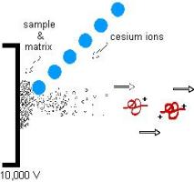

  - Matrix-assisted Laser Desorption Ionization (MALDI)
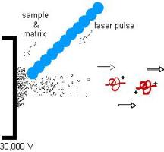
the analyte is first co-crystallized with a large molar excess of a matrix compound, usually a UV-absorbing weak organic acid, after which pulse UV laser radiation of this analyte-matrix mixture results in the vaporization of the matrix which carries the analyte with it. The matrix therefore plays a key role by strongly absorbing the laser light energy and causing, indirectly, the analyte to vaporize. The matrix also serves as a proton donor and receptor, acting to ionize the analyte in both positive and negative ionization modes, respectively.

10) In MS, what is:
(a) the nitrogen rule

If a compound has an odd number of nitrogen atoms, then the molecular ion (the [M]⁺) will have an odd mass and the value for m/e will be odd.

If a compound has no nitrogen atom or an even number of nitrogen atoms, then the m/e value of [M]⁺ will be even.

(b) nominal molecular weight

Molecular weight calculated using the nominal (non fractional) atomic weight for the most abundant isotope (H=1, C=12, O=16).

SECTION II (Review)

1) Describe one property of light that is routinely used in analytical instrumentation. Describe how this property of light is used in the design or application of analytical instrumentations.

Refraction: changes in direction in the travel of a light beam when it comes at an angle to a boundary interface between two transparent media with different densities (prisim).

Routinely used to select a narrow bandwidth of electromagnetic radiation from a polychromatic source to monitor analyte absorbance as a function of wavelength.

Reflection: when radiation crosses an interface between media that differ in refractive index, some or all of the light travels back into the medium from where it travels.

Routinely used to guide or direct (mirror/lens) electromagnetic radiation from the light source to monochromators and the reference and sample cells. Also used to split the beam to create a uniform sample and reference light source

Diffraction: the bending of a parallel beam of light as it passes a sharp barrier or throough a narrow opening.

Routinely used to create interference patterns, position dependent narrow bandwidths of electromagnetic radiation, that again allows the selection of what wavelengths either reach the sample or detector. Also used in the application of FTIR.

2) Sketch a simple block diagram illustrating the basic design of a fluorescence spectrometer.
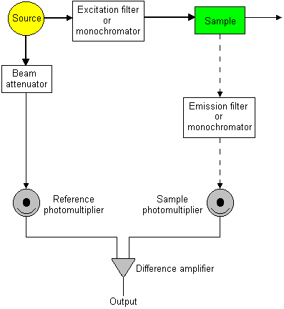

3) Given the following calibration curves:

Conc. (ppm) | Mean A (a) | Std. Dev. (a) | Mean A (b) | Std. Dev. (b)
0.00 | 0.003 | 0.0001 | 0.006 | 0.0002
1.00 | 0.010 | 0.0001 | 0.020 | 0.0002
2.00 | 0.020 | 0.0002 | 0.040 | 0.0004
3.00 | 0.030 | 0.0030 | 0.060 | 0.0060
4.00 | 0.040 | 0.0020 | 0.080 | 0.0040
5.00 | 0.050 | 0.0040 | 0.100 | 0.0080
10.0 | 0.100 | 0.0050 | 0.200 | 0.0100
20.0 | 0.200 | 0.0040 | 0.400 | 0.0080
30.0 | 0.300 | 0.0060 | 0.600 | 0.0120
50.0 | 0.500 | 0.0080 | 1.000 | 0.0160

- What is the calibration sensitivity for graphs (a) and (b)?

Calibration sensitivity = m (slope)
      - 0.0099934
      - 0.019987

- What is the selectivity coefficient (k_{b,a})?

k_{b,a} =m_{b}/m_{a} = 0.019987/0.0099934 = 2.0

- What are the limits of detection for graphs (a) and (b)?

(a)
S_{m} = S_{bl} + ks_{bl} = 0.003 + 3 . 0.0001 = 0.0033
limit of detection = c_{m} = S_{m}-S_{bl}/m = (0.0033-0.00040693)/0.0099934 = 0.29 ppm

(b)
S_{m} = S_{bl} + ks_{bl} = 0.006 + 3 . 0.0002 = 0.0066
limit of detection = c_{m} = S_{m}-S_{bl}/m = (0.0066-0.00081386)/0.019987 = 0.29 ppm

    - Given the following IR and NMR data, determine the molecular structure consistent with a molecular formula of C₆H₁₀O. Label key absorbances and resonances. Relative peak integrals are labeled.
C==O
C-H
O=C-C-H
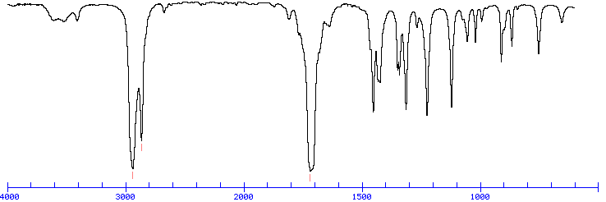
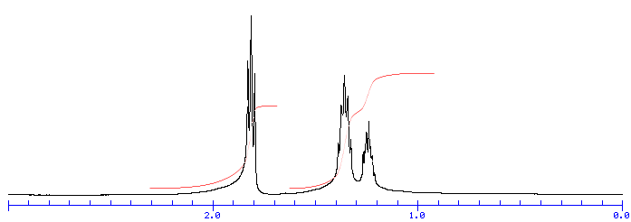
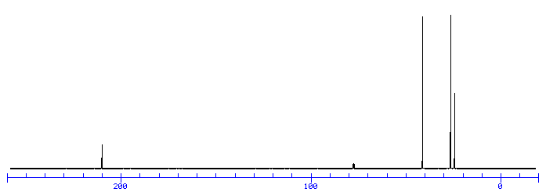
¹H
2
2
1
¹³C
5) Explain how mass spectrometry can be used with liquid or gas chromatography to separate a mixture.

Mass spectrometry can be used as a detector to monitor the elution of compounds. It has relatively general application and specificity since the MW of the compounds provides a unique means to monitor each component of the mixture.

6) Chemical and spectral interference are common sources of problems in atomic absorption spectroscopy (AAS). Please explain the source of chemical and spectral interference.

Elements or ions have extremely narrow absorption lines.

Spectral interference: may arise from a typical UV/Vis continuous light source that has a very large bandwidth relative to the narrow absorbance band of the element or ion. Similarly, molecular species present in the flame would have a very broad absorbance relative to the narrow element or ion. Both interferences would mask the absorbance associated with the element or ion of interest.

Chemical Intereference: more common than spectral interference.
  - formation of compounds of low volatility that decrease the absorbance signal
  - formation of oxides or hydroxides
  - ionization

7) Solute retention in (a) liquid chromatography and (b) gas chromatography are fundamentally dependent on what equilibriums?

- Equilibrium between the analyte affinity with stationary phase and mobile phase.
- Equilibrium between the analyte affinity with the stationary phase and its volatility

8) What are the differences in the basic operation of potentiometric methods, coulometric methods and voltammetry?

Potentiometric methods measures potential of sample or system at or near zero current.

Coulometric methods use up all the analyte under conditions of constant current or potential.

Voltammetry measures current as a change in potential while using only a small amount of the analyte.

9) What vibrations are active in (a) IR spectroscopy and in (b) Raman Spectroscopy?

- IR: asymmetric vibrations are active.
- Raman Spectroscopy: symmetric vibrations are active.

10) Below is a list of analytical techniques that we have covered during the semester and six analytical “problems” that might be solved using one of these techniques. Match each problem with one technique that you think would best address the problem. Use each technique only once.

1. HPLC with UV/VIS Absorbance Detection 4. Gas Chromatography
2. Infrared Absorption Spectroscopy 5. Inductively Coupled Plasma Emission
Spectroscopy
3. Matrix-Assisted laser Desorption/Ionization 6. NMR Spectroscopy
with Time-of-Flight Mass Spectrometry MALDI-TOF

Technique Problem
Selected
- A. __1__ You want to follow the concentration of a new drug and its degradation products in blood serum obtained from patients as a function of time.
B. __6__ You are carrying out a chemical synthesis that involves the dehydration of an alcohol to form an alkene and you want to determine if the proper product has been formed.
C. __4__ You want to measure the relative air quality in Lincoln by monitoring the concentration of ozone and NO₂ at various locations in the city.
D. __5__ A local community is experiencing cancer rates well-above the national average and believe their drinking water has been contaminated with chromium. You want to determine if Cr(VI) exceeds the < 2 ppb average chromium concentration in drinking water.
E. __2__ You want to measure the relative force constant of the C==O bond in various ketone and carboxylic acid compounds.
F. __3__ A common problem with expressing a protein in yeast is the potential for heterogeneous glycosylation of the protein (addition of different lengths and branches of sugar-chains to the protein). You want to determine if a protein has been glycosolated.

