EXAM # 3
ANALYTICAL CHEMISTRY
CHEM 421/821, Spring 2005
Monday April 4th, 2005

NAME_____________________________________

Some useful constants: Some useful constants: h = 6.63x10⁻³⁴J.s
c = 3.00 x 10⁸ m/s
k = 1.38066 x 10⁻²³ JK⁻¹
F = 96485.31 C mol⁻¹
e = -1.602177 x 10⁻¹⁹C
(10)
- A Van Deemter plot comparing high performance liquid chromatography and supercritical fluid chromatography is shown below.
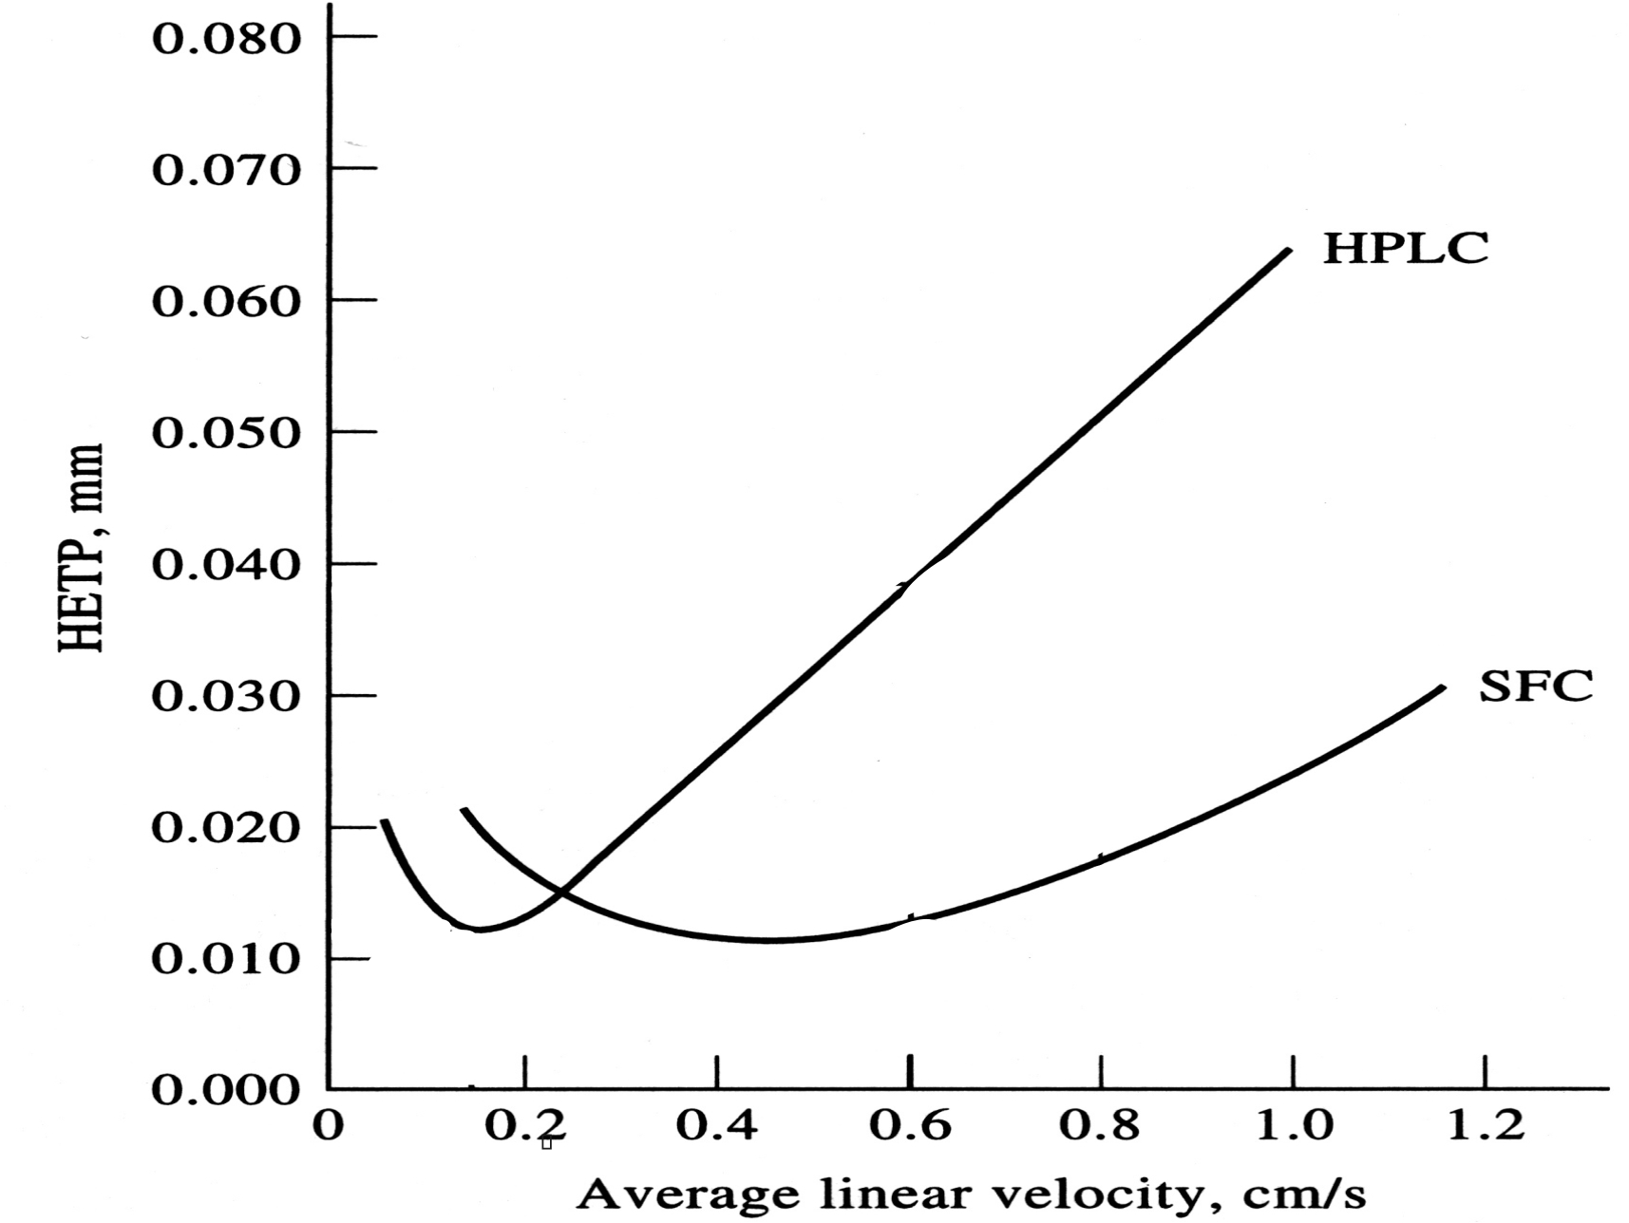

What do these plots tell us about the relative performance of the two methods (i.e. what are some of the advantages of SFC compared to HPLC)?

The Van Deemter plot indicates that SFC yields a lower plate height (H) at a higher flow rate (μ) compared to HPLC. The higher flow rate that can be used by SFC means a faster separation while achieving optimal performance of the chromatography (resolution of the analytes). Similarly, comparing the performance of HPLC and SFC at the optimal SFC flow rate indicates that the SFC bands would be ~ 3x narrower (H=0.010) compared to HPLC (H=0.03). So, SFC yields faster separation with narrower band widths compared to HPLC.

(12)
- A common method to improve resolution in chromatography is to change an experimental parameter as a function of time (gradient). What parameter is changed for:
  - Liguid Chromatography

Composition/concentration of mobile phase

  - Gas Chromatography

Temperature

  - Supercritical Fluid Chromatography

Pressure

  - Slab Electrophoresis

None

(15)
- What liquid chromatography method would you recommend using for separating the following mixtures:
  - Weak acids (maleic acid, lactic acid, acetic acid)

Ion-exchange chromatography

Adsorption chromatography

  - Synthetic DNA with a very hydrophobic dimethoxytrityl attached to the 5’-hydroxyl from the reaction mixture.

Reverse Phase HPLC

  - Mixture of proteins with a range of molecular weights

Size-exclusion Chromatography

  - C₄H₉COOH and C₅H₁₁COOH

Partition Chromatography

(10)
- Gas-Solid Chromatography and Adsorption Chromatography are closely related techniques. Please describe:
  - The similarities between these methods

In both methods the solid support and stationary phase are the same and are composed of a high surface area porous material such as activated carbon or silica, which is the source of the interaction with the analyte. The methods are effective in separating geometric isomers.

  - The differences between these methods

The differences in the methods correspond to the differences between GC and LC. The relative retention in the GAS-Solid chromatography is dependent on the interaction with the stationary phase and the volatility of the analytes. The mobile phase primarily transports the material through the column. Conversely, in Adsorption chromatography, the retention is based on the equilibrium of the interactions between the mobile phase and the stationary phase, where the composition of the mobile phase will impact the relative retention time of the analytes.

(16)
- Given the following normal phase HPLC chromatogram using methanol mobile phase.
-1
0
1
2
3
4
5
0
0.5
2
Time (min)
Response
Void volume
A
B
C
0.30
0.70
1.25
0.10
0.15
0.15

  - What is the resolution for peaks A and B?

R_{S} = $\frac{t_{r2}−t_{r1}}{(W_{b2}+W_{b1})/2}$

R_{AB} = (0.70 – 0.5)/(0.10+0.15)/2 = 1.6

  - What is the separation factor for peaks B and C?

α = k’₂/k’₁ k’ = (t_{R} –t_{M})/t_{M}

k’_{B} = (0.70 – 0.30)/0.30 = 1.33
k’_{C} = (1.25 – 0.30)/0.30 = 3.17

α = k’_{B}/k’_{C} = 3.17/1.33 = 2.38

  - What is the relative polarity of the peaks?

C > B > A

  - How could you improve the resolution for peaks A and B?

Normal phase HPLC separation uses a polar stationary phase and non-polar mobile phase, where more polar analytes are retained on the column. Improved separation of peaks A and B may be obtained by using a gradient elution starting with a weaker mobile phase such as chloroform.

(15)
- Gas Chromatography (GC) and Liquid Chromatography (LC) detectors
  - What is a major difference between GC and LC detectors?

GC detectors tend to be destructive.

  - Describe the basic operation of a GC Flame Ionization Detector (FID)
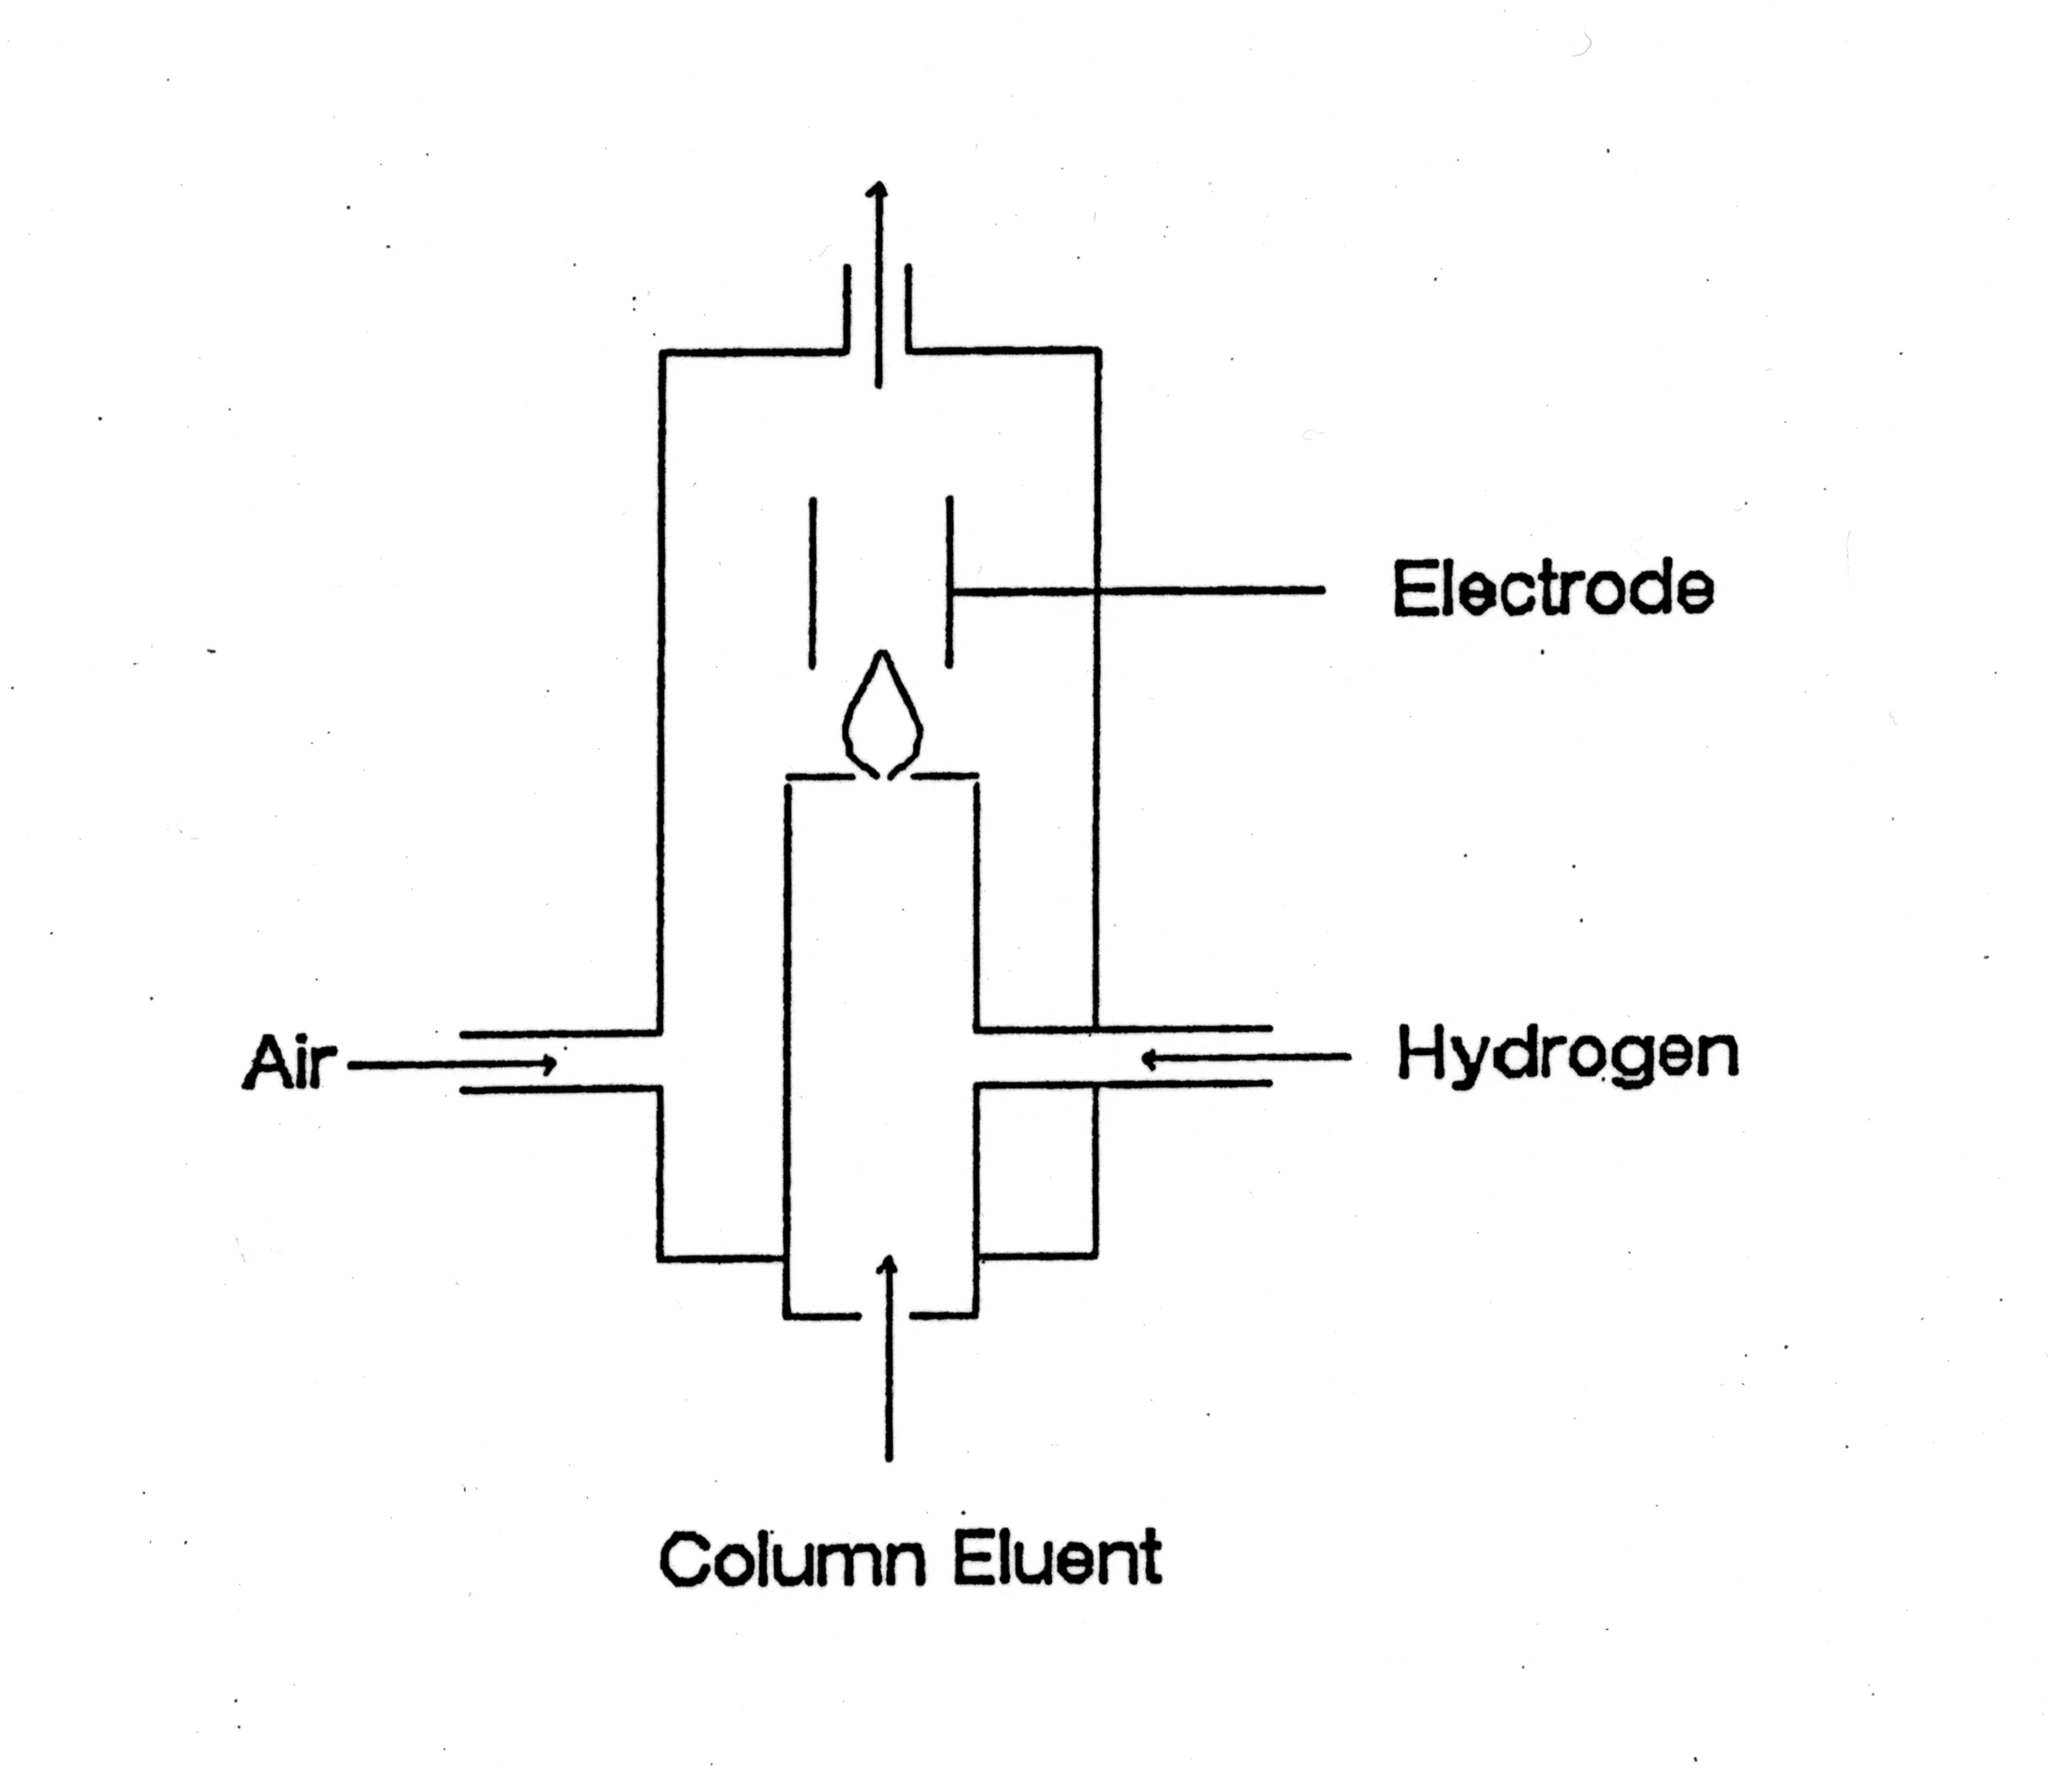
- measures the production of ions when a solute is
burned in a flame.
- ions are collected at an electrode to create a current

  - Describe the basic operation of a LC Refractive Index detector

– light from source passes through flow-cells containing either sample stream
or a reference stream
– when refractive index is the same between the two cells, no bending of light
occurs at the interface between the flow-cells
. maximum amount of light reaches the detector
– as solute elutes, refractive index changes between reference and sample cell
. light is bent as it passes through flow cell interface
. amount of light reaching detector is decreased
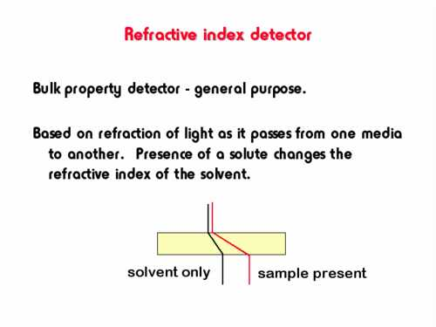

(12)
- Given the following Electrochemical cell (See Table on Last Page)
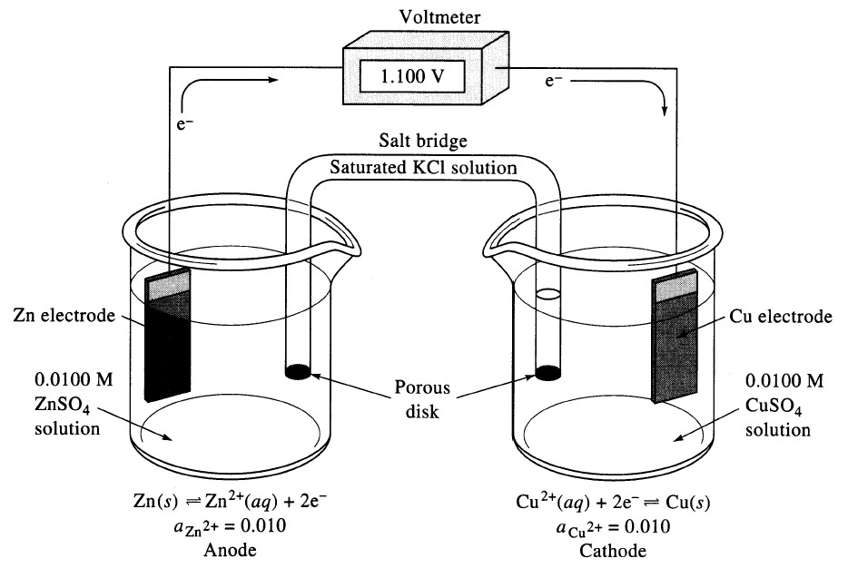
Cd
Cd²⁺ (a_{Cd}²⁺=1.00)
Cu
Cu²⁺ (a_{Cu}²⁺=1.00)

  - Write a net reaction for the electrochemical cell that would occur spontaneously. Label which reaction takes place at the anode and cathode. Label the oxidation and reduction reaction. Label the reducing agent and oxidizing agent.

Cu²⁺ + 2e⁻ à Cu cathode, reduction, oxidizing agent
Cd à Cd²⁺ + 2e⁻ anode, oxidation, reducing agent
-----------------------------
Cu²⁺ + Cd à Cd²⁺ + Cu

  - What is the potential of the cell using the reaction in (a)?

E_{cell} = E_{cathode} - E_{anode}

E_{cell} = +0.340 - -0.401
E_{cell} = 0.741

  - Would this be a galvanic or electrolytic cell?

Galvanic

  - Use the net reaction in (a) to write the short-hand notation for the electrochemical cell.

Cd|Cd²⁺(a_{Cd}²⁺=1)||Cu²⁺(a_{Cu}²⁺=1)|Cu

(10)
- Assuming spherical proteins with similar net charge:
  - Sketch the results of a slab gel electrophoresis for a protein mixture containing: protein A (MW=9 kDa, pI=5.5), protein B (MW=21 kDa, pI=6.9), protein C (MW=35 kDa, pI=9.2) and protein D (MW=97 kDa, pI=9.5)
  - Sketch the gel if a pH gradient ranging from 4 to 11 is used.

a) b)
B
A
C
D
flow
pH 4
pH 11
A
B
C
D

Half-cell Reaction | Half-cell Potential (E_{o})
Al³⁺ + 3e⁻ à Al | -1.706 V
Zn²⁺ + 2e⁻ à Zn | -0.763 V
Cr³⁺ + 3e⁻ à Cr | -0.744
Fe²⁺ + 2e⁻ à Fe | -0.409V
Cd²⁺ + 2e⁻ à Cd | -0.401 V
Ni²⁺ + 2e⁻ à Ni | -0.230 V
Pb²⁺ + 2e⁻ à Pb | -0.126 V
2H⁺ + 2e⁻ à H₂ | 0.00 V
AgCl + e⁻ à Ag + Cl⁻ | +0.223 V
Hg₂Cl₂ + 2e⁻ à 2Hg + 2Cl⁻ | +0.268 V
Cu²⁺ + 2e⁻ à Cu | +0.340 V
Ag⁺ + e⁻ à Ag | +0.799 V
Au⁺ + e⁻ à Au | +1.680 V

