SECTION I (Redox, Spectrophotometry, and Chromatography):

- (24 points) For the following redox titration of Sn²⁺ with Tl³⁺ using a Pt indicator electrode and a Calomel reference electrode (E=0.241):
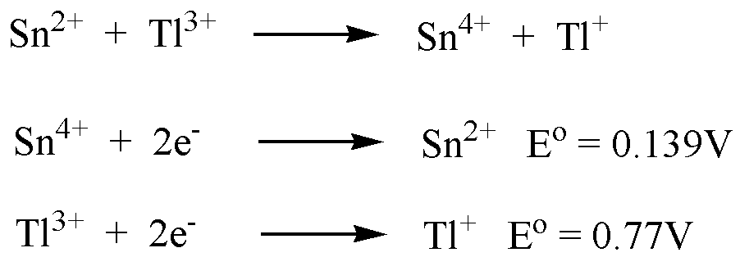

What is the observed potential when the titrant volume (V) is:

- (4 points) V = ½ V_{e}

Observed potential is standard potential of analyte relative to reference electrode. E = E₊ -E₋ = 0.139 – 0.241 = -0.102

- (4 points) V = V_{e}

Observed potential is the average of the two standard potentials relative to reference electrode
E = E₊ -E₋ = ((0.139+0.77)/2) – 0.241 = 0.214

- (4 points) V = 2V_{e}

Observed potential is standard potential of titrant relative to reference electrode. E = E₊ -E₋ = 0.77 – 0.241 = 0.529

- (4 points) What redox indicator would you suggest using for this titration?

Potential of methylene blue relative to calomel is closest to equivalence point.
E = E₊ -E₋ = 0.53 – 0.241 = 0.289

- (4 points) What happens to the potential if the initial Sn²⁺ and Tl³⁺ concentration is doubled?

No change, independent of concentration or volume.

- (4 points) If the analyte was Sn⁴⁺ instead of Sn²⁺, what would be needed before titrating with Tl³⁺?

Addition of a very strong reducing agent for prereduction.

- (25 points)A new drug candidate yields an absorbance of 0.5 at 550 nm with a 0.01M standard sample using a path length of 1 cm. A plasma sample from a patient yielded an absorbance of 0.1 after the sample was concentrated by a factor of ten.

- (5 points) What is the molar absorptivity of the new drug candidate?

A = εbc → ε = A/bc = 0.5/((1 cm)(0.01M)) = 50 L/(moles . cm)

- (5 points) What was the original concentration of the drug in the plasma sample?

A = εbc → c = A/bε = 0.1/((1 cm)(50 L/(moles.cm))) = 2x10⁻³ M
Since a ten-fold concentration was used, initial concentration is 2x10⁻⁴M

- (5 points) What is the energy of a photon of light absorbed by this drug?

E = hc/λ = (6.626x10⁻³⁴J-s) (3.0x10⁸ m/s)/550x10⁻⁹ m = 3.61x10⁻¹⁹ J

- (5 points) What is absorbing this photon of light in the drug (what is being promoted to an excited state)?

Bonding electrons or an electron in a molecular orbital

- (5 points) If the absorption of a photon results in a π to π* transition, what chemical feature must be present in the drug?

A double bond

- (20 points) Fluorescence and Phosphorescence are relatively rare occurrences because most excited electronic states relax very rapidly.
  - (5 points) How does a molecule in an excited electronic state commonly relax back to the ground state?

Energy is converted to heat.

  - (5 points) Fluorescence occurs when:

Photon is emitted from a transition from an excited singlet state to a ground singlet state (S₁ -> S_{o})

  - (5 points) Phosphorescence occurs when:

Photon is emitted from a transition from an excited triplet state to a ground singlet state (T₁ -> S_{o})

  - (5 points) Why are fluorescence and phosphorescence emission spectra of lower energy or higher wavelength compared to their excitation spectra?

Rapid relaxation of excited vibrational and rotational states associated with the excited electronic states.

- (11 points) Phenytoin, an antiepileptic drug, has a partition coefficient (K) = 19.5 for an extraction between water (phase 1) and n-octanol (phase 2). 25 mL of a 1 μM solution of Phenytoin in water is extracted three times with 25 mL of n-octanol. Given that phenytoin is a weak base (pKa = 8.3 for its conjugate acid), what fraction of phenytoin will be extracted at pH 2.0?

$$D=\frac{K_{B}K_{a}}{K_{a}+[H^{+}]}=\frac{\text{19}\text{.}5×5\text{.}\text{01}x{\text{10}}^{−9}}{5\text{.}\text{01}x{\text{10}}^{−9}+1x{\text{10}}^{−2}}=9\text{.}\text{77}x{\text{10}}^{−6}$$

$q_{n}={\left[\frac{V_{1}}{\left(V_{1}+{\text{DV}}_{2}\right)}\right]}^{n}={\left[\frac{\text{25}}{\left(\text{25}+9\text{.}\text{77}x{\text{10}}^{−6}x\text{25}\right)}\right]}^{3}=0\text{.}\text{99997}$

p = q – 1 ≈ 0, all the phenytoin is protonated because of the low pH. It is not extracted into n-octanol.

- (20 points) Given the following HPLC chromatogram using a 25 cm column:
-1
0
1
2
3
4
5
0
0.5
2
Time (min)
Response
Void volume
A
B
C
0.30
0.70
1.25
0.10
0.15
0.15
  - (5 points) What is the resolution between peaks A and B?

$R_{s}=\frac{(t_{r_{2}}−t_{r_{1}})}{(w_{b_{2}}+w_{b_{1}})/2}=\frac{(0\text{.}\text{70}−0\text{.}\text{50})}{(0\text{.}\text{10}+0\text{.}\text{15})/2}=1\text{.}6$

  - (5 points) Name one parameter that could be changed to improve the resolution between peaks A and B?

Column length, flow-rate, decrease particle size, change stationary phase, etc.

  - (5 points) What is the number of theoretical plates for peak C?
$N=\text{16}{\left(\frac{t_{r}}{w_{b}}\right)}^{2}=\text{16}{\left(\frac{1\text{.}\text{25}}{0\text{.}\text{15}}\right)}^{2}=1\text{.}\text{11}x{\text{10}}^{3}$

  - (5 points) What is the height equivalent of a theoretical plate for peak C?

$H=L/N=\text{25}{\text{cm}}/1\text{.}\text{11}x{\text{10}}^{3}=2\text{.}\text{25}x{\text{10}}^{−2}\text{cm}$

SECTION II (Review):

- (5 points) Identify one common mistake in weighing a solid precipitate from a gravimetric analysis that would result in a systematic error (there are multiple possible answers).

Incomplete drying of the solid sample to remove the solvent used in the precipitation reaction.

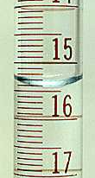
- (5 points) Given the following buret and meniscus level (right), a student recorded a volume of 15.5 mL in her lab notebook. What common mistake is the student making in reading a volume dispensed by this buret?

The volume was not estimated to nearest 1/10 of a division.

- (10 points) What is the (a) accuracy and (b) precision?

(a) Accuracy - how close an answer is to the “true” value
(b) Precision – reproducibility of measurements

- (5 points) Given the following general exothermic reaction:

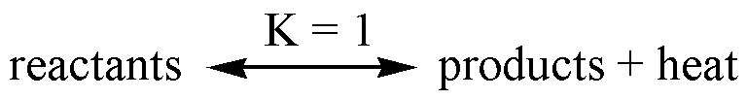

What happens to the equilibrium constant (K) if the sample is heated?

Based on Le Châtelier’s principal, the equilibrium constant would be reduced (K < 1) because the equilibrium would be shifted to reactants to compensate for the added heat.

- (5 points) Given two acids, where acid A has a pKa value of 4.75 and acid B has a pKa of -7. Which of the two acids is a strong acid?

Acid B is the strong acid.

- (10 points) What is (a) end-point and (b) equivalence point?

(a) end-point – marked by a sudden change in the physical property of the solution, what s actually measured.
(b) equivalence point - quantity of added titrant is the exact amount necessary for stoichiometric reaction with the analyte

- (5 points) If you are calculating the pH of a weak acid and you ignore activity, will your calculated pH be lower or higher than the measured pH?

pH = -log(γ_{H+}[H⁺]) If activity is ignored, the effective [H⁺] will be higher (γ < 1) so the calculated pH will be lower than the measured pH.

- (5 points) A weak base has a pKa of 8.3. At what pH would this base, combined with its conjugate acid, make a good buffer?

pH = 8.3  1

- (5 points) A diprotic acid, such as amino acids, exists in three forms: acid form [H₂L⁺], basic form [L⁻] and intermediate form [HL]. What is the basic assumption that is made when calculating the pH of the acid form of the diprotic acid?

It behaves as a monoprotic acid.

- (10 points) An important component of the procedure for the systematic treatment of equilibrium is making assumptions to simplify the calculations. A common assumption is to ignore chemical equations with small equilibrium constants. Why?

The small equilibrium constant indicates very little product is produced. So, the concentrations of the reactants and the products will not change significantly relative to the other chemical reactions.

- (5 points) Why is pH an important consideration in an EDTA titration?

EDTA is a polyprotic acid so the concentration of the form (Y⁴⁻) of EDTA that chelates metal ions is dependent on pH.

- (10 points) ¹⁴C dating of a fossilized bone was measured twice by two different students. Student A measured an average age of 15,000 years based on five measurements. Student B measured an average age of 18,000 years also based on five measurements. The pooled standard deviations for the two sets of data are 800 years. Are the students’ results significantly different at the 95% confidence level?

$$t_{\text{calculated}}=\frac{{\bar{x}}_{1}−{\bar{x}}_{2}}{s_{\text{pooled}}}\sqrt{\frac{n_{1}n_{2}}{n_{1}+n_{2}}}=\frac{\text{18},\text{000}−\text{15},\text{000}}{\text{800}}\sqrt{\frac{5∗5}{5+5}}=\frac{3,\text{000}}{\text{800}}\sqrt{2\text{.}5}=5\text{.}\text{93}$$

Degrees of freedom = 5 + 5 -2 = 8 → from Student’s T table at 95% confidence = 2.306.

Since 5.93 > 2.306, the results are significantly different.

- (10 points) What is the general pH (acidic, basic, neutral) at the equivalence point for the titration of a (a) strong acid with a strong base and a (b) weak base with a strong acid.

(a) pH =7 or neutral

(b) pH is acidic (weak base all converted to its conjugate acid)

- (10 points) Gravimetric analysis is used to measure the concentration of Ag⁺ in an unknown sample by the addition of NaBr.
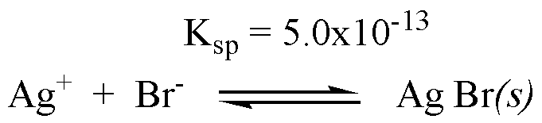

  - What concentration of NaBr is required so the residual Ag⁺ concentration is 1x10⁻¹⁰?

K_{sp} = [Ag⁺][Br⁻] → [Br⁻] = K_{sp}/[Ag⁺] = 5.0x10⁻¹³/1x10⁻¹⁰ = 5x10⁻³

  - What happens to the solubility of Ag⁺ if the unknown sample contains 1M NaCl?

Increases. The increase in ionic strength and the corresponding decrease in activity coefficients decreases the effective concentration resulting in an increase in solubility.

