CHEMISTRY 221 - Dr. Powers Third Exam - FALL 2007

PRINT NAME ______________________________________________
(Last) (First) (MI)
ID# ___________________________

Signature ________________________________________

THIRD EXAM Lab Section______
November 20, 2007
BE SURE YOU HAVE 10 DIFFERENT PAGES OF THIS EXAM
**********WRITE YOUR NAME ON EVERY PAGE****************
SHOW ALL WORK - NO WORK - NO CREDIT

REPORT ALL ANSWERS WITH CORRECT LABELS AND SIGNIFICANT FIGURES

• All Cell phones must be turned off and cannot be used as a calculator.
• You may use a calculator, and an exam data sheet.
• Raise your hand if you have a question.
• Keep your eyes on your own paper.
• Several exam forms may be in use. It is a code violation if data from another exam form appears on your paper.
• Keep all REQUIRED exams as part of your records.

REQUEST FOR REGRADE _______________Date

EXAMS SUBMITTED FOR REGRADES SHOULD NOT LEAVE THE RESOURCE CENTER!

Please regrade question because___________________________________________ _________________________________________________________________________
_________________________________________________________________________
Please regrade question because __________________________________________
_________________________________________________________________________
_________________________________________________________________________
Please regrade question because __________________________________________
_________________________________________________________________________

______ Check here if there is a mistake in addition.
You must sign your regrade request, or it will not be considered a valid request.

I accept responsibility for all answers contained herein. ________________________________ Signature

When submitting regrade request, do not write on exam pages. Additional questions or comments are to be placed on a separate sheet of paper and turned in with your test. Sign these as well.

Question No. | Possible Points | Points Earned | TA Initials
1 | 34
2 | 15
3 | 16
4 | 6
5 | 9
6 | 20
Total | 100

Some Useful Information:
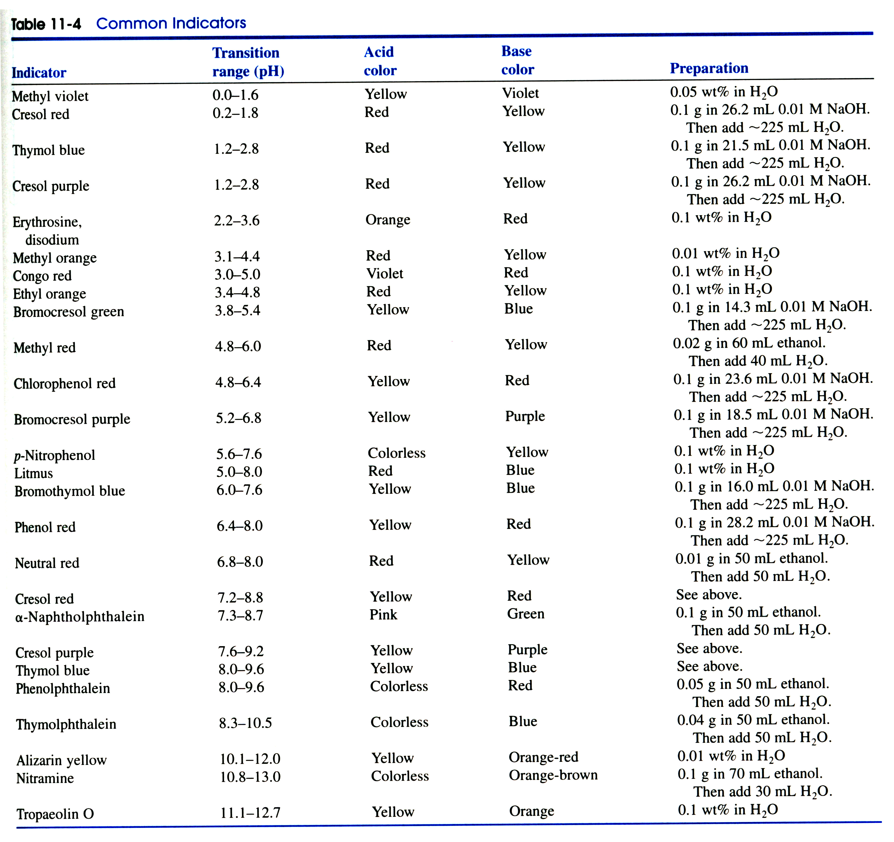

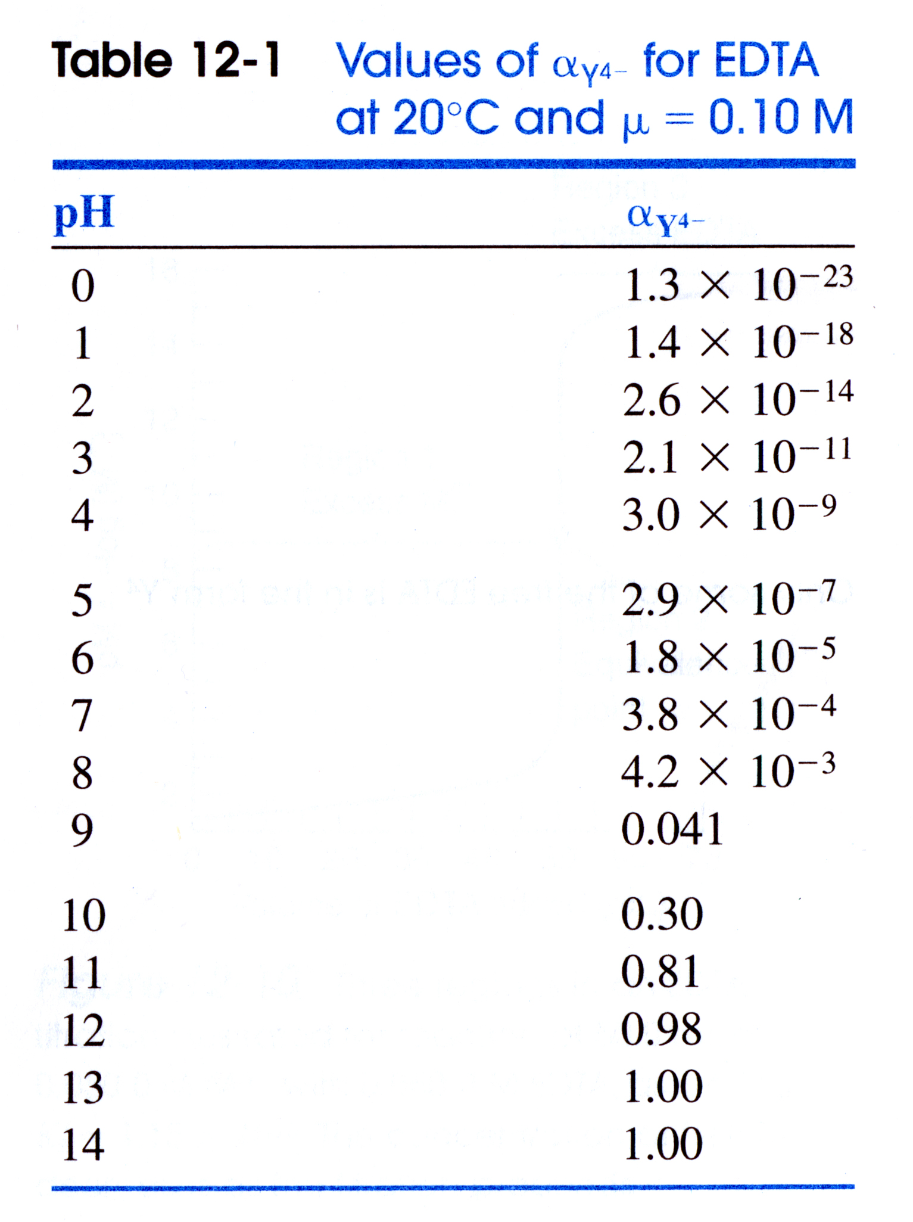

USEFUL EQUATIONS

Monoprotic Weak Acid: Diprotic Weak acid:

$[H^{+}]=\frac{−K_{a}±\sqrt{K_{a}^{2}+4(1)(F)(K_{a})}}{2}$$[H^{+}]=\sqrt{\frac{K_{2}K_{1}F+K_{1}K_{w}}{K_{1}+F}}$

Monoprotic Weak Base:
$x=\frac{−K_{b}±\sqrt{K_{b}^{2}+4(1)(F)(K_{b})}}{2(1)}=[{\text{OH}}^{−}]$

Isoionic point: Triprotic Weak acid:

$[H^{+}]=\sqrt{\frac{K_{1}K_{2}F+K_{1}K_{w}}{K_{1}+F}}$$[H^{+}]=\sqrt{\frac{K_{2}K_{1}F+K_{1}K_{w}}{K_{1}+F}}$$[H^{+}]=\sqrt{\frac{K_{2}K_{3}F+K_{2}K_{w}}{K_{2}+F}}$

Henderson Hasselbach equation:

$\text{pH}={\text{pK}}_{a}+\text{log}\left(\frac{[A^{−}]}{[\text{HA}]}\right)$

- (34 points) Predict the pH at the equivalence points for the following acid-base titrations:
  - (5 points) 10 mL of 0.0250 M HNO₃ is titrated with 0.0125 M LiOH

pH = 7.0, strong acid-strong base titration

  - (10 points)10 mL of 0.0250M Butanoic acid (pK_{a} = 4.818) is titrated with 0.0125M LiOH

At equivalence point, all of the acid is converted to conjugate base.

pK_{b} = pK_{w} - pK_{a} = 14 – 4.818 = 9.182

equivalence volume(Ve) = M₁V₁/M₂ = (0.010 L)(0.0250 M)/0.0125 M) = 20 mL

[A-] = (0.0250 M)(0.010 L)/(0.010 L + 0.020 L) = 0.00833 M

K_{b} = [HA][OH⁻]/[A⁻]

$\begin{aligned}\frac{x^{2}}{F−x}=K_{b}=\frac{K_{w}}{K_{a}}=\frac{1×{\text{10}}^{−\text{14}}}{{\text{10}}^{−4\text{.}\text{818}}}=6\text{.}\text{58}×{\text{10}}^{−\text{10}} \\ \frac{x^{2}}{0\text{.}\text{00833}−x}=6\text{.}\text{58}×{\text{10}}^{−\text{10}}⇒x^{2}+6\text{.}\text{58}x{\text{10}}^{−\text{10}}x−5\text{.}\text{48}x{\text{10}}^{−\text{12}}=0 \\ x=[{\text{OH}}^{−}]=2\text{.}\text{34}×{\text{10}}^{−6}M\end{aligned}$

pH = -log(1x10^{-14/}2.34x10⁻⁶) = 8.37

  - (15 points) 10 mL of 0.0250 M Carbonic acid (pK_{a1}=4.818, pK_{a2}=10.329) is titrated with 0.0125 M LiOH

First equivalence point, [H⁺] determined by intermediate form:
Same as (b), Ve = 20 mL and HA⁻ = 0.00833 M
$\begin{aligned}[H^{+}]=\sqrt{\frac{K_{2}K_{1}F+K_{1}K_{w}}{K_{1}+F}}=\sqrt{\frac{({\text{10}}^{−4\text{.}\text{818}})({\text{10}}^{−\text{10}\text{.}\text{329}})(0\text{.}\text{00833})+({\text{10}}^{−4\text{.}\text{818}})({\text{10}}^{−\text{14}})}{({\text{10}}^{−4\text{.}\text{818}}+0\text{.}\text{00833})}} \\ \\ \sqrt{\frac{5\text{.}\text{94}x{\text{10}}^{−\text{18}}+1\text{.}\text{52}x{\text{10}}^{−\text{19}}}{1\text{.}\text{52}x{\text{10}}^{−5}+0\text{.}\text{00833}}}=\sqrt{\frac{6\text{.}\text{092}x{\text{10}}^{−\text{18}}}{8\text{.}\text{345}x{\text{10}}^{−3}}}=2\text{.}\text{70}x{\text{10}}^{−8} \\ \\ \text{pH}=−\text{log}(2\text{.}\text{70}x{\text{10}}^{−8})=7\text{.}\text{57}\end{aligned}$

Or

Use the approximation:

pH = ½( pK_{a1} + pK_{a2}) = ½( 4.818 + 10.329) = 7.57

Second equivalence point: 2x first equivalence point: Ve = 40 mL

[A⁻²] = (0.0250 M)(0.010 L)/(0.010 L + 0.040 L) = 0.00500 M

Same as (b)

$\begin{aligned}\frac{x^{2}}{F−x}=K_{b}=\frac{K_{w}}{K_{a}}=\frac{1×{\text{10}}^{−\text{14}}}{{\text{10}}^{−\text{10}\text{.}\text{329}}}=2\text{.}\text{13}×{\text{10}}^{−4} \\ \frac{x^{2}}{0\text{.}\text{00500}−x}=2\text{.}\text{13}×{\text{10}}^{−4}⇒x^{2}+2\text{.}\text{13}x{\text{10}}^{−4}x−1\text{.}\text{07}x{\text{10}}^{−6}=0 \\ x=[{\text{OH}}^{−}]=9\text{.}\text{33}×{\text{10}}^{−4}M\end{aligned}$

pH = -log(1x10^{-14/}9.33x10⁻⁴) = 10.97

  - (4 points) Identify an indicator that could be used to monitor the endpoints for c (above).

pH 7.57 α-Naphtholphtalein (7.3-8.7)

pH 10.97 nitramine (10.8-13.0)

- (15 points) 50 mL of 0.0333 M of 1-Naphthoic acid (pKa = 3.67) is titrated with 0.05 M NaOH
  - (5 points) What is the pH after 5 mL of NaOH has been added?

Conjugate base concentration is equal to added concentration of NaOH, account for dillution:

[A⁻] = [NaOH] added = (0.005 L)(0.05M)/(0.050 L + 0.0005 L) = 0.004545 M

Concentration of weak acid decreases by the amount of added base, subtract the number of moles of added base from the original number of moles of acid, account for dilution:

[HA] = ((0.050L)(0.0333M) – (0.005 L)(0.05M)) = 0.0257 M
(0.050 L + 0.0005 L)

$\text{pH}={\text{pK}}_{a}+\text{log}\left(\frac{[A^{−}]}{[\text{HA}]}\right)=3\text{.}\text{67}+\text{log}(\frac{0\text{.}\text{004545}}{0\text{.}\text{0257}})=3\text{.}\text{67}−0\text{.}\text{75}=2\text{.}\text{92}$

  - (5 points) What volume of NaOH is required to obtain a pH of 3.67?

$\text{pH}={\text{pK}}_{a}+\text{log}\left(\frac{[A^{−}]}{[\text{HA}]}\right)=3\text{.}\text{67}+\text{log}(1)=3\text{.}\text{67}$

Need [A⁻] = [HA], at equivalence all HA is converted to A⁻, so at ½Ve, ½ of HA is converted to [A⁻], which means [A⁻] = [HA]

equivalence volume(Ve) = M₁V₁/M₂ = (0.050 L)(0.0333 M)/0.05 M) = 33.3 mL

½Ve = 16.65 mL

  - (5 points) What pH range is 1-Naphthoic acid and its conjugate base a good buffer?

pH = pK_{a} ±1

3.67 ± 1

- (16 points) Given the following titration curve for a weak acid being titrated with a strong base:
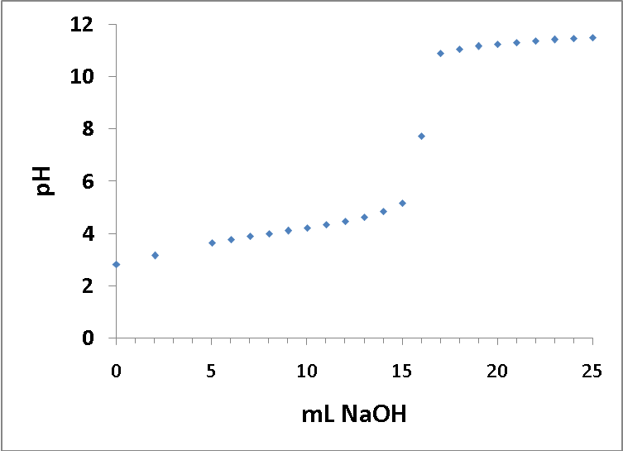

  - (5 points) What is the pK_{a} for the weak acid?

pH = pK_{a} at ½ Ve; Ve = 16 mL; ½ Ve = 8 mL; pH at 8 mL = 4.0

  - (5 points) What is the pK_{b} for the conjugate base?

pK_{a} + pK_{b} = 14 -> pK_{b} = 14 – 4 = 10

  - (6 points) Sketch a first-derivative plot for this titration curve. Please make sure the axes are properly labeled.

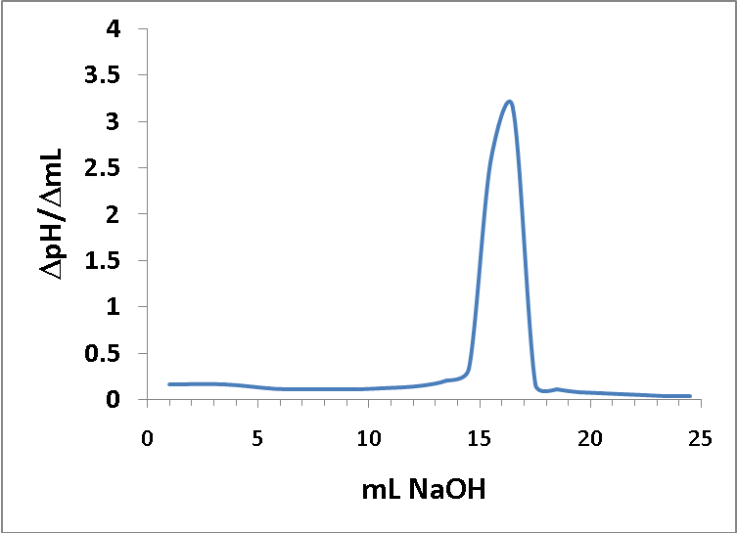

- (6 points) What two factors determine the relative steepness of an acid-base titration curve?
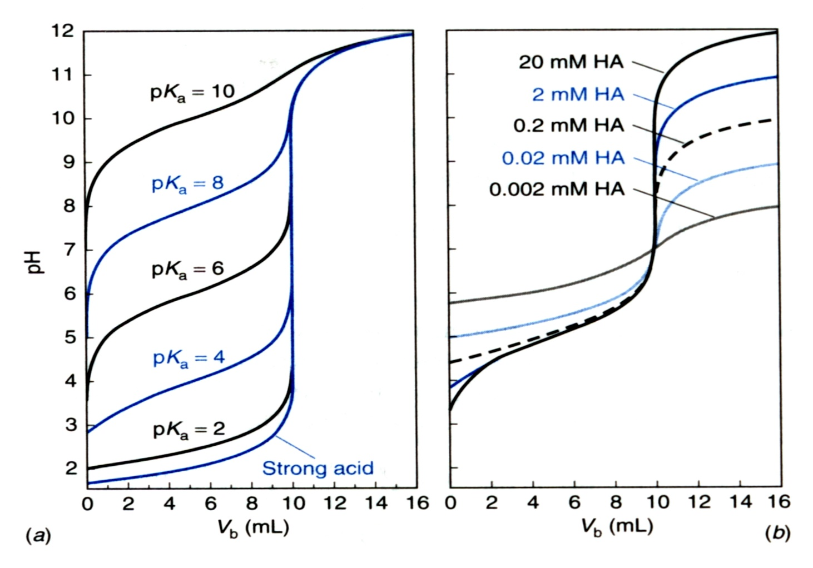
Increasing steepness

K_{a} and concentration of analyte

- (9 points) Malonic acid (HO₂CCH₂CO₂H) is a diprotic acid with pKa values of 2.847 and 5.696.
pK_{a1} = 2.847
pK_{a2} = 5.696
HO₂CCH₂CO₂H HO₂CCH₂CO₂⁻ ⁻O₂CCH₂CO₂⁻

  - (3 points) What is the major species at pH = 7.0?

⁻O₂CCH₂CO₂⁻

  - (3 points) At what pH would HO₂CCH₂CO₂⁻ be the major species?

pH = ½ (2.847+5.696) = 4.27 or between 2.847 and 5.696

  - (3 points) At pH 2.847, what is the relative concentration of HO₂CCH₂CO₂H and HO₂CCH₂CO₂⁻ ?

Equal

- (20 points) EDTA chelates both Co³⁺ (log K_{f} = 41.4) and K⁺ (log K_{f} = 0.8).
  - (5 points) How would you design an EDTA titration to titrate Co³⁺ with minimum interference from K⁺?

Either lower the pH (acidic) or add a masking agent for K⁺

  - (10 points) What would be the concentration of free Co³⁺ if 20 mL of 0.005 M EDTA is added to 20 mL of 0.0125 M Co³⁺ solution in a buffer at pH 2.0?

The intent of the problem was as follows:

EDTA-Co⁺³ = (0.020 L)(0.005 M)/(0.020 L + 0.020 L) = 0.0025 M

α_{Y-4} at pH 2.0 = 2.6x10⁻¹⁴

K_{f}’ = K_{f} α_{Y-4} = (2.6x10⁻¹⁴)(10^{41.4}) = [EDTA-Co⁺³]/[Co⁺³][EDTA] = (0.0025)/x²

6.53x10²⁷ = (0.0025)/x²

x² = (0.0025/6.53x10²⁷) = 3.83x10⁻³¹

x = 6.19x10⁻¹⁶

But not enough EDTA was added to react with all Co⁺³, so it turned out to be a simpler problem:

[Co⁺³] = ((0.020L)(0.0125M) – (0.020 L)(0.005M)) = 3.75x10⁻³
(0.020 L + 0.020 L)

Either solution was acceptable.

  - (5 points) Co³⁺ forms a soluble complex with hydroxide ion (pK_{f} = 13.52), is it possible to titrate Co³⁺ with EDTA under basic conditions?

Yes, K_{f} of EDTA-Co⁺³ complex (10^{41.4}) >> K_{f} of Co³⁺-OH⁻ complex (10^{13.52})

