- (18 points) Given the following curve for the titration of a weak acid (HA) with a strong base (NaOH):

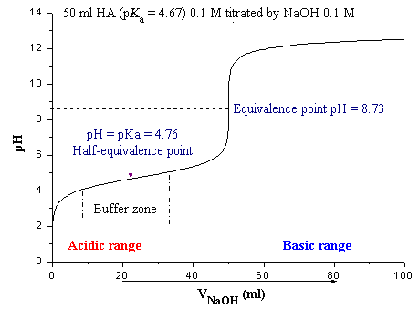

Equivalence point

Buffer region

pH = pK_{a}

Ve ~ 50mL
½Ve ~ 25mL

- (3 points) Indicate on the curve where the titration behaves as a buffer.

The region centered around the pK_{a} of the acid (see graph)

- (3 points) Estimate the pK_{a} of the weak acid.

pKa = 4.76
pH = pK_{a} at ½ V_{e} (see graph)

- (3 points) Estimate the pH at the equivalence point.

pH = 8.73 (see graph)

- (3 points) Why is the pH at the equivalence point not 7.0?

The pH is determined by the pK_{b} of the conjugate base

- (3 points) What would be an appropriate indicator to use for this acid-base titration?

Cresol red to thymolphthalein color transition pH range (8.0-10.5) is centered around the equivalence point pH.

- (3 points) If the concentration of NaOH used for the titration was 0.1M, how many moles of the weak acid (HA) were present in the sample?

Equivalence point means the moles of titrated NaOH equals the moles of the weak acid (M₁V₁ = M₂V₂). The volume of NaOH titrated at the equivalence point can be estimated from the graph (V_{e} ~ 50mL). Thus,

Moles of HA = (0.05L)(0.1M) = 5x10⁻³

- (24 points) Given the following titration reaction:
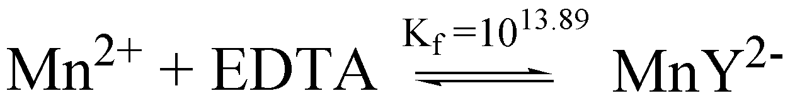

If 25.0 mL of 0.0100 M MnSO₄ solution buffered at a pH of 7.00 is titrated with 0.0200 M EDTA solution, calculate pMn²⁺ at the following volumes:

  - (6 points) 0 mL

Before any EDTA is titrated, pMn²⁺ = -log[Mn²⁺] = -log[0.0100 M] = 2.00

  - (6 points) 5 mL

First, calculate equivalence volume (V_{e}):

V_{e} = (0.025 L )(0.0100 M MnSO₄)/(0.0200 M EDTA)
V_{e} = 12.5 mL

Second, K_{f}’ = α_{Y4-}K_{f} = [MnY²⁻]/[Mn²⁺][EDTA]

At pH =7.0, α_{Y4-} = 3.8x10⁻⁴, so K_{f}’ = (3.8x10⁻⁴)(10^{13.89}) = 2.953x10¹⁰

Therefore, before equivalence point, all Mn²⁺ is complexed to Y⁴⁻. [Mn²⁺] is simply the fraction remaining after the addition of EDTA.

The fraction Mn⁺² remaining is 1-(5/12.5) = 0.6.
The dilution factor is (25mL)/(25mL + 5mL) = 0.833
[Mn2+] = (0.6)(0.0100 M MnSO₄)(0.833) = 5.00x10⁻³
pMn²⁺ = -log[5.00x10⁻³] = 2.30

  - (6 points) 12.5 mL

At the equivalence point, virtually all Mn²⁺ is complexed with EDTA and the only free Mn²⁺ is determined by the dissociation of MnY²⁻.

[MnY²⁻] = (0.0100 M MnSO₄)(25 mL)/(12.5 mL + 25 mL) = 6.67x10⁻³M
Set [Mn²⁺] = [EDTA] = x
$\begin{aligned}K_{{}_{f}}^{'}=2\text{.}\text{953}x{\text{10}}^{\text{10}}=\frac{[\text{Mn}(\text{EDTA})^{−2}]}{[{\text{Mn}}^{2+}][\text{EDTA}]}=\frac{6\text{.}\text{67}x{\text{10}}^{−3}−x}{x^{2}} \\ 2\text{.}\text{953}x{\text{10}}^{\text{10}}x^{2}+x−6\text{.}\text{67}x{\text{10}}^{−3}=0 \\ \\ x=4\text{.}\text{75}x{\text{10}}^{−7}M \\ \\ {\text{pMn}}^{2+}=−\text{log}[4\text{.}\text{75}x{\text{10}}^{−7}]=6\text{.}\text{32}\end{aligned}$

  - (6 points) 13 mL

After equivalence point, excess EDTA and virtually all Mn²⁺ is complexed with EDTA and the only free Mn²⁺ is determined by the dissociation of MnY²⁻.

[MnY²⁻] = (0.0100 M MnSO₄)(25 mL)/(13 mL + 25 mL) = 6.58x10⁻³M

[EDTA] = (0.0200 M EDTA)(13 mL – 12.5 mL)/(13 mL + 25 mL) = 2.63x10⁻⁴M

Set [Mn²⁺] = x

$\begin{aligned}K_{{}_{f}}^{'}=2\text{.}\text{953}x{\text{10}}^{\text{10}}=\frac{[\text{Mn}(\text{EDTA})^{−2}]}{[{\text{Mn}}^{2+}][\text{EDTA}]}=\frac{6\text{.}\text{58}x{\text{10}}^{−3}−x}{x(2\text{.}\text{63}x{\text{10}}^{−4})} \\ 7\text{.}\text{766}x{\text{10}}^{6}x+x=6\text{.}\text{58}x{\text{10}}^{−3} \\ \\ x=8\text{.}\text{47}x{\text{10}}^{−\text{10}}M \\ \\ {\text{pMn}}^{2+}=−\text{log}[8\text{.}\text{47}x{\text{10}}^{−\text{10}}]=9\text{.}\text{07}\end{aligned}$

- (23 points) Given the following electrochemical cell and half-cell potentials:

Ni(s) | NiSO₄ (0.0020M) || CuCl₂ (0.0030M) | Cu(s)
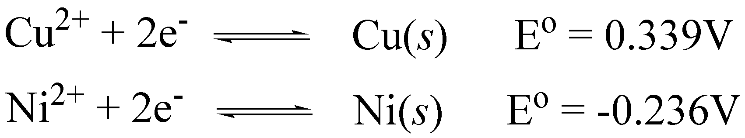

  - (3 points) Write a net or total cell reaction for the electrochemical cell.

Ni(s) + Cu²⁺ → Ni²⁺ + Cu(s)

  - (3 points) What is the standard reduction potential for the reaction?

Eº = Eº₊ –Eº₋ = 0.339 - -0.236 = 0.575

  - (6 points) What is the equilibrium constant and free energy (ΔGº) for this reaction?

$K={\text{10}}^{{\text{nE}}^{o}0\text{.}\text{05916}}={\text{10}}^{(2)(0\text{.}\text{575})/0\text{.}\text{05916}}=2\text{.}\text{75}x{\text{10}}^{\text{19}}$

ΔG = -nFE = - (2)( 9.649x10⁴ C/mol)(0.575J/C)=-111 KJ/mol

  - (3 points) Is this a Galvanic or electrolytic cell?

Galvanic (spontaneous)

  - (8 points) What is the potential for this reaction under the given conditions?
$E_{+}=E_{+}^{o}−\frac{0\text{.}\text{05916}V}{2}\text{log}\frac{1}{[{\text{Cu}}^{2+}]}=0\text{.}\text{339}−\frac{0\text{.}\text{05916}}{2}\text{log}\frac{1}{(0\text{.}\text{0030})}=0\text{.}\text{264}$

$E_{−}=E_{−}^{o}−\frac{0\text{.}\text{05916}V}{2}\text{log}\frac{1}{[{\text{Ni}}^{2+}]}=−0\text{.}\text{236}−\frac{0\text{.}\text{05916}}{2}\text{log}\frac{1}{(0\text{.}\text{0020})}=−0\text{.}\text{316}$

Eº = Eº₊ –Eº₋ = 0.264 - -0.316 = 0.580

- (25 points) Please explain the following:
  - (5 points) What is the source of the junction potential?

Different ion mobility at solution interface.

  - (5 points) What is a reference electrode?

Second electrode or ½ cell maintained at a constant potential

  - (5 points) What is an indicator electrode?

Electrode that responds to analyte and donates/accepts electrons.

  - (5 points) How can EDTA be used to differentiate between different metal ions during a titration?

Adjust the pH of the titration.

  - (5 points) How a first derivative can be used to assist in the analysis of an acid-base titration curve?

The maxima of a first derivative of a titration curve correspond to the equivalence point.

- (10 points) Describe how a pH glass indicator electrode works.

A potential results from a charge separation, where H⁺ selectively binds to the glass membrane and exchanges bound Na⁺ that migrates across the glass membrane.
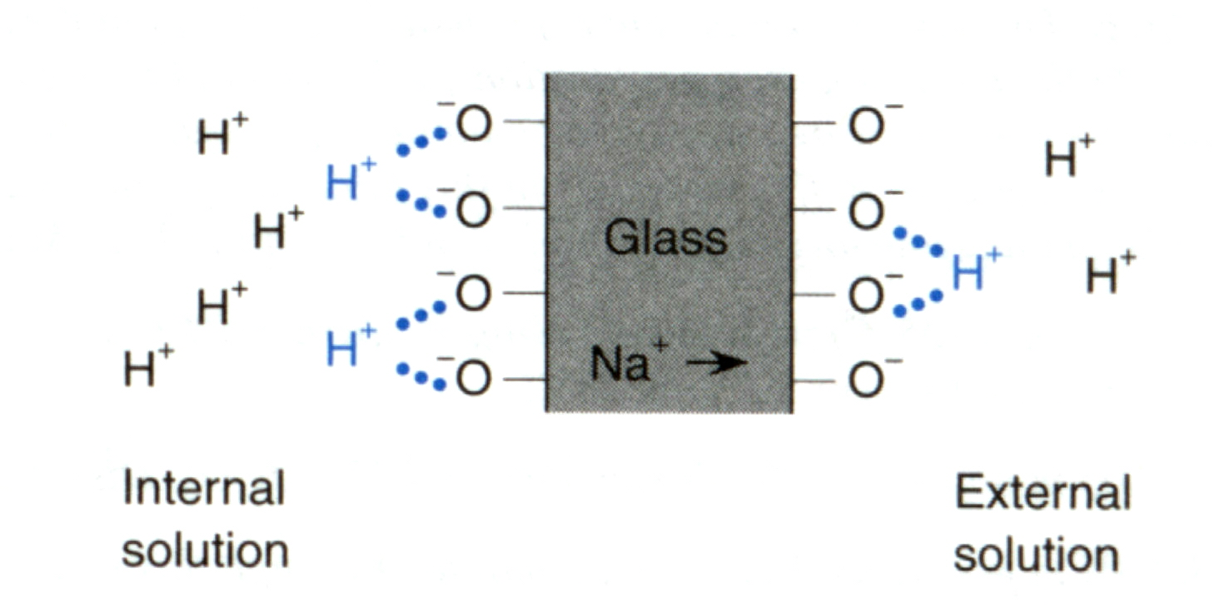

Thus, a difference in the [H⁺] on the two surfaces of the glass membrane will result in the a different charge on the glass surfaces and a corresponding measurable potential that is related to the pH of the solution.
$E=\text{constant}−β(0\text{.}\text{05916})pH$

