**CHEMISTRY 221** - **Dr. Powers**  **Second Exam -**  **FALL 2007**

**PRINT NAME** ______________________________________________

(Last) (First) (MI)

***ID# ___________________________***

Signature ________________________________________

**SECOND EXAM Lab Section**______

**October 18, 2007**

**BE SURE YOU HAVE 12 DIFFERENT PAGES OF THIS EXAM**

***\*\*\*\*\*\*\*\*\*\*WRITE YOUR NAME ON EVERY PAGE\*\*\*\*\*\*\*\*\*\*\*\*\*\*\*\****

**SHOW ALL WORK - NO WORK - NO CREDIT**

**REPORT ALL ANSWERS WITH CORRECT LABELS AND SIGNIFICANT FIGURES**

• All Cell phones must be turned off and cannot be used as a calculator.

• You may use a calculator, and an exam data sheet.

• Raise your hand if you have a question.

• Keep your eyes on your own paper.

• Several exam forms may be in use. It is a code violation if data from another exam form appears on your paper.

• Keep all REQUIRED exams as part of your records.

**REQUEST FOR REGRADE _______________Date**

***EXAMS SUBMITTED FOR REGRADES SHOULD NOT LEAVE THE RESOURCE CENTER!***

Please regrade question because___________________________________________ _________________________________________________________________________

_________________________________________________________________________

Please regrade question because **__________________________________________**

_________________________________________________________________________

_________________________________________________________________________

Please regrade question because __________________________________________

_________________________________________________________________________

**______ Check here if there is a mistake in addition.**

**You must sign your regrade request, or it will not be considered a valid request.**

I accept responsibility for all answers contained herein. ________________________________ Signature

When submitting regrade request, **do not write on exam pages.** Additional questions or comments are to be placed on a separate sheet of paper and turned in with your test. **Sign these as well.**

|  |  |  |  |
| --- | --- | --- | --- |
| **Question No.** | **Possible Points** | **Points Earned** | **TA Initials** |
| **1** | **25** |  |  |
| **2** | **5** |  |  |
| **3** | **14** |  |  |
| **4** | **16** |  |  |
| **5** | **18** |  |  |
| **6** | **22** |  |  |
| **Total** | **100** |  |  |

**Some Useful Information:**

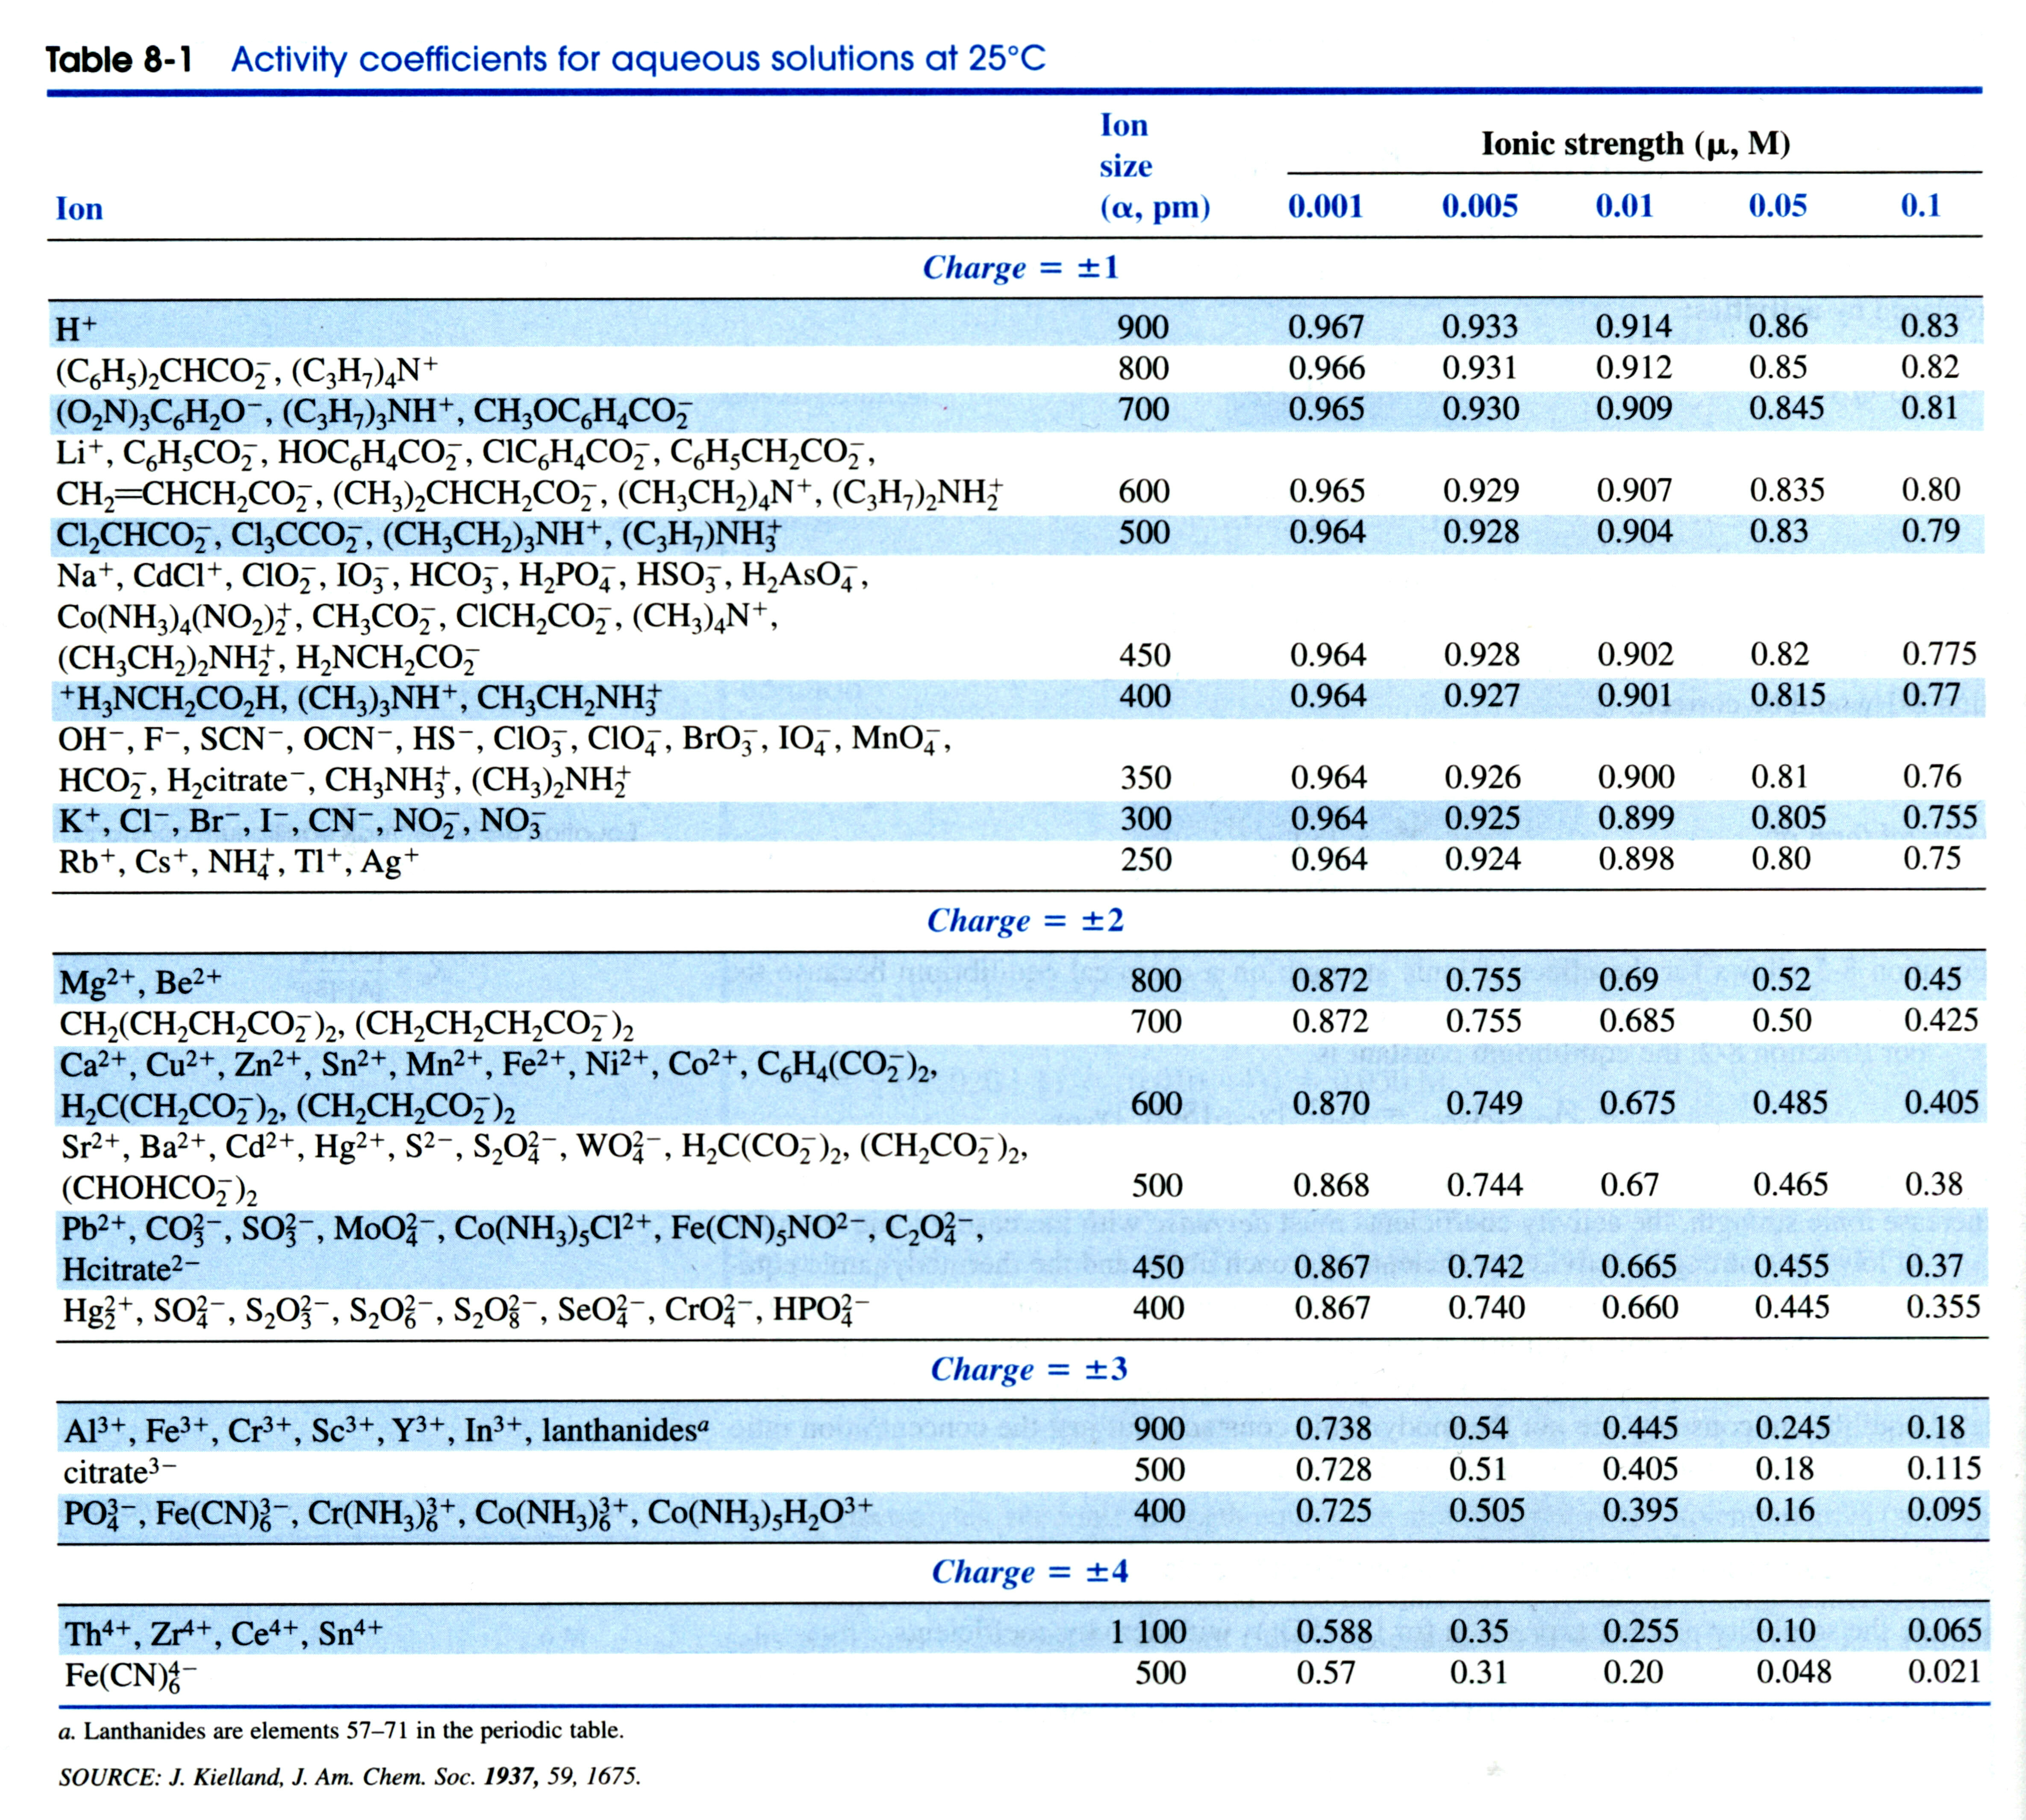

**USEFUL EQUATIONS**

**Debye-Hϋckel Equation:** **Gas Constant**:

**8.314472 J/K.mol**



1. **(25 points)** Given the following chemical reactions, identify how the reaction is expected to respond based on the listed changes to the equilibria (***does the equilibrium move toward reactants, products or no change***):
2. **(5 points)** Photosynthesis is an endothermic chemical reaction. What happens if the temperature is decreased from 20o to 10o C



**Equilibrium moves toward reactants, endothermic reaction moves towards products only if heat is added (increased temperature)**

1. **(5 points)** What happens if 1 g of solid CaF2 is added to a saturated solution of CaF2?

Ksp = 3.2x10-11



**No change, concentration/activity of pure solid is one. Saturated solution indicates ion concentration at limit, additional solid will not increase ion concentration.**

1. **(5 points)** What happens if 10 mL of 1 mM NaOH is added to 10 mL of 100 mM of acetic acid?



Ka = 1.75x10-5

**Equilibrium moves toward products. Addition of NaOH (base) neutralizes acid (H+) results in a decrease in H+ concentration.**

1. **(5 points)** What happens if 0.01 M of NaCl is added to a solution of benzoic acid?



Ka = 6.28x10-5

**No change, addition of 0.01 M NaCl increases ionic strength which decreases activity but concentration of reactants and products unaffected. No common ion effect.**

1. **(5 points)** What happens if 0.01 M of NaCl is added to a solution of TlCl?

Ksp = 1.8x10-4



**Equilibrium moves toward reactants. Common ion effect, increase in [Cl-] from NaCl decreases TlCl solubility.**

1. (**5 points**) What is the difference between a Lewis acid and a Brønsted-Lowry acid?

**Lewis acid accepts a pair of electrons, while a Brønsted-Lowry acid donates a proton H+**.

1. **(14 points)** G for photosynthesis was determined to be +502 kJ/mol at 25oC.



* 1. (**3 points**) Is the reaction spontaneous?

**No, G is positive**

* 1. (**4 points**) What is the equilibrium constant for this reaction?



* 1. (**4 points**) If the change in enthalpy was determined to be +469 kJ/mol, what is the change in entropy?

**G = H - TS 🡪 S = -(G – H)/T = -(502 kJ/mol - 469 kJ/mol)/298.15K**

**S = -(33 kJ/mol)/298.15K = -111 J/mol**

* 1. (**3 points**) What does the G, enthalpy and entropy values listed above tell us about the *rate* of this reaction?

**Nothing, thermodynamics determines if a reaction is spontaneous or not, but it does not tell us anything regarding kinetics (rate of reaction).**

1. **(16 points)** Given 10 mL of a 100 mM solution of benzoic acid in pure water



Ka = 6.28x10-5

(C6H5CO2-)

* 1. (**4 points**) What is the pH of this solution?

**Set x = [H+] = [benzoate]**



* 1. **(4 points)** What is the pH if 0.01 M of NaCl is added to the solution?

**Ionic strength is now 0.01 M, from table activity coefficient for H+ is 0.914**



\

* 1. (**4 points**) If the benzoic acid solution was titrated with a 25 mM solution of NaOH, what volume of NaOH would be required to reach an *equivalence point*?

**Equivalence point: moles of benzoic acid = moles of NaOH.**

**M1V1 = M2V2**

**(10 mL)(100 mM) = (25 mM)(x mL)**

**x mL = [(10 mL)(100 mM)]/(25 mM) = (1000)/(25) = 40 mL**

* 1. (**4 points**) Would the pH at the *endpoint* for the titration in (c) be acidic, basic or neutral?

**Endpoint requires slight excess of titrant to induces observable physical change in color, precipitate, current etc. Since NaOH is the titrant and is a strong base, a slight excess of NaOH will result in a basic solution.**

1. **(18 points)** Given the following titration curve for the precipitation of MgCO3 where Mg+2 is the titrant:

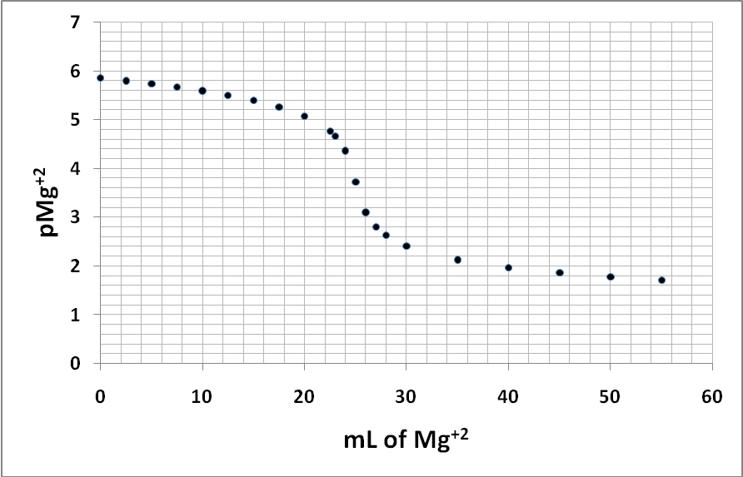

**O mL of added Mg+2, due to dissociated MgCO3**

**Equivalence point**

* 1. (**4 points**) Using the graph, estimate the concentration of Mg+2 at the equivalence point

**(See graph, red arrows) pMg+2 at 25 mL = 3.73**



* 1. (**5 points**) Based on your answer to (a), what is the Ksp of MgCO3?

**At equivalence point, [Mg+2]=[CO3-2]=1.86x10-4 M**

**Ksp = [Mg+2][CO3-2] = (1.86x10-4)2 = 3.47x10-8**

* 1. (**5 points**) Based on your answer to (b) and the graph, what was the original concentration of CO3-2

**(see graph) At 0 mL of added Mg+2, pMg+2 = 5.85 , only from dissociation of original MgCO3**



**Ksp = 3.47x10-8 = [Mg+2][CO3-2] = (1.41x10-6) [CO3-2]**

**[CO3-2] = (3.47x10-8)/ (1.41x10-6) = 24.6 mM**

* 1. (**4 points**) Roughly estimate and sketch on the graph what would happen to the titration curve if the Ksp of MgCO3 increased by 100-fold (***What would the curve look like if the Ksp is 100x the current value?***).

**See Graph (dark blue curve)**

1. (**22 points**) Given the following equilibria:

(1)

(2)

(3)

(4)



* 1. (**4 points**) Write a mass balance equation using chemical reaction 1.

**[Ca2+] = [CO32-]**

* 1. (**5 points**) Write a charge balance equation using chemical reactions 1, 2, 3 & 4 (***Make sure to use all the chemical reactions***).

**2[Ca2+] + 1[H+] = 2[CO32-] + 1[HCO3-]**

* 1. (**5 points**) Calculate the equilibrium constant for the following reaction:



**K = (KspK1)/(K2) = (4.5x10-9)(4.46x10-7)(2.13x1010)**

**K = 4.28x10-5**

* 1. (**8 points**) Using your answer from (c) and the reactions from (c), 1, 2, 3 & 4, determine the pH of the solution if PCO2 = 3.8x10-4 bar and [Ca+2] = 5.07x10-4 M (***ignore activity coefficients***).

**First, calculate [HCO3-] from equation in (c)**

**K = 4.28x10-5 = [Ca+][HCO3-]2/PCO2**

**[HCO3-] = sqrt[(K)(PCO2)/ [Ca+]]**

**[HCO3-] = sqrt[(4.28x10-5)(1.216x10-5)/(5.07x10-4 M)] = 1.013x10-4**

**Then Calculate [CO2(ag)] from equation 2**

**KCO2 = 0.032 = [CO2(*ag*)]/ PCO2**

**[CO2(*ag*)] = KCO2* PCO2 = 0.032*3.8x10-4 = 1.216x10-5**

**Then calculate [H+] from equation 3**

**K1 = 4.46x10-7 = [H+][HCO3-]/[CO2(*ag*)]**

**[H+] = (K1)[CO2(*ag*)]/[HCO3-] = (4.46x10-7)( 1.216x10-5)/ (1.013x10-4) = 5.35x10-8**

**pH = -log[H+] = -log(5.35x10-8) = 7.27**