- (20 points) Identify which reactions are expected to proceed spontaneously and which are expected to be non-spontaneous. Please explain why.

- (8 points) Conversion of n-hexane to 2,2-dimethylbutane at room temperature (25ºC)?
compound | Hº (kcal/mol) | Sº (cal/mol.K)
n-hexane | -167 | +389
2,2-dimethylbutane | -186 | +359

ΔH = Hº (products) – Hº (reactants) = -186 kcal/mol - -167 kcal/mol = -19 kcal/mol

ΔS = Sº (products) – Sº (reactants) = 359 cal/mol.K - 389 cal/mol.K = -30 cal/mol.K

ΔG = ΔH – TΔS = -19 kcal/mol – (25ºC+273.15)x(-30 cal/mol.K)x( 1 kcal/1000 cal)
ΔG = -19 kcal/mol – (298.15K)(-3.0x10⁻² kcal/mol.K) = -19 kcal/mol + 8.9 kcal/mol
ΔG = -10 kcal/mol

ΔG is negative, therefore reaction is spontaneous

- (4 points) Conversion of n-hexane to 2,2-dimethylbutane during the petroleum cracking process (400ºC)?

ΔG = ΔH – TΔS = -19 kcal/mol – (400ºC+273.15)x(-30 cal/mol.K)x( 1 kcal/1000 cal)
ΔG = -19 kcal/mol – (673.15K)(-3.0x10⁻² kcal/mol.K) = -19 kcal/mol + 20.2 kcal/mol
ΔG = 1 kcal/mol

ΔG is positive, therefore reaction is non-spontaneous

- (4 points) Ionization of acetic acid in water (K_{a} = 1.75x10⁻⁵)?

K_{a} < 1 so reaction is non-spontaneous also ΔG = -RTlnK

ΔG = -(8.314472 J/K.mol)(25ºC + 273.15)ln(1.75x10⁻⁵)
ΔG = -(8.314472 J/K.mol)(298.15K)(-1.095) = 2.72 J/mol
ΔG is positive, therefore reaction is non-spontaneous

- (4 points) Ionization of HCl in water?

HCl is a strong acid and completely dissociates, so K_{a} >>1 and the reaction is spontaneous

- (5 points) Based strictly on your answers to problem one (ignore your vast knowledge of chemistry), which of the above reactions are expected to proceed rapidly?

Undetermined, thermodynamic and equilibrium data only determines the likelihood that a reaction will proceed. It provides no information on the kinetics of a reaction. A reaction can be spontaneous, but may also proceed at a very slow rate.

- (6 points) The charge state of amino acids play a significant role in how enzymes catalyze a chemical reaction. Histidine, serine and aspartic acid are amino acids commonly found in enzyme active-sites and form a “catalytic triad”. The backbone α-carboxylic acid and α-amino group are involved in a peptide bond and pKa values are no longer relevant. The pKa value for the aspartic acid side-chain is 3.86 and the histidine side-chain pKa value is 6.10.
  - (4 points) What is the protonation state of aspartic acid and histidine at pH 7.0?
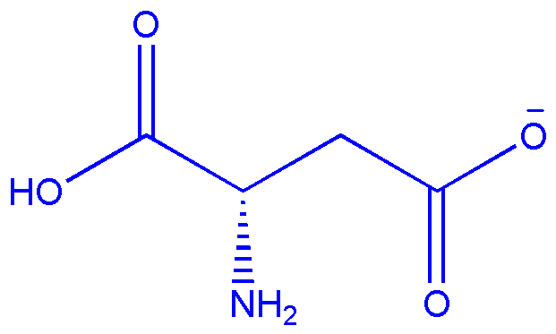
α

α

unprotonated
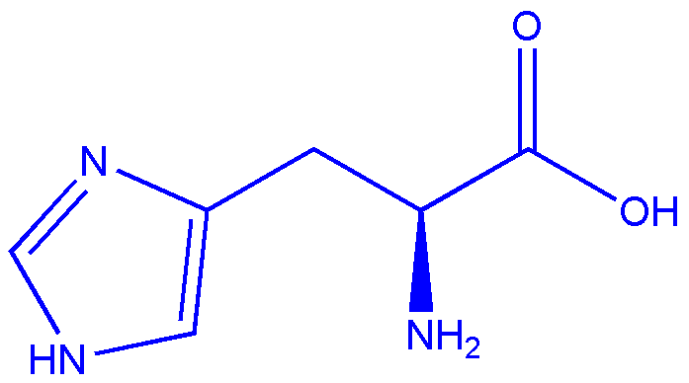
α

α

unprotonated

  - (2 points) What happens if the pKa of histidine is shifted to 7.2?

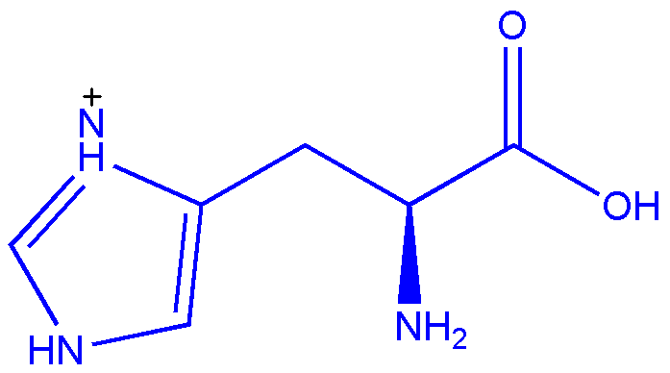
The histidine side-chain will now be protonated.

protonated

- (12 points) Provide an example for the following terms. Please write out a complete chemical reaction using real compounds to illustrate the concepts (do not use a general description).
  - Lewis acid

Lewis acid à accepts a pair of electrons
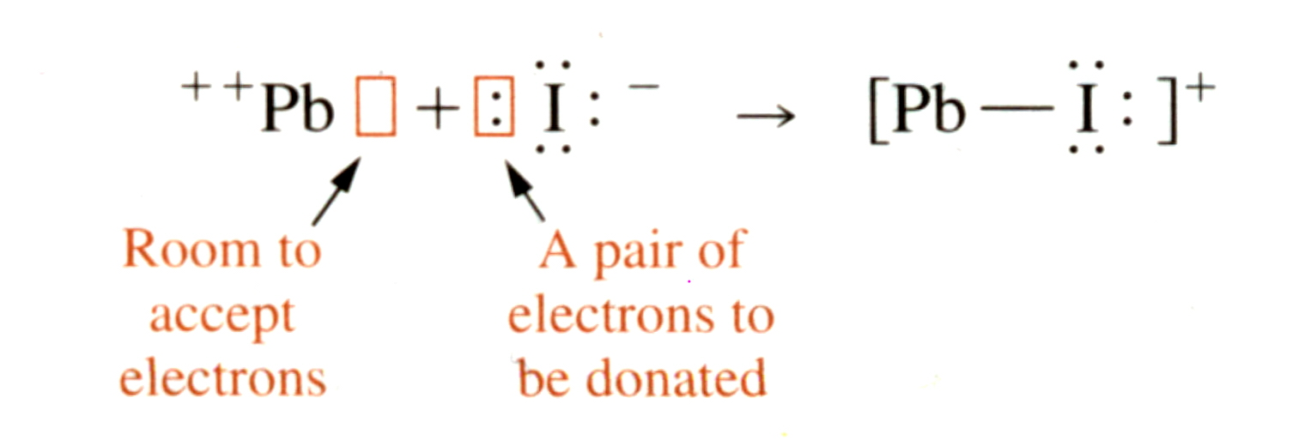

Lewis acid

  - Protic Acid

Protic Acid – is a substance that increases the concentration of H₃O⁺
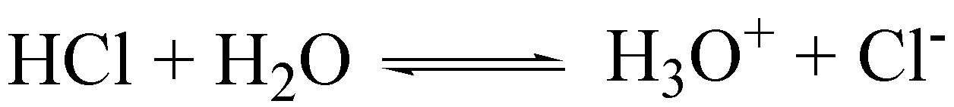

Protic acid

  - Brønsted-Lowry Base

Brønsted-Lowry Base – proton acceptor

Brønsted-Lowry Base

  - Base/Conjugate acid pair
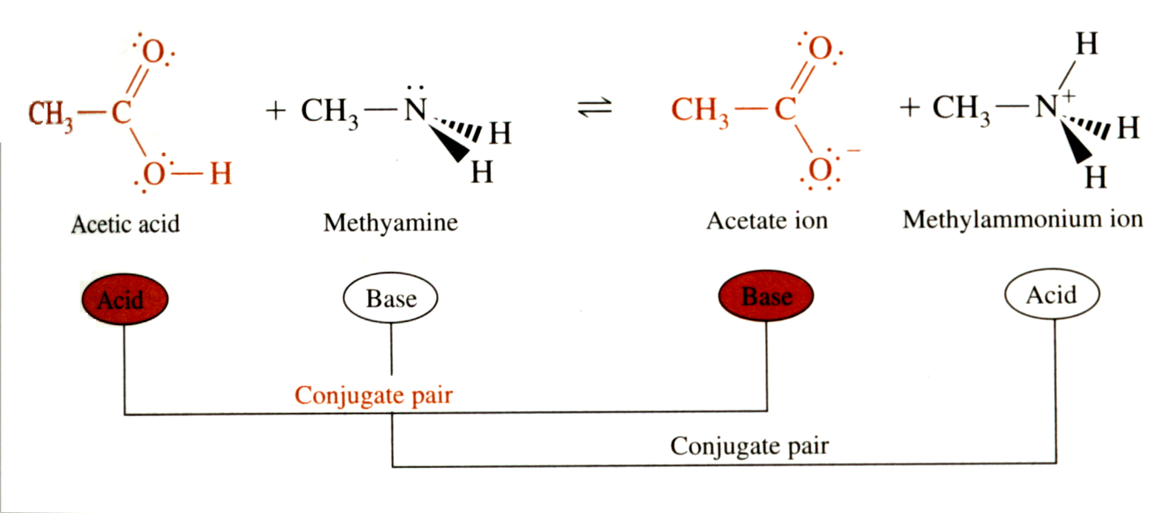

A conjugate acid and its base or a conjugate base and its acid in an aqueous system are related to each other by the gain or loss of H+

- (32 points) What is the Hg₂⁺² concentration when Hg₂Cl₂ (K_{sp} = 1.2x10⁻¹⁸) is dissolved in:
  - (6 points) pure water

Very low ionic strength (K_{sp} = 1.2x10⁻¹⁸) assume activity coefficients are 1.

K_{sp} = 1.2x10⁻¹⁸ = [Hg₂⁺²][Cl⁻]²

Assume [Hg₂⁺²] = x, 1.2x10⁻¹⁸ = [x][2x]²

4x³ =1.2x10⁻¹⁸ → x = 6.7x10⁻⁷ = [Hg₂⁺²]

  - (8 points) 0.01 M NaOH

$\begin{aligned}μ=\frac{1}{2}\sum_{i}{c_{i}z_{i}^{2}} \\ =\left(\frac{1}{2}\right)×\left[ [{\text{Na}}^{+}]{\left(+1\right)}^{2}+[{\text{OH}}^{−}]{\left(−1\right)}^{2}\right] \\ =\left(\frac{1}{2}\right)×\left[ (1)\left(0\text{.}\text{01M}\right){\left(+1\right)}^{2}+\left(0\text{.}\text{01M}\right){\left(−1\right)}^{2}\right]=0\text{.}\text{10}M\end{aligned}$

Ionic strength = 0.01 M, from table:
γ(Hg₂⁺²) = 0.660
γ(Cl⁻) = 0.899

K_{sp} = 1.2x10⁻¹⁸ = γ(Hg₂⁺²)[Hg₂⁺²] γ²(Cl⁻)[Cl⁻]²

Assume [Hg₂⁺²] = x, 1.2x10⁻¹⁸ = γ(Hg₂⁺²)[x] γ²(Cl⁻)[2x]²

(0.660)(0.899)²4x³ = 1.2x10⁻¹⁸ → x = 8.3x10⁻⁷ = [Hg₂⁺²]

  - (10 points) 0.01M NaCl.

Ionic strength = 0.01 M, from table:
γ(Hg₂⁺²) = 0.660
γ(Cl⁻) = 0.899

K_{sp} = 1.2x10⁻¹⁸ = γ(Hg₂⁺²)[Hg₂⁺²] γ²(Cl⁻)[Cl⁻]²

Assume [Hg₂⁺²] = x, [Cl⁻] > [Hg₂⁺2] and [Cl⁻]= 0.01M

K_{sp} = 1.2x10⁻¹⁸ = γ(Hg₂⁺²)[x] γ²(Cl⁻)[0.01M]²

(0.660)(0.899)²(1.0x10⁻⁴)(x) = 1.2x10⁻¹⁸ → x = 2.2x10⁻¹⁴

Assumption holds: [Cl⁻] = 0.01M > [Hg₂⁺²] = 2.2x10⁻¹⁴

  - (4 points) Please explain why the Hg₂⁺² concentrations differ?

For (b), the increase in ionic strength results in a decrease in the activity coefficient, which requires an increase in concentration to maintain the same equilibrium constant. The decrease in activity results in an increase in solubility.

For (c), the same ionic strength effect occurs, but the common ion effect has a more substantial impact. The addition of Cl⁻ from NaCl requires a shift to reactants in the Hg₂Cl₂ solubility equilibrium (Le Châtelier’s Principal). This results in a dramatic decrease in the solubility of Hg₂²⁺.

  - (4 points) What is the charge balance and mass balance equations for c?

Charge balance: [Na⁺] + 2[Hg₂²⁺] = [Cl⁻]
[Na⁺] = [Cl⁻]

Mass balance: [Na⁺] = [Cl⁻] and 2[Hg₂²⁺] = [Cl⁻]
[Na⁺] = [Cl⁻]

[Hg₂²⁺] << [Cl⁻], [Na⁺]

- (10 points) Fe³⁺ and Cu²⁺ form complexes with EDTA (Cu²⁺-EDTA: K_{f} = 5×10¹⁸, Fe²⁺-EDTA: K_{f} =1.7×10²⁴). Fe³⁺, EDTA, and the Fe³⁺-EDTA complex are colorless. The Cu²⁺-EDTA complex is colored a deep blue. The following spectrophotometric titration curve was obtained when a solution containing both Fe³⁺ and Cu²⁺ was titrated with EDTA and absorbance was measured at 745 nm (red).
Absorbance
A
B
[EDTA]

  - (2 points) What happens at point A?

Endpoint for Fe³⁺ titration

  - (2 points) What happens at point B?

Endpoint for Cu²⁺ titration

  - (3 points) A new technician is being trained using Fe³⁺ and Cu²⁺ standards. He is using a calibrated buret and obtains a similar titration curve as above, but his measured concentrations are systematically high. Why?

Endpoint is not the same as equivalence point. An endpoint typically requires excess titrant which is why the concentrations are systematically higher.

  - (3 points) Describe one method that would correct the technician’s mistake.

Do a blank titration with only Cu²⁺ do determine the amount of EDTA that is required to first observe a color change. Subtract the blank titration volume from the Fe³⁺ endpoint to obtain a better estimate of the equivalence point.

- (15 points) A solution is composed of 0.1 M acetic acid (pKa = 4.756) in H₂O (ignore activity coefficients).

Acetic acid acetate

  - (5 points) What is the pH of this solution?

pK_{a} = -logK_{a} → K_{a} = 10^{-pKa} = 1.75x10⁻⁵
$K_{a}=1\text{.}\text{75}×{\text{10}}^{−5}=\frac{[\text{acetate}][H^{+}]}{[\text{acetic} \text{acid}]}=\frac{x^{2}}{0\text{.}1M−x}⇒x^{2}+1\text{.}\text{75}x{\text{10}}^{−5}x−1\text{.}\text{75}x{\text{10}}^{−6}=0$

$K_{a}=1\text{.}\text{75}×{\text{10}}^{−5}=\frac{[\text{acetate}][H^{+}]}{[\text{acetic} \text{acid}]}=\frac{x^{2}}{9\text{.}\text{6578}x{\text{10}}^{−2}M−x}⇒x^{2}+1\text{.}\text{75}x{\text{10}}^{−5}x−1\text{.}\text{69}x{\text{10}}^{−6}=0$

  - (5 points) What is required to make the above solution a buffer with a pH of 3.0?

Need to add the appropriate concentration of sodium acetate (conjugate base) based on the Henderson-Hasselbalch equation:
$\begin{aligned}\text{pH}={\text{pK}}_{a}+\text{log}\left(\frac{[A^{−}]}{[\text{HA}]}\right) 3\text{.}0=4\text{.}\text{756}+\text{log}\left(\frac{x}{0\text{.}1M}\right) \\ \\ −1\text{.}\text{756}=\text{log}\left(\frac{x}{0\text{.}1M}\right) 1\text{.}\text{754}x{\text{10}}^{−2}=\frac{x}{0\text{.}1M} \\ \\ x=1\text{.}\text{754}x{\text{10}}^{−3}M\end{aligned}$

Add sodium acetate to a final concentration of 1.754x10⁻³ M to 0.1 M acetic acid.

  - (2 points) Is this an optimal pH for this buffer?

No, the best pH is near the pKa value of 4.756.

  - (3 points) If instead of acetic acid, a polyprotic acid such as citric acid was used with pKa values of 3.13, 4.76 and 6.40 how would you make a buffer with a pH of 3.0? (No need to do the math, just provide a brief explanation)

Any solution only contains a single pH value and each pKa value has a corresponding Henderson-Hasselbalch equation. Simply use the Henderson-Hasselbalch equation associated with the first pKa (3.13), which is closes to the desired pH of 3.0.

