CHEMISTRY 221 - Dr. Powers First Exam - FALL 2007

PRINT NAME ______________________________________________
(Last) (First) (MI)
ID# ___________________________

Signature ________________________________________

FIRST EXAM Lab Section______
September 20, 2007
BE SURE YOU HAVE 12 DIFFERENT PAGES OF THIS EXAM
**********WRITE YOUR NAME ON EVERY PAGE****************
SHOW ALL WORK - NO WORK - NO CREDIT

REPORT ALL ANSWERS WITH CORRECT LABELS AND SIGNIFICANT FIGURES

• All Cell phones must be turned off and cannot be used as a calculator.
• You may use a calculator, and an exam data sheet.
• Raise your hand if you have a question.
• Keep your eyes on your own paper.
• Several exam forms may be in use. It is a code violation if data from another exam form appears on your paper.
• Keep all REQUIRED exams as part of your records.

REQUEST FOR REGRADE _______________Date

EXAMS SUBMITTED FOR REGRADES SHOULD NOT LEAVE THE RESOURCE CENTER!

Please regrade question because___________________________________________ _________________________________________________________________________
_________________________________________________________________________
Please regrade question because __________________________________________
_________________________________________________________________________
_________________________________________________________________________
Please regrade question because __________________________________________
_________________________________________________________________________

______ Check here if there is a mistake in addition.
You must sign your regrade request, or it will not be considered a valid request.

I accept responsibility for all answers contained herein. ________________________________ Signature

When submitting regrade request, do not write on exam pages. Additional questions or comments are to be placed on a separate sheet of paper and turned in with your test. Sign these as well.

Question No. | Possible Points | Points Earned | TA Initials
1 | 16
2 | 20
3 | 6
4 | 16
5 | 15
6 | 15
7 | 12
Total | 100

Some Useful Information:
Gaussian Curve:
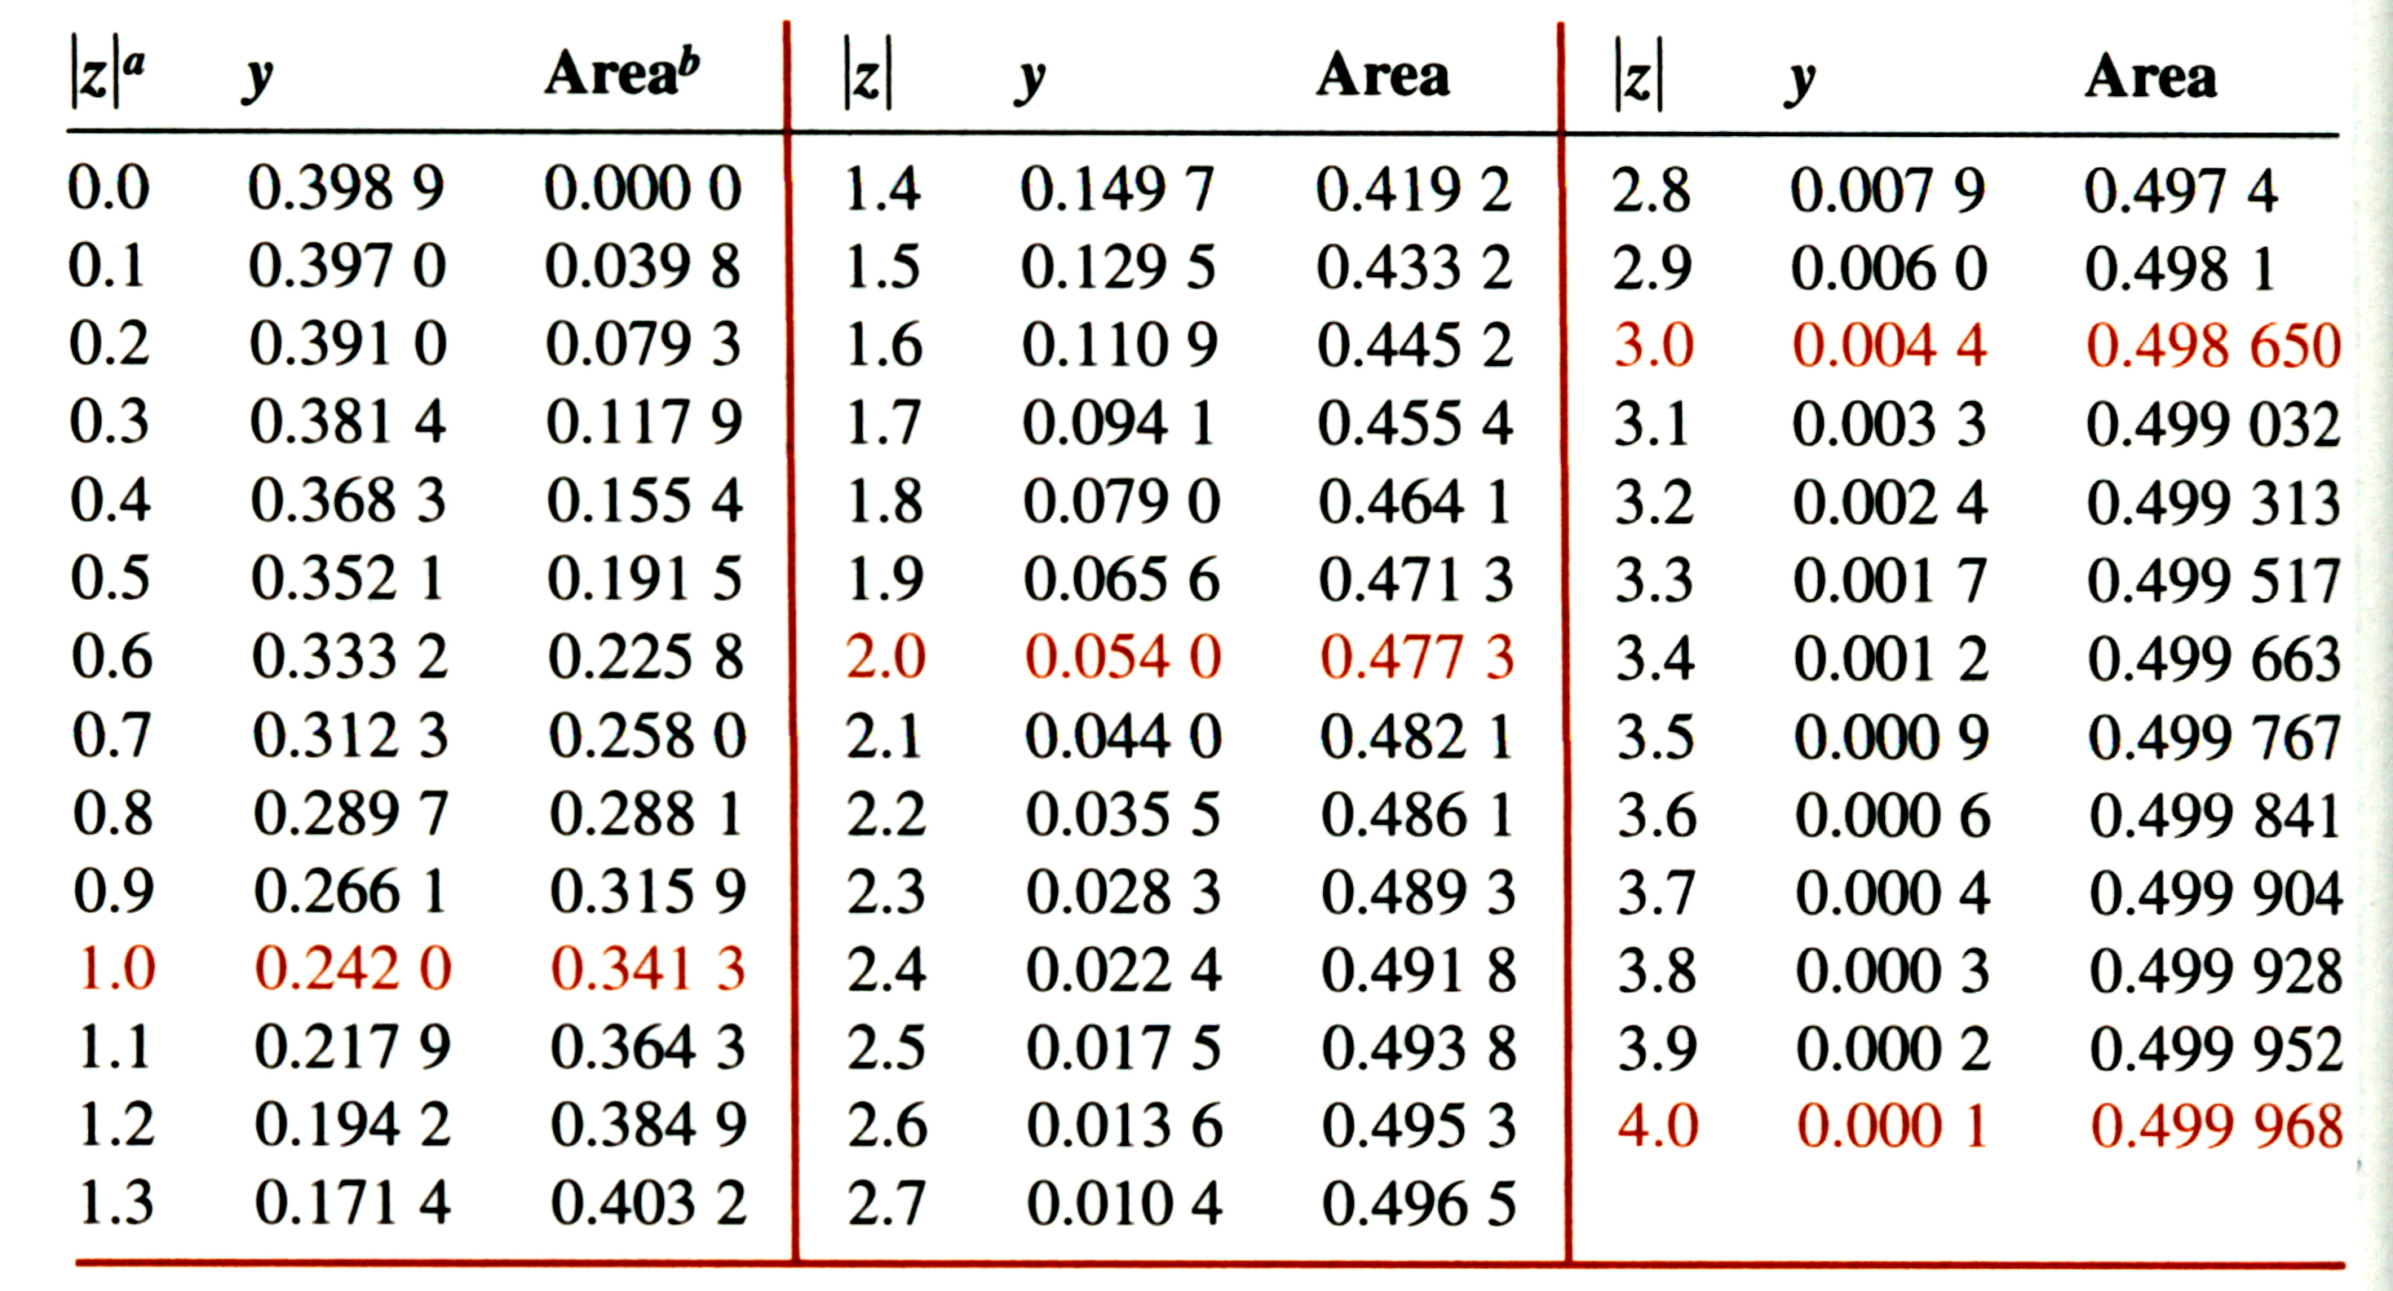

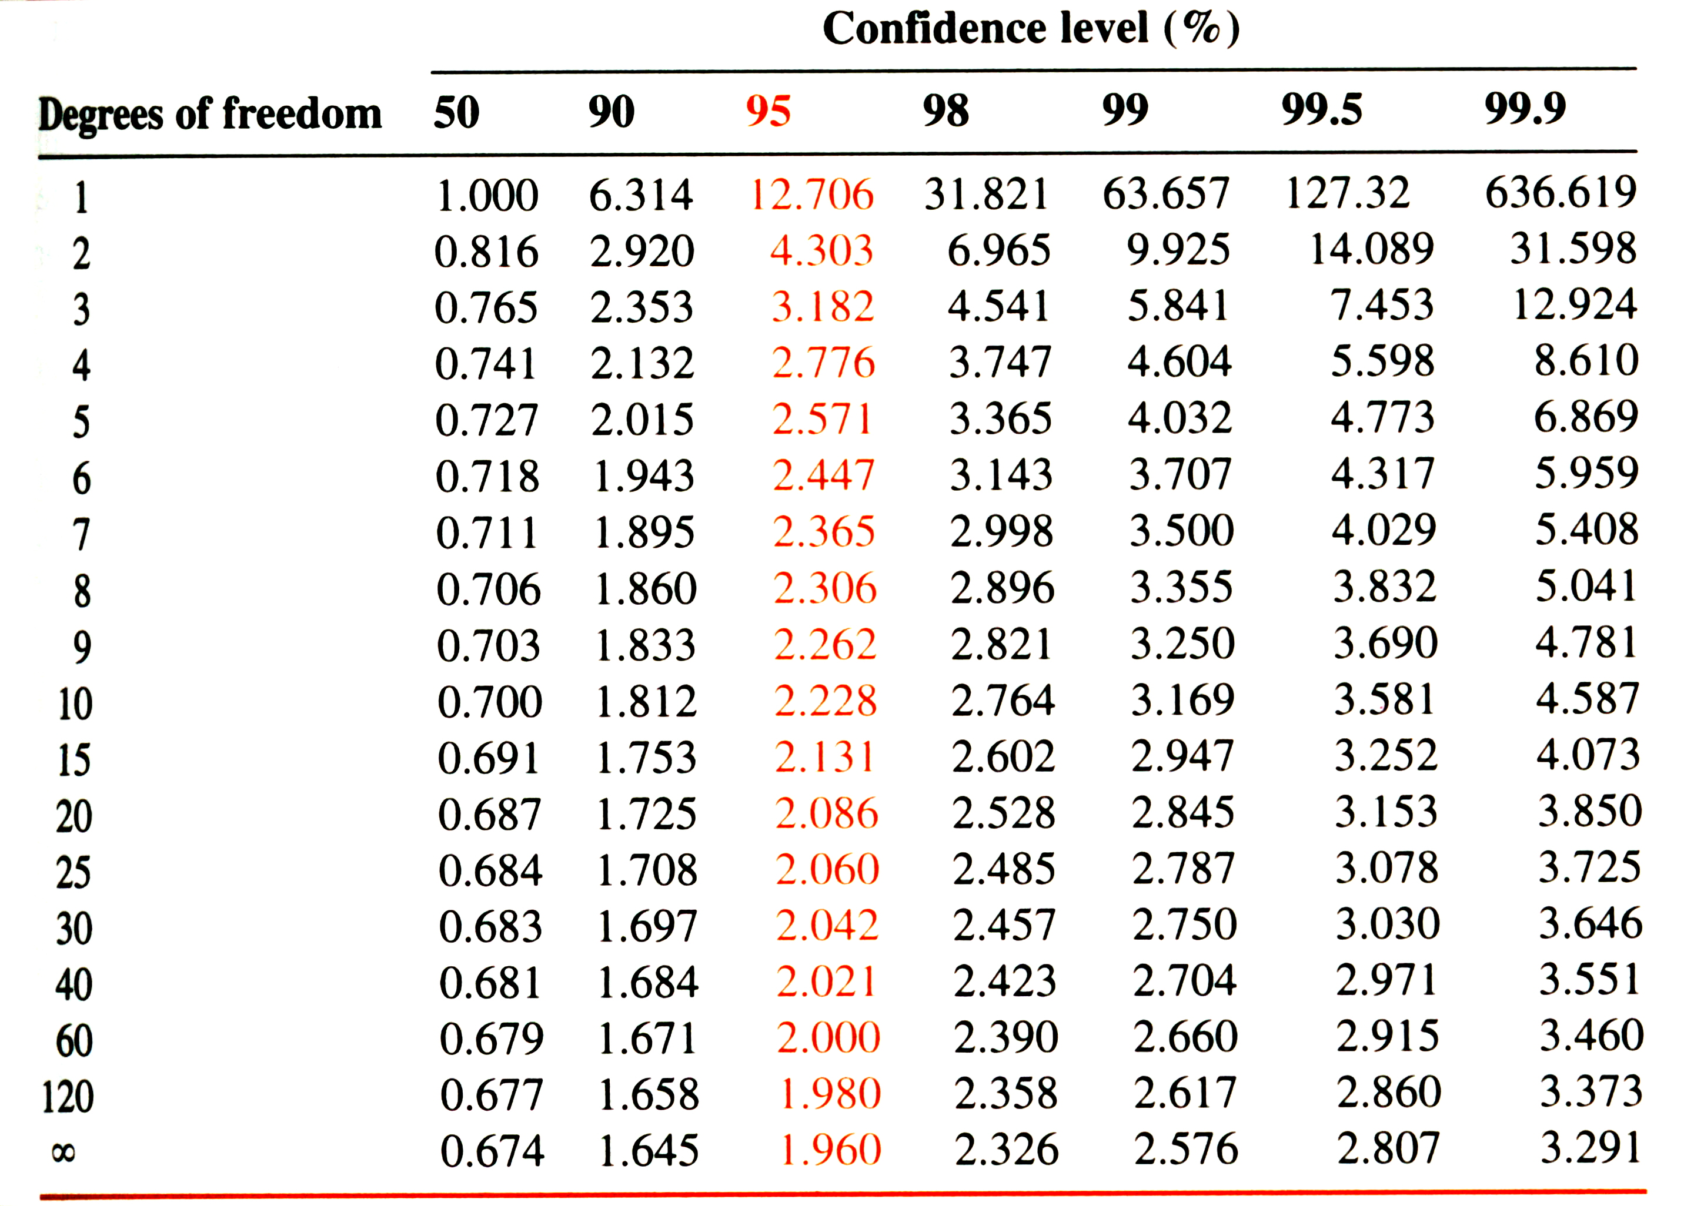
Student’s t

Q test:
Values of Q for rejection of data
Q (90% confidence) | 0.94 | 0.76 | 0.64 | 0.56 | 0.51 | 0.47 | 0.44 | 0.41
Number of Observations | 3 | 4 | 5 | 6 | 7 | 8 | 9 | 10

- ( 16 points) Please Identify and Explain the mistakes made in the following laboratory protocols:
  - (4 points) A 10.00 mM solution of glucose (FW 180.16 g/mole) was prepared by first adding 180.16 mg of glucose to a 100 mL empty volumetric flask, and then DI H₂O was added to the volumetric flask until the meniscus reached the 100 mL volume mark. The flask was capped and the solution vigorously mixed until the glucose completely dissolved.

Adding the glucose to an empty volumetric flask and filling to the meniscus was incorrect. When the glucose completely dissolves, the volume will increase and the concentration will be incorrect.

  - (4 points) A gravimetric analysis of dissolved Pb⁺² (FW 207.2 g/mole) in water was carried out by the slow addition of a 0.1 M solution of NaOH to three separate 10 mL samples. The three PbO (FW 223.20 g/mole) precipitates were filtered, dried and then pooled together to give a single weight of 10.3491 mg and an average weight of 3.4497 mg. It was then determined that 3.202 mg of Pb⁺² was present in the water sample.

Pooling the samples was a mistake. Repeat measurements are needed to better approximate the “true” value from a mean and determine an error associated with the measurements.

  - (4 points) A 100 mg sample of NaOH were weighed by transferring pellets directly onto the balance pans until enough pellets were added until the balance read as close to 0.1000 g as possible.

A sample should not be directly added to the balance pan and the weight should be accurately measured by the difference method.

  - (4 points) A colloidal suspension was initially observed during a gravimetric analysis, so the beaker containing the sample was transferred to an ice bath for 1 hour.

Increasing the temperature not decreasing the temperature will lead to crystal formation.

- (20 points) Two students titrated a 100.00 mL sample of HCl with an unknown concentration with a standardized 0.1339 M NaOH sample.

The students obtained the following results:
Student A: 23.17 mL, 22.69 mL, 23.25 mL, 22.97 mL
Student B: 25.25 mL, 25.19 mL, 25.23 mL, 25.23 mL

  - (4 points) Determine the average (mean) and standard deviation for each student’s data set.

Mean A = 23.02 mL
Standard deviation A: 0.25

Mean B = 25.22 mL
Standard deviation B: 0.03

  - (2 points) Which student was more precise? Explain.

Student B, smaller standard deviation

  - (4 points) If the unknown HCl sample has a concentration of 0.0030 M, which student is more accurate?

1 mole of HCl reacts with 1 mole of NaOH

Student A: moles of NaOH = moles HCl = (23.02 mL)(0.1339 M) = 3.082 mmoles
Molarity of HCl = (3.082 mmoles)/(100.00 mL) = 3.082 mM = 0.003082 M

Student B: moles of NaOH = moles HCl = (25.22 mL)(0.1339 M) = 3.377 mmoles
Molarity of HCl = (3.377 mmoles)/(100.00 mL) = 3.377 mM = 0.003377 M

Student A is more accurate.

  - (5 points) Are the results (titration volumes) obtained by the two students significantly different at the 95% confidence level (Given: S_{spooled} = 0.18)?

$t_{\text{calculated}}=\frac{{\bar{x}}_{1}−{\bar{x}}_{2}}{s_{\text{pooled}}}\sqrt{\frac{n_{1}n_{2}}{n_{1}+n_{2}}}$

$t_{\text{calculated}}=\frac{\text{25}\text{.}\text{22}−\text{23}\text{.}\text{02}}{0\text{.}\text{18}}\sqrt{\frac{(4)(4)}{4+4}}=\frac{2\text{.}2}{0\text{.}\text{18}}\sqrt{2}=\text{17}\text{.}\text{28}$

Degrees of freedom = n₁ + n₂ -2 = 4 + 4 -2 = 6

From Student’s t table at 95% confidence level : 2.447

17.28 > 2.447 → results are significantly different

  - (5 points) Using the Q test, decide if the second measurement (22.69 mL) for student A should be discarded.

Arrange in ascending order, 23.17 mL, 22.69 mL, 23.25 mL, 22.97 mL:

22.69, 22.97, 23.17 23.25

Range = 23.25 – 22 .69 = 0.56

Gap = 22.97 – 22.69 = 0.28

$Q=\frac{\text{Gap}}{\text{Range}}=\frac{0\text{.}\text{28}}{0\text{.}\text{56}}=0\text{.}\text{50}$

n = total number of observations = 4

Q from table = 0.76

0.50 < 0.76

Since Q(calculated) < Q(table), data point cannot be excluded.

- (6 points) While conducting an experiment, a lab technician records notes and data on a loose piece of paper and plans on transferring the information in his lab notebook later.
  - (4 points) Give two reasons why this is an incorrect procedure.

Paper (data) can be easily lost. Mistakes can easily be made when transferring data from paper to notebook.

  - (2 points) Is there a similar problem with transferring the data to a computer program to create a graph?

No, while a mistake may be made in transferring the data, it is easily caught because the point would be an outlier in the graph.

- (16 points) Crystal formation is an important component of gravimetric analysis.
  - (4 points) What process (not experimental condition) causes the formation of colloidal solutions instead of crystals?

Nucleation is faster than particle growth.

  - (4 points) Describe an experimental technique that would increase the likelihood of forming crystals.

Any of the following: increase temperature, increase volume, add precipitant slowly, adjust pH

  - (4 points) Describe a process where an impurity can be incorporated into a crystal.

Any of the following: adsorbed on surface, occlusion, inclusion

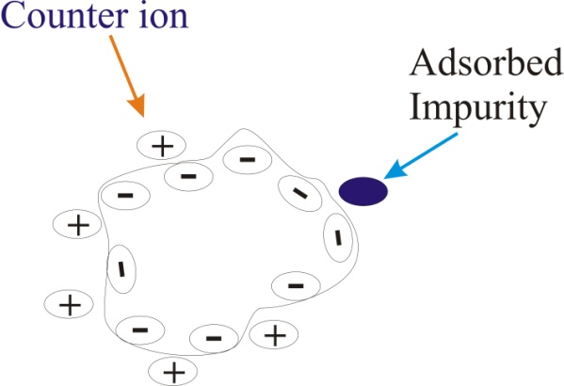
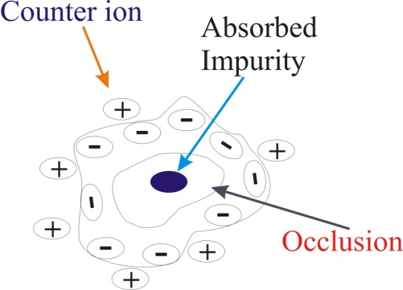
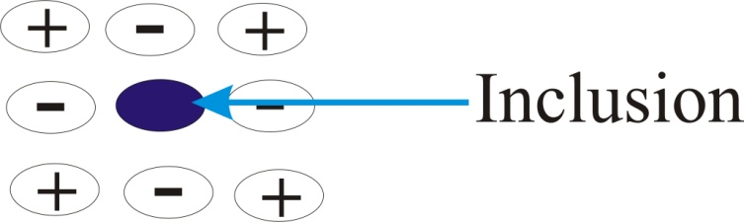

  - (4 points) What is the relationship between Relative Supersaturation (R) and crystal formation?

Smaller R → increase crystals and decrease impurities

- (15 points) The aluminum (FW 26.98 g/mole) in a 1.200g sample of impure ammonium aluminum sulfate was precipitated with aqueous ammonia as the hydrous Al₂O₃ ⋅ xH₂O. The precipitate was filtered and ignited at 1000ºC to give anhydrous Al₂O₃ (FW 101.96 g/mole) which weighed 0.1798g. Calculate the percentage of aluminum in the sample.

Al → Al₂O₃ One mole of Al₂O₃ yields two moles of Al

Moles of Al₂O₃ = (0.1798 g) (1 mole/ 101.96 g) = 1.763x10⁻³ moles

Moles of Al = (1.763x10⁻³ moles Al₂O₃)(2 moles Al/1 mole Al₂O₃) = 3.526x10⁻³

Weight of Al = (3.526x10⁻³ moles Al)(26.98 g/mole) = 9.513x10⁻² g

Percentage of Al in sample = (9.513x10⁻² g/1.200 g)x100 = 7.928%

- (15 points) A heterogeneous mixture of the 20 common amino acids was analyzed by gravimetric analysis. Adding 15% v/v of ethanol to the solution followed by slow titration of the samples pH down to 5.5 results in the selective precipitation of L-alanine (FW 89.09 g/mole) and L-glycine (FW 75.07 g/mole). The properly filtered and dried precipitate weighed 1.6259 g. Chromatographic analysis of standard 0.1000 g samples of L-alanine and L-glycine gave peak areas of 126.8 and 373.1, respectively. A similar chromatographic analysis using 0.5884 g of the 1.6259 g precipitate gave peak areas of 499.9 for L-alanine and 724.5 for L-glycine. What was the weight of L-alanine in the original heterogeneous mixture?

Set weight of L-alanine = x and weight of L-glycine = y in sub-sample,

then 0.5884 = x + y → y = 0.5884-x

Calculate response factor for L-alanine relative to L-glycine:

$\frac{A_{x}}{\left[X\right]}=F\left(\frac{A_{S}}{\left[S\right]}\right)=\frac{\text{126}\text{.}8}{0\text{.}\text{1000}}=F\frac{\text{373}\text{.}1}{0\text{.}\text{1000}}⇒F=0\text{.}\text{3399}$

Then:
$\frac{A_{x}}{\left[X\right]}=F\left(\frac{A_{S}}{\left[S\right]}\right)=\frac{\text{499}\text{.}9}{x}=(0\text{.}\text{3399})\frac{\text{724}\text{.}5}{y}$

Substitute y = 0.5884-x:

$\begin{aligned}\frac{\text{499}\text{.}9}{x}=(0\text{.}\text{3399})\frac{\text{724}\text{.}5}{(0\text{.}\text{5884}−x)}⇒1=\frac{0\text{.}\text{4926}x}{(0\text{.}\text{5884}−x)}⇒0\text{.}\text{5884}−x=0\text{.}\text{4926}x⇒ \\ \\ 0\text{.}\text{5884}=1\text{.}\text{4926}x⇒x=0\text{.}\text{3942}g\end{aligned}$

Find total amount of L-alanine in precipitate, which is equal to amount in original mixture:

(1.6259 g / 0.5884 g) (0.3942 g) = 1.0893 g

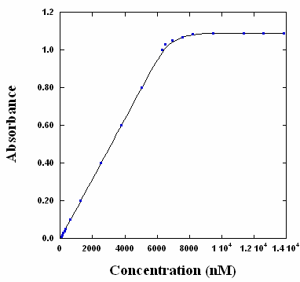
- (12 points) The following calibration curve was obtained to measure the concentration of arsenic in blood serum by measuring the absorbance of an EDTA:As⁵⁺ complex. Linear-least squares method was used to obtain a best-fit line of the linear region of the calibration curve. The equation is:

y = -2.79x10⁻⁵ ± 2x10⁻⁷ + 1.59x10⁻⁴ ± 3x10⁻⁶x

- (6 points) Calculate the concentration of an unknown that yielded an absorbance of 0.337 ± 0.005.

Substitute 0.337 ± 0.005 for y in equation and solve for x first then propagate error:

(0.337 ± 0.005) = -2.79x10⁻⁵ ± 2x10⁻⁷ + (1.59x10⁻⁴ ± 3x10⁻⁶)x

x = [(0.337 ± 0.005)/(1.59x10⁻⁴ ± 3x10⁻⁶)] + 2.79x10⁻⁵ ± 2x10⁻⁷ → x = 2.12x10³ nM = 2120 nM

Propagate error, first division, calculate relative uncertainty:

(0.005/0.337)(100) = 1.48% (3x10⁻⁶/1.59x10⁻⁴)(100)=1.89%

$\text{Re}l\text{.} \text{Uncert}{\text{.}}_{\text{Answer}}=\sqrt{{\left(1\text{.}\text{48}\right)}^{2}+{\left(1\text{.}\text{89}\right)}^{2}}=2\text{.}\text{40}\text{\%}$

Convert back to absolute uncertainty:

(2.40%)(0.337/1.59x10⁻⁴) = 2.1195x10³ ± 50.87

Do addition:
$\text{Abs}\text{.} \text{Uncert}{\text{.}}_{\text{Answer}}=\sqrt{{\left(2x{\text{10}}^{−7}\right)}^{2}+{\left(\text{50}\text{.}\text{87}\right)}^{2}}=\text{50}\text{.}\text{87}$

Final answer with uncertainty:

2120 nM ± 50.87 -> 2120 ± 50

- (3 points) From the calibration curve figure, estimate the upper-limit of detection. (i.e. what is the largest concentration that can be reliable determined?)

The end of the linear region of the calibration curve occurs at ~ 6100 nM

- (3 points) Would you expect the R² for the best-fit line to be close to zero or one?

One

