Chapter 1

1-19 How many grams of perchloric acid, HClO4, are contained in 37.6 g of 70.5 wt% aqueous perchloric acid? How many grams of water are in the same solution?



1-30 What is the maximum volume of 0.25M sodium hypochlorite solution (NaOCl, laundry bleach) that can be prepared by dilution of 1.00 L of 0.80 M NaOCl?

**McVc = MdVd**



Chapter 2

2-9 The densities (g/ml) of several substances are:

acetic acid 1.05 CCl4 1.59 Sulfur 2.07

lithium 0.53 mercury 13.5 PbO2 9.4

lead 11.4 iridium 22.5

From figure 2.5, predict which substance will have the smallest percentage buoyancy correction and which will have the greatest.



**PbO2: lowest correct density closest to density**

**(8.0 g/ml) of calibration weights.**

**Lithium: largest, lowest density (0.53 g/ml)**

Chapter 3

3-16 Find the absolute and percent relative uncertainty and express each answer with a reasonable number of significant figures:

(c) [4.97 ± 0.05 – 1.86 ± 0.01]/21.1 ± 0.2 =



**Error for subtraction:**

**= [3.11 ± 0.0510]/21.1 ± 0.2 both 4.97 & 1.86 have two numbers to the right**

**of decimal point**

**Error for division, convert to relative uncertainty:**

**= [3.11 ± 1.64%]/21.1 ± 0.95% 1.64% = 0.051/3.11 & 0.95% = 0.2/21.1**



**= 0.147 ± 1.90% both 3.11 and 21.1 have 3 significant figures**

**=0.147 ± 0.003 [1.90% x 0.147 = 0.0027 round up to 0.003]**

Chapter 27

What is the %KCl in a solid if 5.1367 g of solid gives rise to 0.8246 g AgCl?

**Cl- + Ag+ 🡪 AgCl(s)**



**Note: 4 significant figures**

27-35 A mixture weighing 7.290 mg contained only cyclohexane, C6H12 (FM 84.159), and oxirane, C2H4O (FM 44.053). When the mixture was analyzed by combustion analysis, 21.999 mg of CO2 (FM 44.010) was produced. Find the weight percent of oxirane in the mixture.

**C6H12 + C2H4O 🡪 CO2 + H2O**

**FM 84.159 44,053 44.010**

**Let x = mg of C6H12 and y = mg of C2H4O**

**x + y = 7.290**

**Also: CO2 = 6 (moles of C6H12) + 2(moles of C2H4O)**

**Conserve number of carbon atoms:**



**Make substitution x = 7.290 –y and solve for y**

**y = 0.767 mg = 0.767 mg / 7.290 mg = 10.5 wt%**

27-21. A mixture containing only Al2O3 (FM 101.96) and Fe2O3 (FM 159.69) weighs 2.019 g. When heated under a stream of H2, Al2O3 is unchanged, but Fe2O3 is converted into metallic Fe plus H2O (g). If the residue weighs 1.774 g, what is the weight percent of Fe2O3 in the original mixture?

**heat**

**Fe2O3 + Al2O3 🡪 Fe + Al2O3**

**H2**

**2.019 g 1.774 g**

**Mass of oxygen lost: 2.019 g – 1.774 g = 0.245 g**

**Moles of oxygen atoms lost: (0.245 g )(1 mole / 15.9994 g) = 0.01531 moles**

**Fe2O3 : 3 moles of oxygen = 1 mole of Fe2O3**

**Moles of Fe2O3 = 1/3(0.01531) = 0.005105**

**Mass of Fe2O3 = (0.005105 moles)(159.69 g /mole) = 0.815 g**

**wt% = (0.815 g / 2.019 g)x100 = 40.4%**

Chapter 4

4-A(i) For the following bowling scores116.0, 97.9, 114.2, 106.8 and 108.3, find the mean, median, range and standard deviation.



**Median = 97.9, 106.8, 108.3, 114.2, 116.0 🡪 108.3 (middle)**

**Range = 116.0 – 97.9 = 18.1**



4-A(ii) A bowler has a mean score of 108.6 and a standard deviation of 7.1. What fraction of the bowler’s scores will be less than 80.2?

**Determine how many standard deviations the value 80.2 is from the mean.**



**From Gaussian table:**

**Area below 4 standard deviation is 0.5000 - 0.499968 = 0.000032 = 3.2x10-3%**

**Therefore, the bowler only has a 3.2x10-3% chance of bowling a game below 80.2**

4-A(iii) For the following bowling scores 116.0, 97.9, 114.2, 106.8 and 108.3, a bowler has a mean score of 108.6 and a standard deviation of 7.1. What is the 90% confidence interval for the mean?



**Degrees of freedom 5-1 =4, 90% confidence from student’s t table = 2.132**

**90% confident range contains “true” mean :**

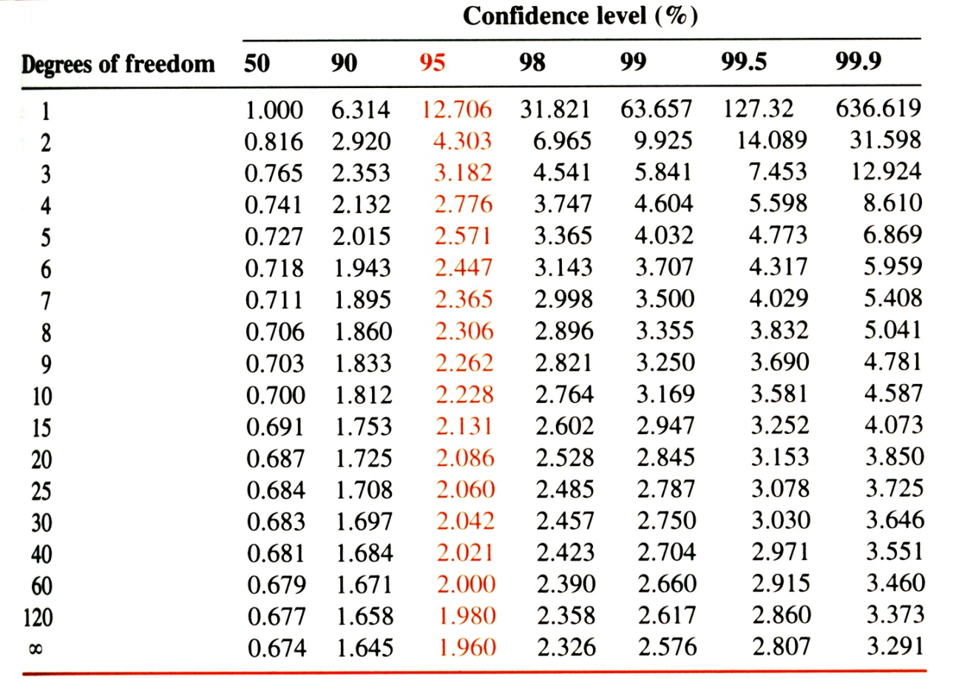

4-A(iv) For the following bowling scores 116.0, 97.9, 114.2, 106.8 and 108.3, a bowler has a mean score of 108.6 and a standard deviation of 7.1. Using the *Q* test, decide whether the number 97.9 should be discarded.

**97.9, 106.8, 108.3, 114.2, 116.0**



**Therefore, 97.9 should be retained.**

Chapter 5

Ex: The amount of protein in a sample is measured by the samples absorbance of light at a given wavelength. Using standards, a best fit line of absorbance vs. mg protein gave the following parameters:

m = 0.01630 sm = 0.00022

b = 0.1040 sb = 0.0026

An unknown sample has an absorbance of 0.246 ± 0.0059. What is the amount of protein in the sample?



**First, determine the absolute uncertainty associated with the subtraction:**



**Then convert to relative uncertainty:**



**Determine uncertainty associated with division:**



**Convert back to absolute uncertainty:**



5-19. Low concentrations of Ni-EDTA near the detection limit gave the following counts in a mass spectral measurement: 175, 104, 164, 193, 131, 189, 155, 133, 151, 176. Ten measurements of a blank had a mean of 45 counts. A sample containing 1.00 mM Ni-EDTA gave 1,797 counts. Estimate the detection limit for Ni-EDTA

**Standard deviation for the 10 measurements: 28.2**



**Detection limit:**

**Convert counts to molarity:**



**Minimum detectable concentration:**



5-24 Tooth enamel consists mainly of the mineral calcium hydroxyapatite, Ca10(PO4)6(OH)2. Trace elements in teeth of archaeological specimens provide anthropologists with clues about diet and disease of ancient people. Students at Hamline University measured strontium in enamel from extracted wisdom teeth by atomic absorption spectroscopy. Solutions with a constant total volume of 10.0 mL contained 0.750 mg of dissolved tooth enamel plus variable concentrations of added Sr. Find the concentration of Sr.

|  |  |
| --- | --- |
| **Added Sr (ng/mL = ppb)** | **Signal (arbitrary units)** |
| **0** | **28.0** |
| **2.50** | **34.3** |
| **5.00** | **42.8** |
| **7.50** | **51.5** |
| **10.00** | **58.6** |

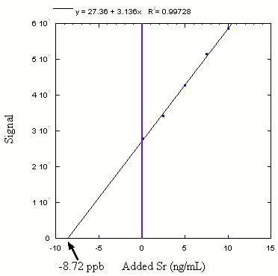

**y = 3.136x + 27.36**

**y-intercept = -8.72 ng/mL = ppb 🡪 concentration of unknown in the 10 mL sample**

5.29A solution containing 3.47 mM X (analyte) and 1.72 mM S (standard) gave peak areas of 3,473 and 10,222, respectively, in a chromatographic analysis. Then 1.00 mL of 8.47 mM S was added to 5.00 mL of unknown X, and the mixture was diluted to 10.0 mL. The solution gave peak areas of 5,428 and 4,431 for X and S, respectively

1. Calculate the response factor for the analyte
2. Find the concentration of S (mM) in the 10.0 mL of mixed solution.
3. Find the concentration of X (mM) in the 10.0 mL of mixed solution.
4. Find the concnetration of X in the original unknown.



1. **Simple dilution**



1. **Use answers to a and b**



1. **Simple dilution**



Chapter 6

6-16: Find [Cu2+] in a solution saturated with Cu4(OH)6(SO4) if [OH-] is fixed at 1.0x10-6M. Note that Cu4(OH)6(SO4) gives 1 mol of SO42- for 4 mol of Cu2+?

reaction90.tif



**[Ksp table 🡪 appendix F on page AP9]**

**Let x = [Cu2+], then [SO42-]=1/4x**



6-16 (B). Find [Cu2+] in a solution saturated with Cu4(OH)6(SO4) if [OH-] is fixed at 1.0x10-6M and 0.10M Na2SO4 is added to the solution.

reaction90.tif

|  |  |  |  |  |
| --- | --- | --- | --- | --- |
|  | **Cu4(OH)6(SO4)** | **Cu+** | **OH-** | **SO4-2** |
| **Initial Concentration** | **solid** | **0** | **1.0x10-6** | **0.10M** |
| **Final concentration** | **solid** | **x** | **1.0x10-6** | **0.10M -1/4x** |

**Let x = [Cu2+], then [SO42-]=1/4x**

**Assume 1/4x << 0.10M**



**Check assumption: ( ¼)1.2x10-8<< 0.10M**

**3.1x10-9 << 0.10M 🡪 true**

**1.2x10-8M < 3.9x10-7M solubility of Cu2+ is reduced**

**[compare to results from previous problem 6-16)**

6-25 Given the following equilibria, calculate the concentration of each zinc-containing species in a solution saturated with Zn(OH)2(s) and containing [OH-] at a fixed concentration of 3.2x10-7 M.

Zn(OH)2 (s) *Ksp* = 3.0x10-16

Zn(OH+) 1 = 2.5 x104

Zn(OH)3- 3 = 7.2x1015

Zn(OH)42- 4 = 2.8x1015



pH Ex: (a) What is the pH of a solution containing 1x10-6 M H+?



(b) What is the [OH-] of a solution containing 1x10-6 M H+?



6-49. Write the *Kb* reaction of CN-. Given that the *Ka* value for HCN is 6.2x10-10, calculate *Kb* for CN-.

**CN- + H2O <--> HCN + OH-**



Chapter 7

7-A (a) Suppose 29.41 mL of I3- solution is required to react with 0.1970 g of pure ascorbic acid, what is the molarity of the I3- solution?

reaction91.tif

**(0.1970g)(1 mole/176.124 g) = 1.1185x10-3 mol (1.1185 mmol) of ascorbic acid**

**1 mole ascorbic acid = 1 mole I3- 🡪 1.1185 mmol I3-**

**Molarity of I3- : 1.1185 mmol/29.41 mL = 0.03803 M**

(b) A vitamin C tablet containing ascorbic acid plus an inert binder was ground to a powder, and 0.4242g was titrated by 31.63 mL of I3-. Find the weight percent of ascorbic acid in the tablet.

**(31.63 mL)(0.03803M) = 1.203 mmol of I3-**

**1 mole ascorbic acid = 1 mole I3- 🡪 1.203 mmol ascorbic acid**

**(1.203x10-3 mol)(176.124 g/mol) = 0.2119g ascorbic acid**

**(0.2119g)/(0.4242g)x100 =49.94%**

Chapter 8

8-3. What is the ionic strength of a 0.0087 M KOH and 0.0002 M La(IO3)3 solution? Assume complete dissociation and no formation of LaOH2+



**[K+]=[OH-]=0.0087**

**3x[La+3] =[IO3-]**

**K+ OH-  La+3 IO3-**

**½[0.0087x12+0.0087x(-1)2 + 0.0002x32+0.0006x(-1)2] = 0.0099 M**

8-11. What is the pH of a solution containing 0.010M HCl plus 0.040 M KClO4?

**First determine the ionic strength of the solution, since the ion charges are all 1:**

** = 0.010M (HCl) + 0.040M (KClO4) = 0.050 M**

**Using table, H+ = 0.86**

**[H+] = 0.010M**



**Ignoring difference between activity and concentration:**



8-9 (a) What is the [Hg22+] in a saturated solution of Hg2Br2 with 0.00100M KCl, where

and KCl acts as an “inert salt”?

**reaction92.tif**

**First determine the ionic strength,  = 0.00100M (KCl) negligible contribution from Hg2Br2**

**Using table, Hg2+ = 0.867, Br- = 0.965**

**[Hg2+2] = x, [Br-] = 2x**



(b) What is the [Hg22+] in a saturated solution of Hg2Br2 with 0.00100M KBr?

**reaction92.tif**

**First determine the ionic strength, m = 0.00100M (KBr) negligible contribution from Hg2Br2**

**Using table, gHg2+ = 0.867, gBr- = 0.965**

**[Br-] = 0.00100M (KBr), negligible contribution from Hg2Br2**



8-24 Write a mass balance for a solution of Fe2(SO4)3, if the species are Fe3+, Fe(OH)2+, Fe(OH)2+, Fe2(OH)24+, FeSO4+, SO42- and HSO4-.

**Fe2(SO4)3 🡪 3(total Fe) = 2(total SO4)**

**(3){[Fe3+] + [Fe(OH)2+] + [Fe(OH)2+] + 2[Fe2(OH)24+] +[** **FeSO4+] } =**

**(2){[** **FeSO4+] + [SO42-] + [HSO4-]}**

**2 in front of Fe2(OH)24+ because it contains 2 Fe.**

Chapter 12

ex: What is the concentration of free Fe3+ in a solution of 0.10 M Fe(EDTA)- at pH 8.00?

**Kf = 1025.1=1.3x1025 from table 12-2**

**Y4- at pH 8.0 = 4.2x10-3 from table 12-1**



|  |  |  |  |
| --- | --- | --- | --- |
|  | **Fe3+** | **EDTA** | **Fe(EDTA)-** |
| **Initial conc:** | **0** | **0** | **0.10** |
| **Final conc:** | **x** | **x** | **0.10-x** |



**Solve quadratic for x:**



Chapter 14

14-25 (a): Calculate Eo for the following reaction:

reaction96.tif

**Identify the half-reactions, look for atoms that with a change charge (ionic) state:**

**Standard reaction potentials are listed in appendix H.**

**reaction97.tif E+o = 1.92V -**

**reaction98b.tif E-o = 1.229V**

**reaction96.tif Eo = 0.69V**



14-19 (a) : Calculate the cell voltage if the concentration of NaF and KCl were each 0.10 M in the following cell:

**(anode, E-) Pb(*s*) | PbF2(*s*) | F- (*aq*) || Cl- (*aq*) | AgCl(*s*) | Ag(*s*) (cathode, E+)**

**Identify the half-reactions, look for atoms that with a change charge (ionic) state:**

**Standard reaction potentials are listed in appendix H.**

**reaction99.tif Eo = 0.222**

**reaction100.tif Eo = -0.350**

**Solve the Nernst equation for each half-reaction:**



14-25 (b): Calculate K for the following reaction:

reaction101.tif

**Identify the half-reactions, look for atoms that with a change charge (ionic) state:**

**Standard reaction potentials are listed in appendix H.**

**reaction102.tif E+o = 0.017V**

**-**

**reaction103.tif E-o = 0.356V**

**reaction101.tif Eo = -0.339V**



14-40: If the voltage for the following cell is 0.512V, find *Ksp* for Cu(IO3)2:

**Identify the half-reactions, look for atoms that with a change charge (ionic) state:**

**Standard reaction potentials are listed in appendix H.**

**reaction104.tif E+o = 0.339V**

**reaction105.tif E-o = -0.236V**

**reaction106.tif Eo = 0.575V**



Chapter 16

16-17: A 50.00 mL sample containing La3+ was titrated with sodium oxalate to precipitate La2(C2O4)3, which was washed, dissolved in acid, and titrated with 18.0 mL of 0.006363 M KMnO4. Calculate the molarity of La3+ in the unknown.

**Need to identify the titration reaction, first determine the two ½ reactions.**

**Oxidation with Potassium permanganate:**

**Reduction:**

**reaction79**

**Oxidation:**

**reaction107.tif Eo = -0.432V**

**reaction111.tif**

**Eo=-2.379V**

**Then write a balanced reaction:**

**2[reaction79 ] Eo =1.507V**

**5[reaction107.tif] Eo = -0.432V**

**reaction108.tif Ecell=E+-E- = 1.507-(-0.432)**

**Ecell=1.939V**

***Above is the correct balanced reaction***

**3[reaction79 ] Eo =1.507V**

**5[reaction111b.tif] Eo = -2.379V**

**reaction108b.tif Ecell=E+-E- = 1.507-(-2.379)**

**Ecell = 3.879V**

***Don’t have La(s), have La+3, so the above balanced reaction is not possible***

**3[reaction108c.tif ] Eo =1.507V**

**5[reaction111.tif] Eo = -2.379V**

**reaction108c.tif Ecell=E+-E- = -2.379-1.507**

**Ecell = -3.879V**

***Negative Ecell, so the above reaction is not spontaneous***

**18.04 mL of 0.006363 M KMnO4 = 0.1148 mmol of MnO4-**

**Reacts with (5/2)(0.1148) = 0.2870 moles of H2C2O4**

**which came from (2/3)(0.2870) = 0.1913 mmol of La3+ [La2(C2O4)3]**

**[La3+] = 0.1913 mmol/50.00 mL = 3.826 mM**

Chapter 18

18-B: A 3.96x10-4 M solution of compound A exhibited an absorbance of 0.624 at 238 nm in a 1.000 cm cuvet. A blank had an absorbance of 0.029. The absorbance of an unknown solution of compound A was 0.375. Find the concentration of A in the unknown.

**First, find the molar absorptivity of compound A:**

 **(Correct absorbance for blank)**

**Use molar absorptivity to calculate concentration of unknown:**



18-20: In formaldehyde, the transition n🡪 p*(T1) occurs at 397 nm, and the n🡪p*(S1) transition comes at 355 nm. What is the difference in energy (kJ/mol) between the S1 and T1 states?

**n🡪 *(T1)**



**Convert to J/mol, multiply by Avogadro’s number**



**n🡪 p*(S1)**



**Convert to J/mol, multiply by Avogadro’s number**



**The difference between the T1 and S1 statest is 337-301 = 36 kJ/mol**

Chapter 9

9-11. (a) A 0.0450 M solution of benzoic acid has a pH of 2.78. Calculate *pKa* for this acid

reaction93.tif

**Concentrations: HA A- H+**

**F-10-2.78  10-2.78 10-2.78**

**F=0.0450M; pH =-log[H+]; [H+] = 10-pH = [A-]**



(b) What is the percent fraction dissociation?



9-40. (a) Calculate how many milliters of 0.626 M KOH should be added to 5.00 g of MOBS (FW: 223.29) to give a pH of 7.40?

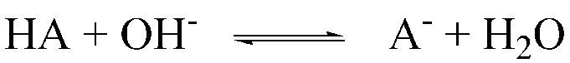

|  |  |  |  |
| --- | --- | --- | --- |
|  | HA | OH- | A- |
| Initial moles: | 0.0224 | x | - |
| Final moles: | 0.0224-x | - | x |



(b) What is the pH if an additional 5 mL of the KOH solution is added?

**Total moles of KOH = (21.2 ml)(0.626M)=0.01327 mol**



Chapter 23

23-11: Butanoic acid has a partition coefficient of 3.0 (favoring benzene) when distributed between water and benzene. Find the formal concentration of butanoic acid in each phase when 100 mL of 0.10 M aqueous butanoic acid is extracted with 25 mL of benzene at pH 4.00 and pH 10.00.

**Ka for butanoic acid = 1.52x10-5 from appendix G AP12**

**At pH 4.00:**



**Fraction remaining in water:**



**Molarity in water:**



**Molarity in benzene:**

**Total moles in system =** 

**Fraction in benzene = (1-0.606) = 0.394**

**Molarity in benzene = (0.394)(0.010 mol)/(0.025 L) = 0.16 M**

**At pH 10.00:**



**Fraction remaining in water:**



**Molarity in water:**



**Molarity in benzene:**

**Total moles in system = **

**Fraction in benzene = (1-0.9999951) = 4.9x10-4**

**Molarity in benzene = (4.9x10-4)(0.010 mol)/(0.025 L) = 2x10-6 M**

23-24: The retention volume of a solute is 76.2 mL for a column with Vm = 16.6 mL and Vs = 12.7 mL. Calculate the capacity factor and the partition coefficient for this solute.

**Vm – volume of mobile phase**

**Vs – volume of stationary phase**

**Capacity factor:**



**Partition coefficient:**



23-42: Two compounds with partition coefficients of 15 and 18 are to be separated on a column with Vm/Vs = 3.0 and tm = 1.0 min. Calculate the number of theoretical plates needed to produce a resolution of 1.5

**Want *Rs* = 1.5,**



**Need t2 and t1**

** **





**Determine **



**Determine N**



Chapter 10

reaction94.tif10-11 How many grams of Na2CO3 (FM 105.99) should be mixed with 5.00 g of NaHCO3 (FM 84.01) to produce 100 mL of buffer with pH 10.00?

**We know, [CO3-2] and [HCO3-], so use pKa2**

**pKa from Appendix G acid dissociation constants page AP12**



**Note: volume not used since it simply cancels.**

reaction95.tif10-12 How many milliliters of 0.202 M NaOH should be added to 25.0 mL of 0.0233 M of salicylic acid (2-hydroxybenzoic acid) to adjust the pH to 3.50?



**Treat as monoprotic acid**

**At pH 3, mixture of H2A and HA-**

**Moles of salicylic acid (H2A) = (25.0 mL)(0.0233 M) = 0.5825 mmol**

|  |  |  |  |
| --- | --- | --- | --- |
|  | **H2A** | **OH-** | **HA-** |
| **Initial moles:** | **0.5825** | **x** | **-** |
| **Final moles:** | **0.5825-x** | **-** | **x** |



10-20 How many milliters of 1.00 M KOH should be added to 100 mL of solution containing 10.0 g of histidine hydrochloride (His.HCl FM 191.62) to get a pH of 9.30?

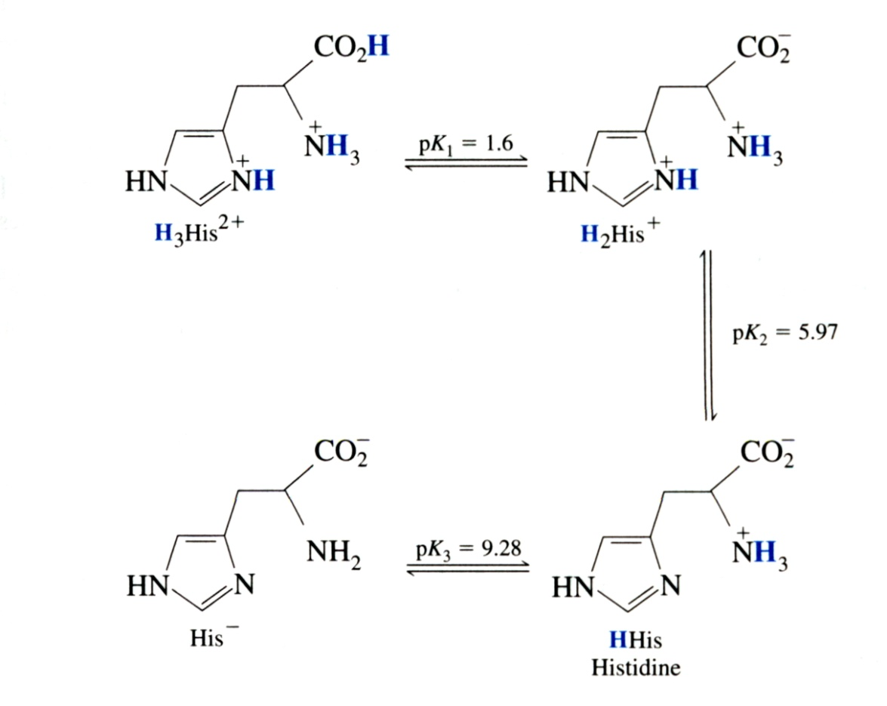

**Treat as monoprotic acid.**

**histidine hydrochloride is the intermediate form (H2His+) between pK1 & pK2.**

1. **Must add enough KOH (1:1 molar ratio) to convert all H2His+ to HHis**
2. **Must added more KOH to obtain mixture of HHis and His- to obtain pH of 9.30**

**Initial moles of H2His+ = 10.0g/(191.62 g/mol) = 0.05219 mol**

**Require 0.05219 mol of KOH plus:**

|  |  |  |  |
| --- | --- | --- | --- |
|  | **HHis** | **OH-** | **His-** |
| **Initial moles:** | **0.05219** | **x** | **-** |
| **Final moles:** | **0.05219-x** | **-** | **x** |



Chaper 11

11-8 a) What is the pH at the equivalence point when 0.100 M hydroxyacetic acid is titrated with 0.0500 M KOH?

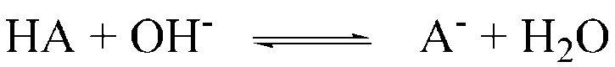

**Equivalence point 🡪 exactly enough KOH to consume hydroxyacetic acid (HA)**

**Twice the volume of KOH (0.0500) is required to titrate hydroxyacetic acid (0.100)**

**Formal concentration of A- = (volume of HA/(volume of HA + volume KOH))(0.100M)**

**= V/(V+2V)(0.100M) set V = 1**

**= 1/(1+3)(0.100M)**

**= 0.0333M**

**The solution only contains A- 🡪 weak base (Ka = 1.48x10-4, Appendix G, AP14)**

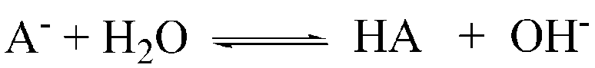

F-x x x



b) What indicator would be a good choice to monitor the endpoint?

**Cresol red to phenolphtelen or any number of inidcators that change color around pH 8.18 (see table)**