**CHEMISTRY 221** - **Dr. Powers**  **First Exam -**  **FALL 2007**

**PRINT NAME** ______________________________________________

(Last) (First) (MI)

***ID# ___________________________***

Signature ________________________________________

**FIRST EXAM Lab Section**______

**September 20, 2007**

**BE SURE YOU HAVE 12 DIFFERENT PAGES OF THIS EXAM**

***\*\*\*\*\*\*\*\*\*\*WRITE YOUR NAME ON EVERY PAGE\*\*\*\*\*\*\*\*\*\*\*\*\*\*\*\****

**SHOW ALL WORK - NO WORK - NO CREDIT**

**REPORT ALL ANSWERS WITH CORRECT LABELS AND SIGNIFICANT FIGURES**

• All Cell phones must be turned off and cannot be used as a calculator.

• You may use a calculator, and an exam data sheet.

• Raise your hand if you have a question.

• Keep your eyes on your own paper.

• Several exam forms may be in use. It is a code violation if data from another exam form appears on your paper.

• Keep all REQUIRED exams as part of your records.

**REQUEST FOR REGRADE _______________Date**

***EXAMS SUBMITTED FOR REGRADES SHOULD NOT LEAVE THE RESOURCE CENTER!***

Please regrade question because___________________________________________ _________________________________________________________________________

_________________________________________________________________________

Please regrade question because **__________________________________________**

_________________________________________________________________________

_________________________________________________________________________

Please regrade question because __________________________________________

_________________________________________________________________________

**______ Check here if there is a mistake in addition.**

**You must sign your regrade request, or it will not be considered a valid request.**

I accept responsibility for all answers contained herein. ________________________________ Signature

When submitting regrade request, **do not write on exam pages.** Additional questions or comments are to be placed on a separate sheet of paper and turned in with your test. **Sign these as well.**

|  |  |  |  |
| --- | --- | --- | --- |
| **Question No.** | **Possible Points** | **Points Earned** | **TA Initials** |
| **1** | **16** |  |  |
| **2** | **20** |  |  |
| **3** | **6** |  |  |
| **4** | **16** |  |  |
| **5** | **15** |  |  |
| **6** | **15** |  |  |
| **7** | **12** |  |  |
| **Total** | **100** |  |  |

**Some Useful Information:**

**Gaussian Curve:**

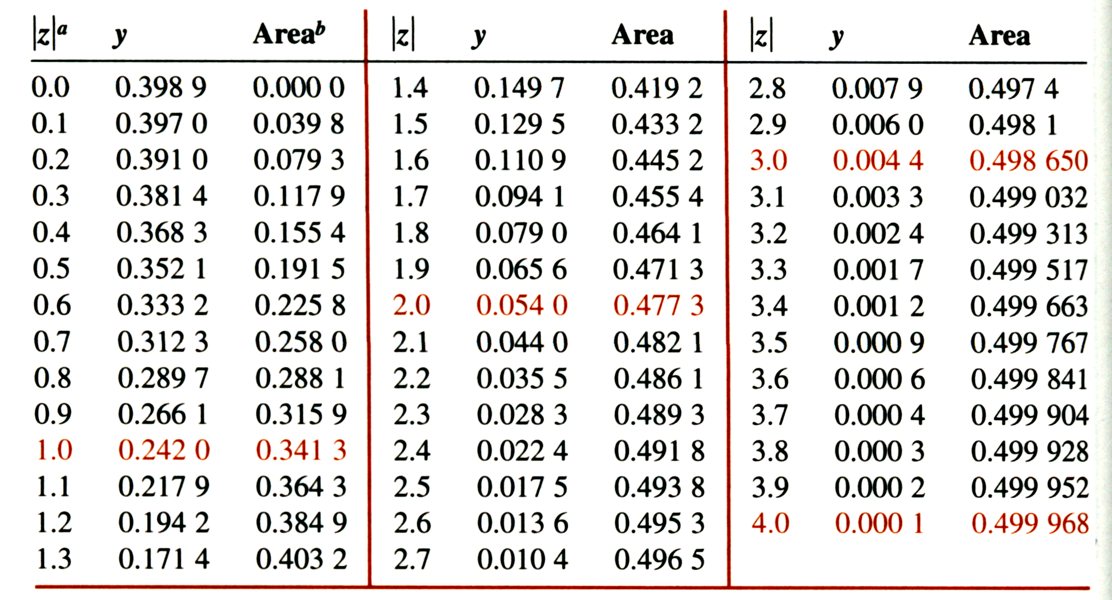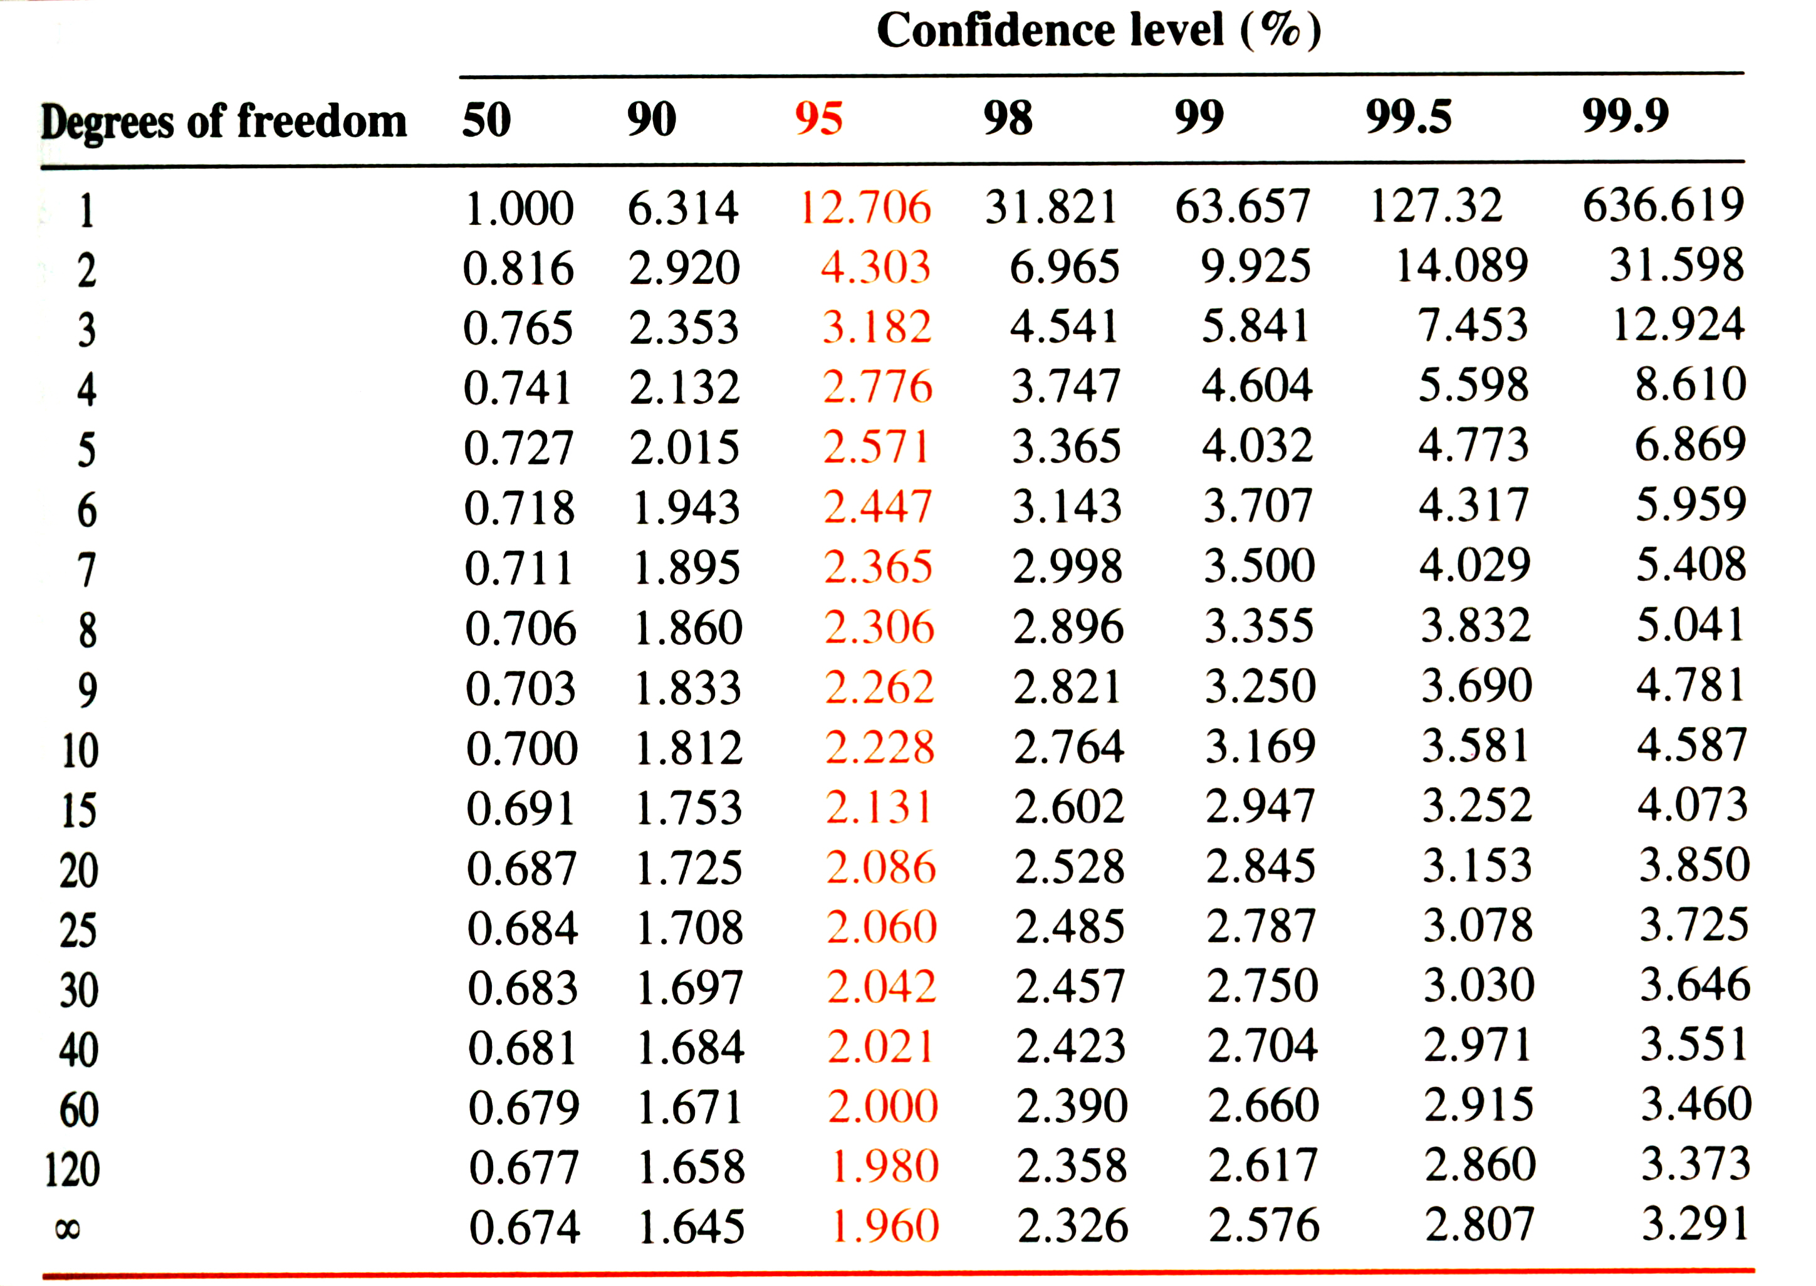

**Student’s t**

**Q test:**

|  |  |  |  |  |  |  |  |  |
| --- | --- | --- | --- | --- | --- | --- | --- | --- |
| **Values of Q for rejection of data** | | | | | | | | |
| **Q (90% confidence)** | **0.94** | **0.76** | **0.64** | **0.56** | **0.51** | **0.47** | **0.44** | **0.41** |
| **Number of Observations** | **3** | **4** | **5** | **6** | **7** | **8** | **9** | **10** |

1. ( 16 points) Please Identify and Explain the mistakes made in the following laboratory protocols:
   1. (4 points) A 10.00 mM solution of glucose (FW 180.16 g/mole) was prepared by first adding 180.16 mg of glucose to a 100 mL empty volumetric flask, and then DI H2O was added to the volumetric flask until the meniscus reached the 100 mL volume mark. The flask was capped and the solution vigorously mixed until the glucose completely dissolved.
   2. (4 points) A gravimetric analysis of dissolved Pb+2 (FW 207.2 g/mole) in water was carried out by the slow addition of a 0.1 M solution of NaOH to three separate 10 mL samples. The three PbO (FW 223.20 g/mole) precipitates were filtered, dried and then pooled together to give a single weight of 10.3491 mg and an average weight of 3.4497 mg. It was then determined that 3.202 mg of Pb+2 was present in the water sample.
   3. (4 points) A 100 mg sample of NaOH were weighed by transferring pellets directly onto the balance pans until enough pellets were added until the balance read as close to 0.1000 g as possible.
   4. (4 points) A colloidal suspension was initially observed during a gravimetric analysis, so the beaker containing the sample was transferred to an ice bath for 1 hour.
2. (20 points) Two students titrated a 100.00 mL sample of HCl with an unknown concentration with a standardized 0.1339 M NaOH sample.



The students obtained the following results:

*Student A:* 23.17 mL, 22.69 mL, 23.25 mL, 22.97 mL

*Student B:* 25.25 mL, 25.19 mL, 25.23 mL, 25.23 mL

* 1. (4 points) Determine the average (mean) and standard deviation for each student’s data set.
  2. (2 points) Which student was more precise? Explain.
  3. (4 points) If the unknown HCl sample has a concentration of 0.0030 M, which student is more accurate?
  4. (5 points) Are the results (titration volumes) obtained by the two students significantly different at the 95% confidence level (**Given: Sspooled = 0.18**)?
  5. (5 points) Using the Q test, decide if the second measurement (22.69 mL) for *student A* should be discarded.

1. (6 points) While conducting an experiment, a lab technician records notes and data on a loose piece of paper and plans on transferring the information in his lab notebook later.
   1. (4 points) Give two reasons why this is an incorrect procedure.
   2. (2 points) Is there a similar problem with transferring the data to a computer program to create a graph?
2. (16 points) Crystal formation is an important component of gravimetric analysis.
   1. (4 points) What process (not experimental condition) causes the formation of colloidal solutions instead of crystals?
   2. (4 points) Describe an experimental technique that would increase the likelihood of forming crystals.
   3. (4 points) Describe a process where an impurity can be incorporated into a crystal.
   4. (4 points) What is the relationship between Relative Supersaturation (R) and crystal formation?
3. (15 points) The aluminum (FW 26.98 g/mole) in a 1.200g sample of impure ammonium aluminum sulfate was precipitated with aqueous ammonia as the hydrous Al2O3 ⋅ xH2O. The precipitate was filtered and ignited at 1000oC to give anhydrous Al2O3 (FW 101.96 g/mole) which weighed 0.1798g. Calculate the percentage of aluminum in the sample.
4. (15 points) A heterogeneous mixture of the 20 common amino acids was analyzed by gravimetric analysis. Adding 15% v/v of ethanol to the solution followed by slow titration of the samples pH down to 5.5 results in the selective precipitation of L-alanine (FW 89.09 g/mole) and L-glycine (FW 75.07 g/mole). The properly filtered and dried precipitate weighed 1.6259 g. Chromatographic analysis of standard 0.1000 g samples of L-alanine and L-glycine gave peak areas of 126.8 and 373.1, respectively. A similar chromatographic analysis using 0.5884 g of the 1.6259 g precipitate gave peak areas of 499.9 for L-alanine and 724.5 for L-glycine. What was the weight of L-alanine in the original heterogeneous mixture?
5. (12 points) The following calibration curve was obtained to measure the concentration of arsenic in blood serum by measuring the absorbance of an EDTA:As5+ complex. Linear-least squares method was used to obtain a best-fit line of the linear region of the calibration curve. The equation is:

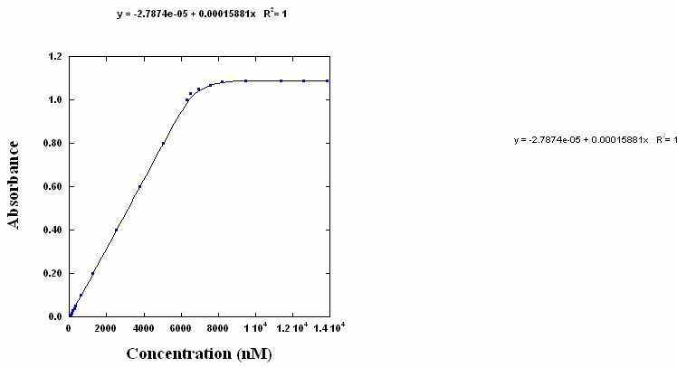

**y = -2.79x10-5 ± 2x10-7 + 1.59x10-4 ± 3x10-6x**

1. (6 points) Calculate the concentration of an unknown that yielded an absorbance of 0.337 ± 0.005.
2. (3 points) From the calibration curve figure, estimate the upper-limit of detection. (i.e. what is the largest concentration that can be reliable determined?)
3. (3 points) Would you expect the R2 for the best-fit line to be close to zero or one?