CHEMISTRY 221 - Dr. Powers First Exam - FALL 2006

PRINT NAME ______________________________________________
(Last) (First) (MI)
ID# ___________________________

Signature ________________________________________

FIRST EXAM Lab Section______
September 14, 2006
BE SURE YOU HAVE 9 DIFFERENT PAGES OF THIS EXAM
**********WRITE YOUR NAME ON EVERY PAGE****************
SHOW ALL WORK - NO WORK - NO CREDIT

REPORT ALL ANSWERS WITH CORRECT LABELS AND SIGNIFICANT FIGURES

• All Cell phones must be turned off and cannot be used as a calculator.
• You may use a calculator, and an exam data sheet.
• Raise your hand if you have a question.
• Keep your eyes on your own paper.
• Several exam forms may be in use. It is a code violation if data from another exam form appears on your paper.
• Keep all REQUIRED exams as part of your records.

REQUEST FOR REGRADE _______________Date

EXAMS SUBMITTED FOR REGRADES SHOULD NOT LEAVE THE RESOURCE CENTER!

Please regrade question because___________________________________________ _________________________________________________________________________
_________________________________________________________________________
Please regrade question because __________________________________________
_________________________________________________________________________
_________________________________________________________________________
Please regrade question because __________________________________________
_________________________________________________________________________

______ Check here if there is a mistake in addition.
You must sign your regrade request, or it will not be considered a valid request.

I accept responsibility for all answers contained herein. ________________________________ Signature

When submitting regrade request, do not write on exam pages. Additional questions or comments are to be placed on a separate sheet of paper and turned in with your test. Sign these as well.

Question No. | Possible Points | Points Earned | TA Initials
1 | 26
2 | 9
3 | 10
4 | 10
5 | 8
6 | 8
7 | 29
Total | 100

Some Useful Information:
Gaussian Curve:
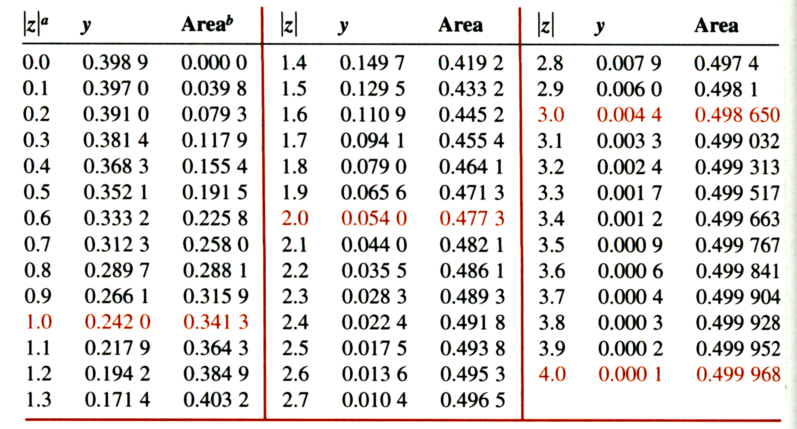

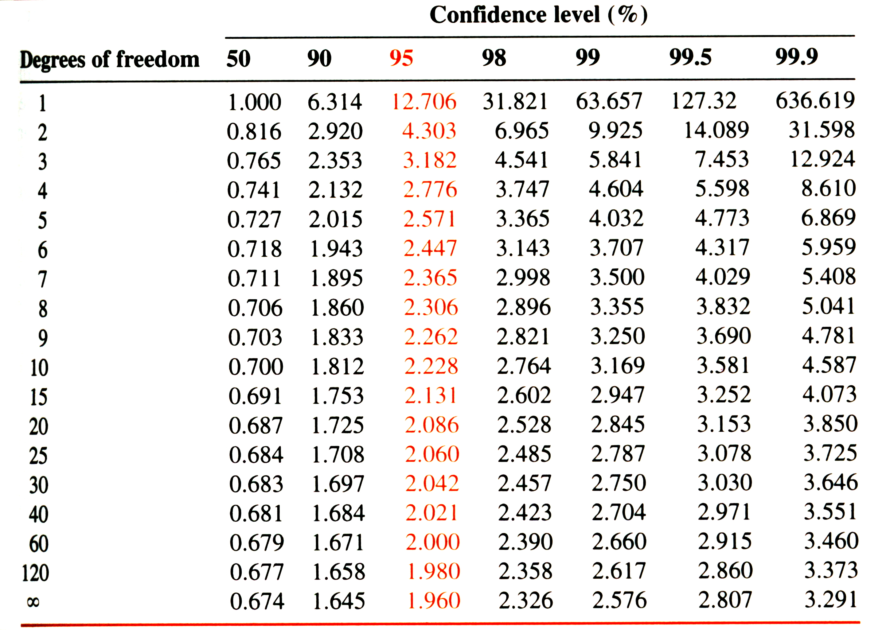
Student’s t

Q test:
Values of Q for rejection of data
Q (90% confidence) | 0.94 | 0.76 | 0.64 | 0.56 | 0.51 | 0.47 | 0.44 | 0.41
Number of Observations | 3 | 4 | 5 | 6 | 7 | 8 | 9 | 10

- (26 points) The amount of caffeine in an unknown liquid was measured by five different laboratory classes where the results are summarized below:

Class | Average | Standard Deviation
A | 44.3 | 5.3
B | 47.9 | 6.5
C | 34.0 | 2.5
D | 44.8 | 4.9
E | 45.6 | 3.7

The unknown sample was prepared to contain 46.0 mg of caffeine.
- (10 points) What is the average and uncertainty for the results reported for all five laboratory classes?

- (8 points) Using the Q test, which class data (if any) is an outlier at the 90% confidence level?

- (2 point) Which class was the most accurate?

- (2 point) Which class had the best precision?

- ( 2 point) It was later determined that the unknown for Class C was accidentally spilled. What type of error would this cause?

- (2 point) What type of error does the standard deviation represent?

- (9 points) Given the following lab notebook entry, identify three mistakes (there are more).

Experiment #3 done on Friday at noon

The measured data points were plotted in Excel and fitted to a best-line.
Protein was ppt. from skim, 1%, 2% and whole (3%) milk using 1M acetic acid.

10ml, 25ml, 50ml and 100ml aliquots of each milk sample was titrated with the 1M acetic acid. The ppt. protein was filtered from the remaining milk and dried for 12 hrs. at 110ºC.

An inverse linear relationship was found between the amount of ppt. protein and fat content, suggesting some protein is lost in the process of removing fat from milk

John Q. Smith

- (10 points) What Lab equipment (excluding lab notebook) would you use for each of the following tasks?
  - (2 points) making a 100 mL of a 0.1M solution of NaCl

  - (4 points) making a 100 mL of a 0.1 M solution of NaCl using a 1M stock solution of NaCl

  - (4 points) Weighing the precipitate from a gravimetric analysis of the iron content in blood.

- (10 points) A suspected drug dealer is arrested with 10 grams of an unknown white substance that is expected to be crack cocaine. If the dealer is found with 5 grams or more of crack cocaine he will receive a mandatory 5-year jail sentence. A set of 6 measurements indicated the unknown substance yielded a mean value of 48.5% crack cocaine with a standard deviation of the measurement being 0.8 %. What is the 95% confidence interval within which it is expected that the true value will lie? Using this as criteria, should the suspect receive a mandatory jail sentence?

- (8 points) Lead in drinking water is a common problem and has adverse health effects including developmental problems in babies and kidney problems in adults. Lead can be measured in water using gravimetric analysis based on the following reaction:
A 10L water sample was treated with K₂CO₃ to determine the concentration of lead in the water. The empty funnel had a mass of 35.3312 grams. After precipitation, filtration, and proper drying, the funnel had a mass of 35.4729 grams. What was the lead molarity in the original solution? PbCO₃ has a formula mass of 267.21 g/mole. Atomic weight of Pb = 207.2.

- (8 points) Because only a small amount of PbCO₃ is collected from a relatively large volume of water in problem #5, you are concerned about possible errors.
  - (5 points) You are concerned about the amount of soluble Pb⁺² that may still be present and the formation of a colloidal suspension. Describe an experimental condition that you could change to decrease the solubility of PbCO₃ and increase the formation of crystals.

  - (3 points) You are also concerned by the possible precipitation of other trace ions in the solution. What could you do to minimize this problem?

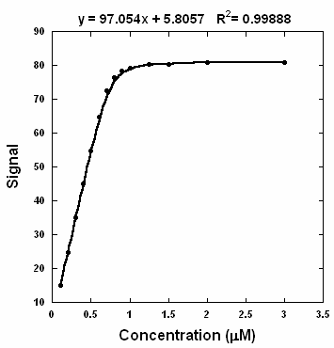
- (29 points) The following calibration curve was obtained for measuring the concentration of sugars in urine to monitor diabetes. Linear-least squares method was used to obtain a best-fit line of the linear region of the calibration curve.

  - (5 points) Please indicate on the graph the linear range and dynamic range.

  - (5 points) What does the R² value indicate about the best-fit line?

  - (5 points) An unknown urine sample yielded a signal of 53.97. Use the calibration curve to determine the sugar concentration.

  - (14 points) The above experiment was repeated four times (0.4963, 0.5012, 0.4937, 0.4955 μM) with a corresponding mean of 0.4968 μM. A completely different method yielded the following results (0.4977, 0.5001, 0.4969, 0.4940 μM) with a corresponding mean of 0.4972 μM. Are these methods equivalent at the 99% confidence level?

