CHEMISTRY 221 - Dr. Powers Third Exam - FALL 2007

PRINT NAME ______________________________________________
(Last) (First) (MI)
ID# ___________________________

Signature ________________________________________

THIRD EXAM Lab Section______
November 20, 2007
BE SURE YOU HAVE 10 DIFFERENT PAGES OF THIS EXAM
**********WRITE YOUR NAME ON EVERY PAGE****************
SHOW ALL WORK - NO WORK - NO CREDIT

REPORT ALL ANSWERS WITH CORRECT LABELS AND SIGNIFICANT FIGURES

• All Cell phones must be turned off and cannot be used as a calculator.
• You may use a calculator, and an exam data sheet.
• Raise your hand if you have a question.
• Keep your eyes on your own paper.
• Several exam forms may be in use. It is a code violation if data from another exam form appears on your paper.
• Keep all REQUIRED exams as part of your records.

REQUEST FOR REGRADE _______________Date

EXAMS SUBMITTED FOR REGRADES SHOULD NOT LEAVE THE RESOURCE CENTER!

Please regrade question because___________________________________________ _________________________________________________________________________
_________________________________________________________________________
Please regrade question because __________________________________________
_________________________________________________________________________
_________________________________________________________________________
Please regrade question because __________________________________________
_________________________________________________________________________

______ Check here if there is a mistake in addition.
You must sign your regrade request, or it will not be considered a valid request.

I accept responsibility for all answers contained herein. ________________________________ Signature

When submitting regrade request, do not write on exam pages. Additional questions or comments are to be placed on a separate sheet of paper and turned in with your test. Sign these as well.

Question No. | Possible Points | Points Earned | TA Initials
1 | 20
2 | 20
3 | 5
4 | 15
5 | 4
6
Total | 100

Some Useful Information:
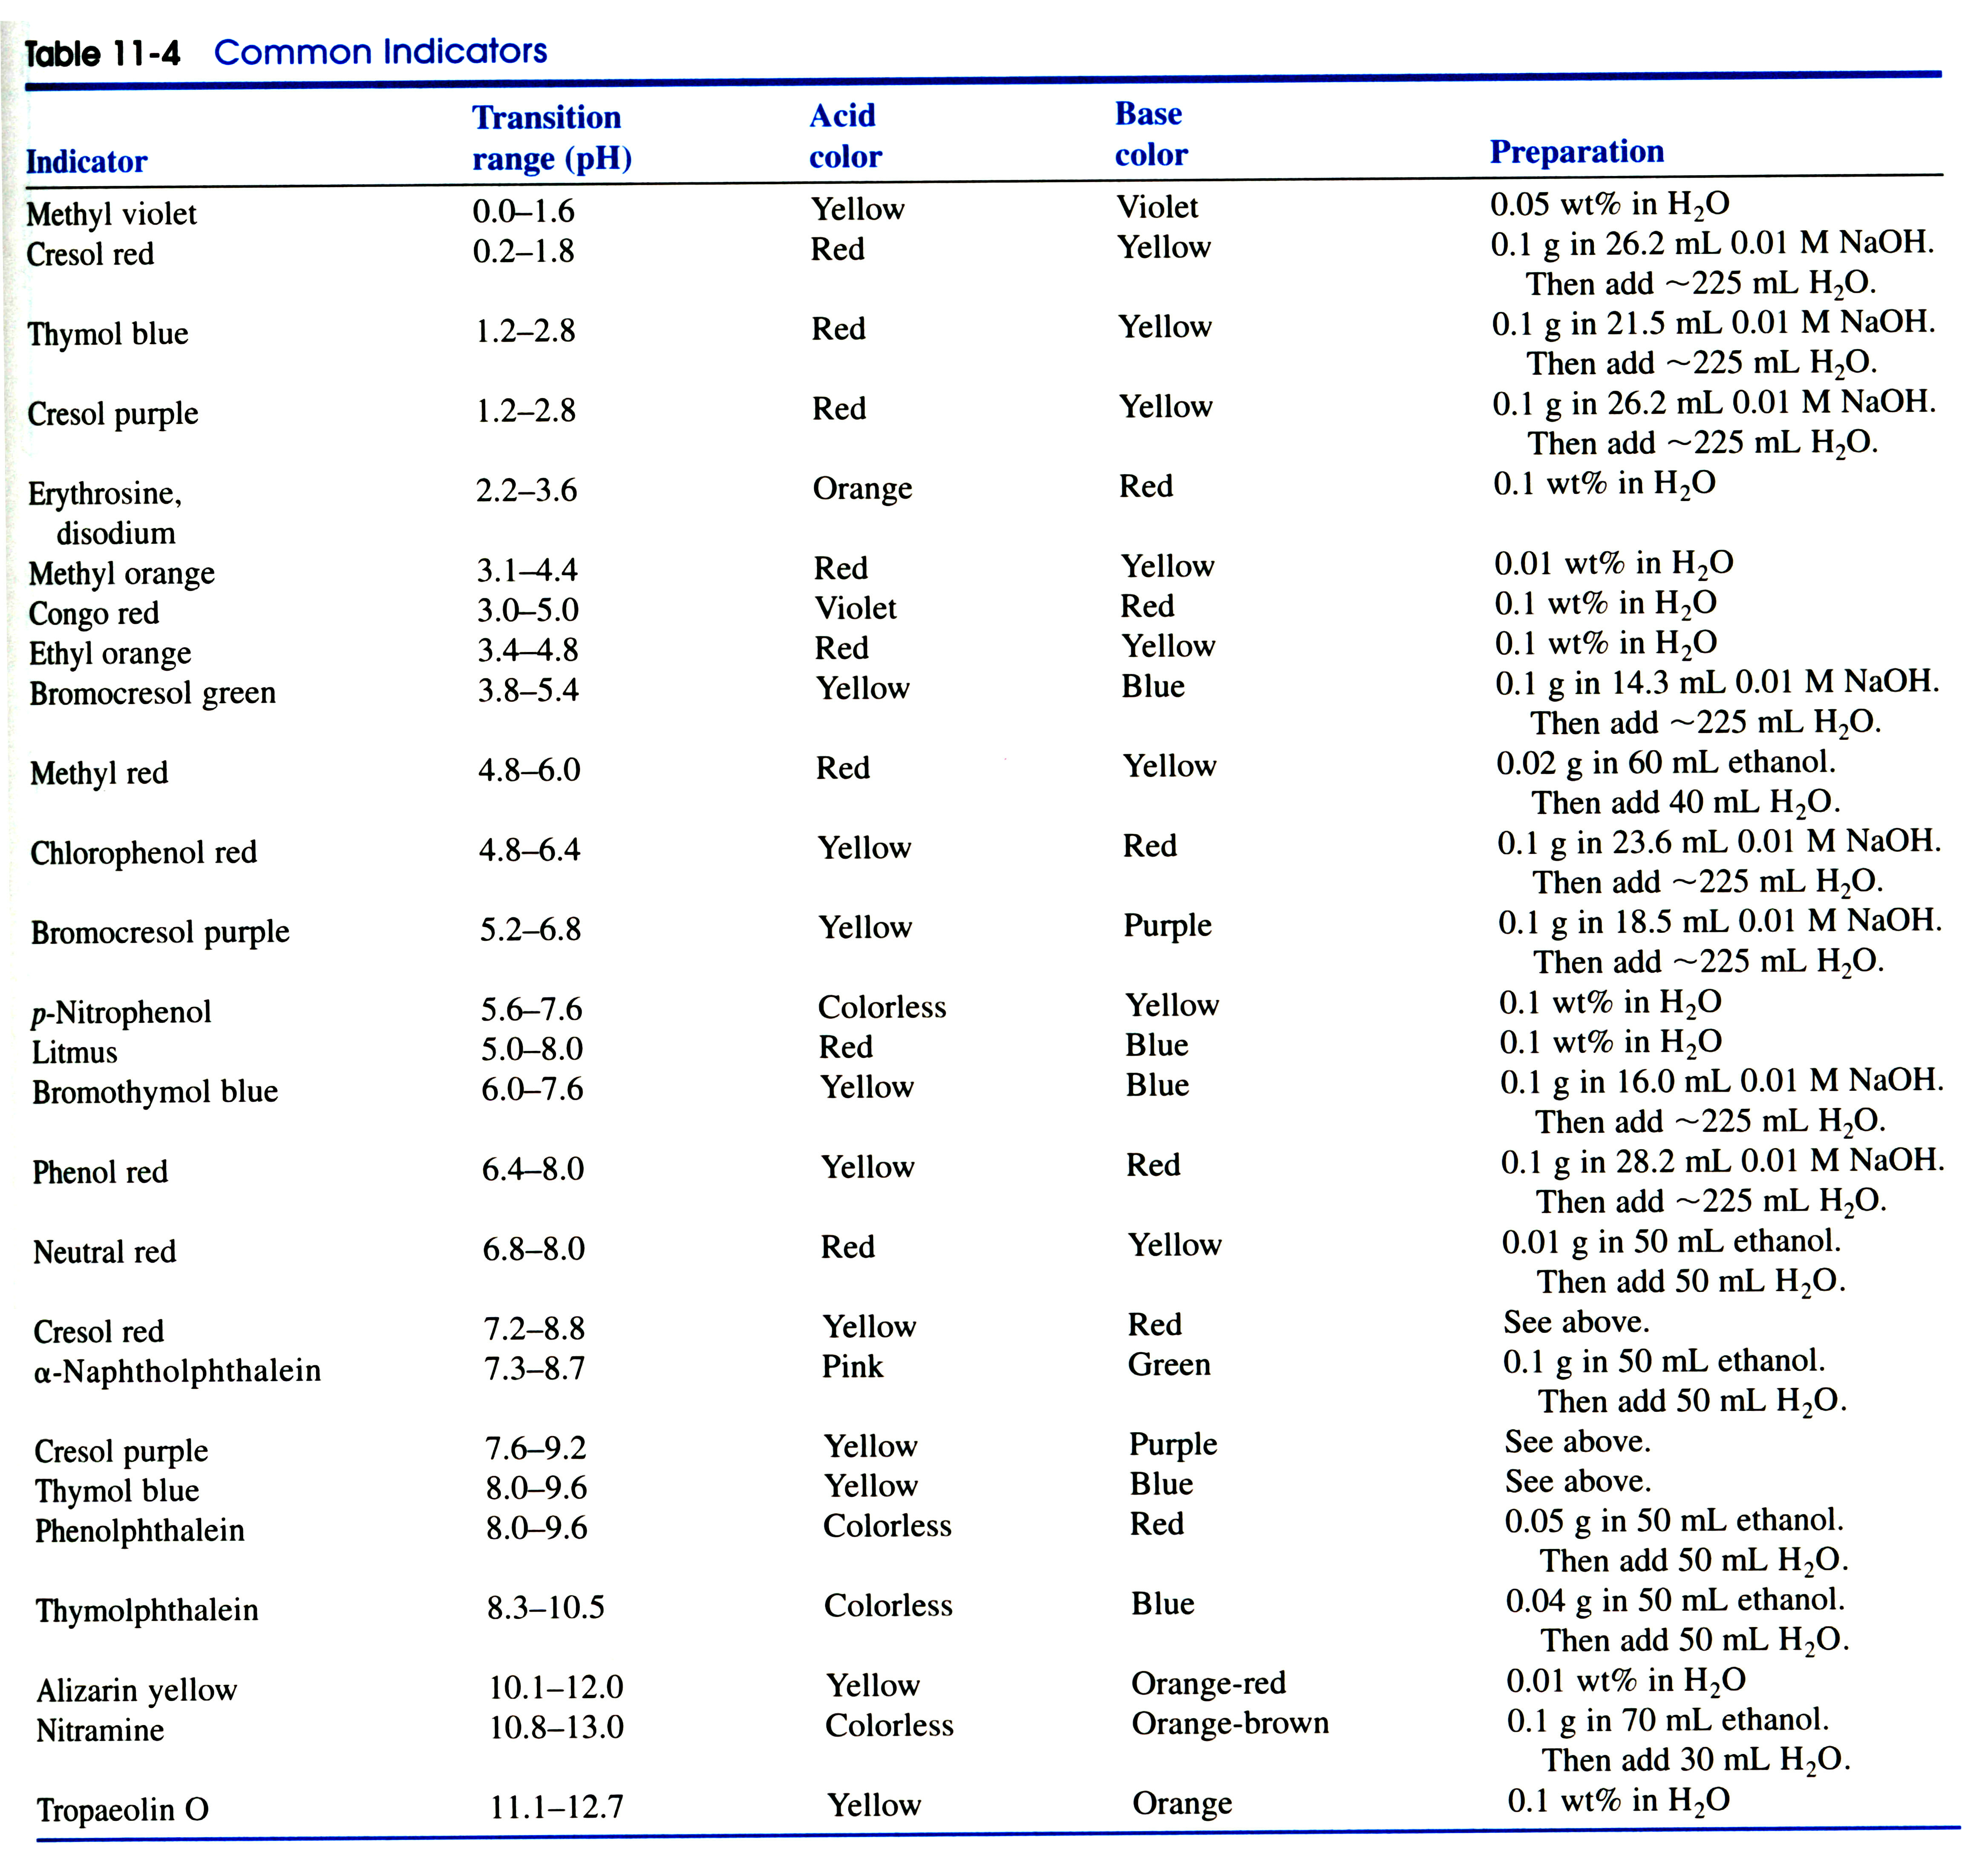

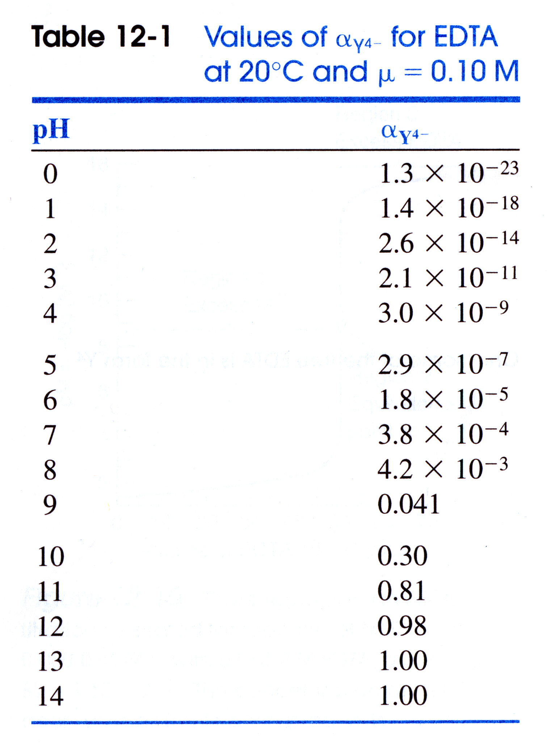

USEFUL EQUATIONS

Monoprotic Weak Acid: Diprotic Weak acid:

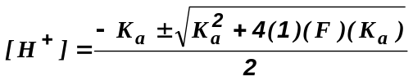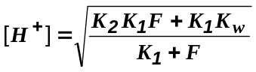

Isoionic point: Triprotic Weak acid:

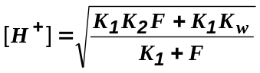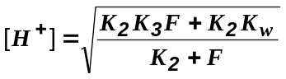

Debye-Hϋckel Equation: Gas Constant:

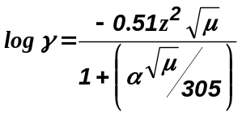 8.314472 J/K.mol

Faraday constant:

9.649x10⁴ C/mol

- (20 points) Predict the pH at the equivalence points for the following acid-base titrations:
  - (5 points) 10 mL of 0.0250 M HNO₃ is titrated with 0.0125 M LiOH

  - (5 points)10 mL of 0.0250 M Butanoic acid (pK_{a} = 4.818) is titrated with 0.0125 M LiOH

  - (5 points) 10 mL of 0.0250 M Carbonic acid (pK_{a1}=4.818, pK_{a2}=10.329) is titrated with 0.0125 M LiOH

  - (5 points) Identify an indicator that could be used to monitor the endpoints for a, b and c (above).

- (20 points) 50 mL of 0.0333 M of 1-Naphthoic acid (pKa = 3.67) is titrated with 0.05 M NaOH
  - (5 points) What is the pH before any NaOH is added?

  - (5 points) What is the pH after 5 mL of NaOH has been added?

  - (5 points) What volume of NaOH is required to obtain a pH of 3.67?

  - (5 points) What pH range would 1-Naphthoic acid and its conjugate base be a good buffer?

- (5 points) What is the Isoelectric point of Carbonic acid (pK_{a1}=4.818, pK_{a2}=10.329)

- (15 points) Given the following titration curve for a weak acid being titrated with a strong base:
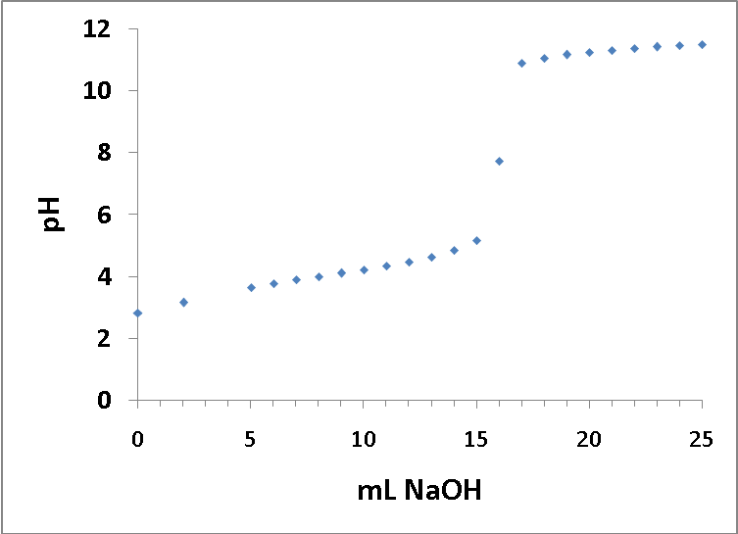

  - (5 points) What is the pK_{a} for the weak acid?

  - (5 points) What is the pK_{b} for the conjugate base?

  - (5 points) Sketch a first-derivative plot for this titration curve. Please make sure the axes are properly labeled.

- (4 points) What two factors determine the relative steepness of an acid-base titration curve?
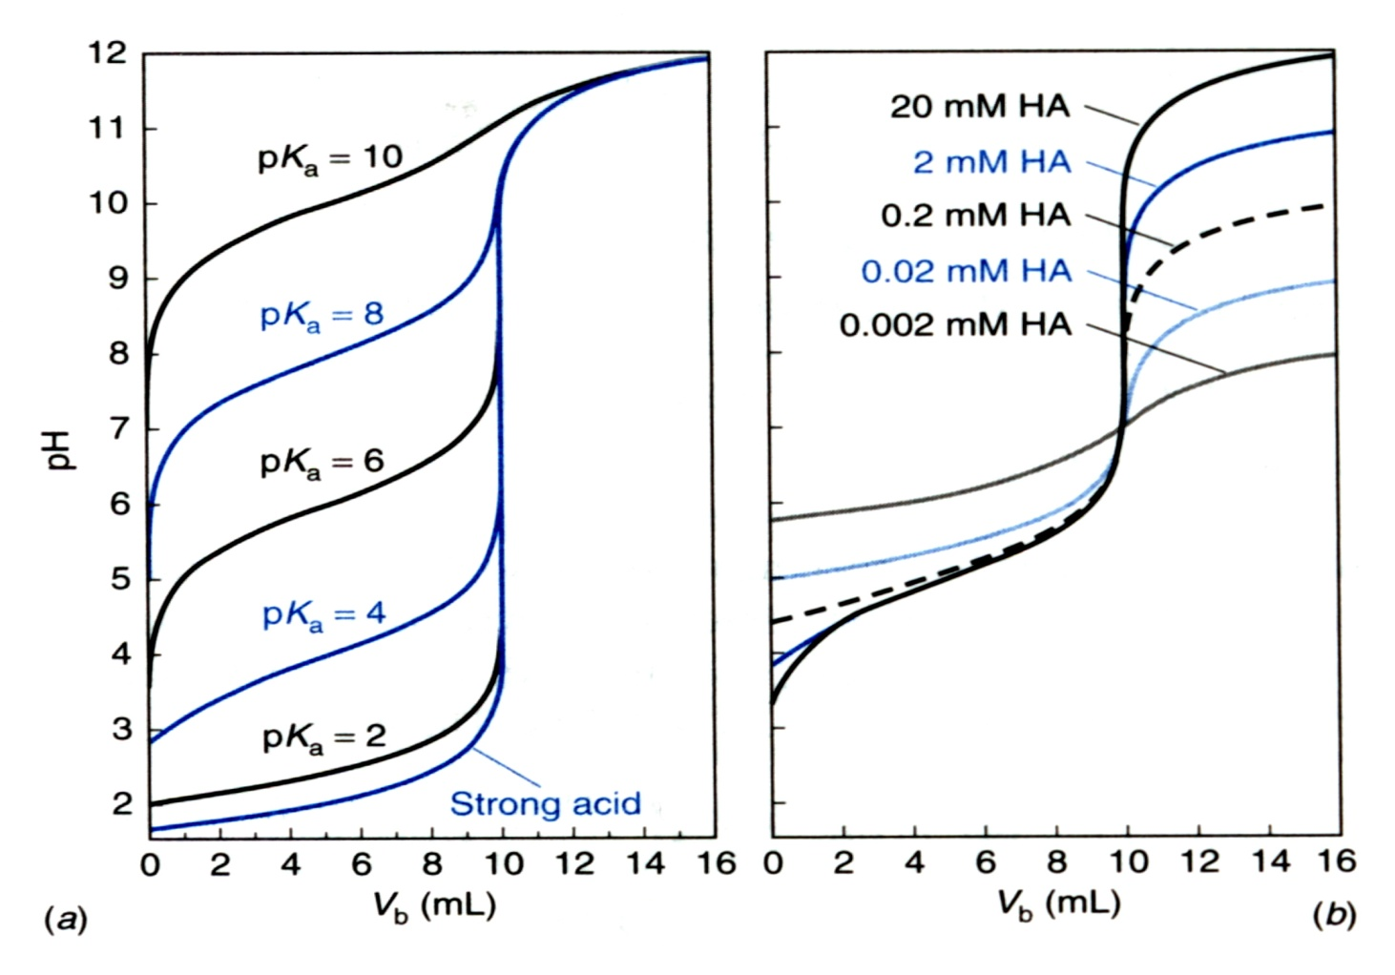
Increasing steepness

