CHEMISTRY 221 - Dr. Powers Third Exam - FALL 2006

PRINT NAME ______________________________________________
(Last) (First) (MI)
ID# ___________________________

Signature ________________________________________

THIRD EXAM Lab Section______
November 21, 2006
BE SURE YOU HAVE 10 DIFFERENT PAGES OF THIS EXAM
**********WRITE YOUR NAME ON EVERY PAGE****************
SHOW ALL WORK - NO WORK - NO CREDIT

REPORT ALL ANSWERS WITH CORRECT LABELS AND SIGNIFICANT FIGURES

• All Cell phones must be turned off and cannot be used as a calculator.
• You may use a calculator, and an exam data sheet.
• Raise your hand if you have a question.
• Keep your eyes on your own paper.
• Several exam forms may be in use. It is a code violation if data from another exam form appears on your paper.
• Keep all REQUIRED exams as part of your records.

REQUEST FOR REGRADE _______________Date

EXAMS SUBMITTED FOR REGRADES SHOULD NOT LEAVE THE RESOURCE CENTER!

Please regrade question because___________________________________________ _________________________________________________________________________
_________________________________________________________________________
Please regrade question because __________________________________________
_________________________________________________________________________
_________________________________________________________________________
Please regrade question because __________________________________________
_________________________________________________________________________

______ Check here if there is a mistake in addition.
You must sign your regrade request, or it will not be considered a valid request.

I accept responsibility for all answers contained herein. ________________________________ Signature

When submitting regrade request, do not write on exam pages. Additional questions or comments are to be placed on a separate sheet of paper and turned in with your test. Sign these as well.

Question No. | Possible Points | Points Earned | TA Initials
1 | 18
2 | 24
3 | 23
4 | 25
5 | 10
Total | 100

Some Useful Information:
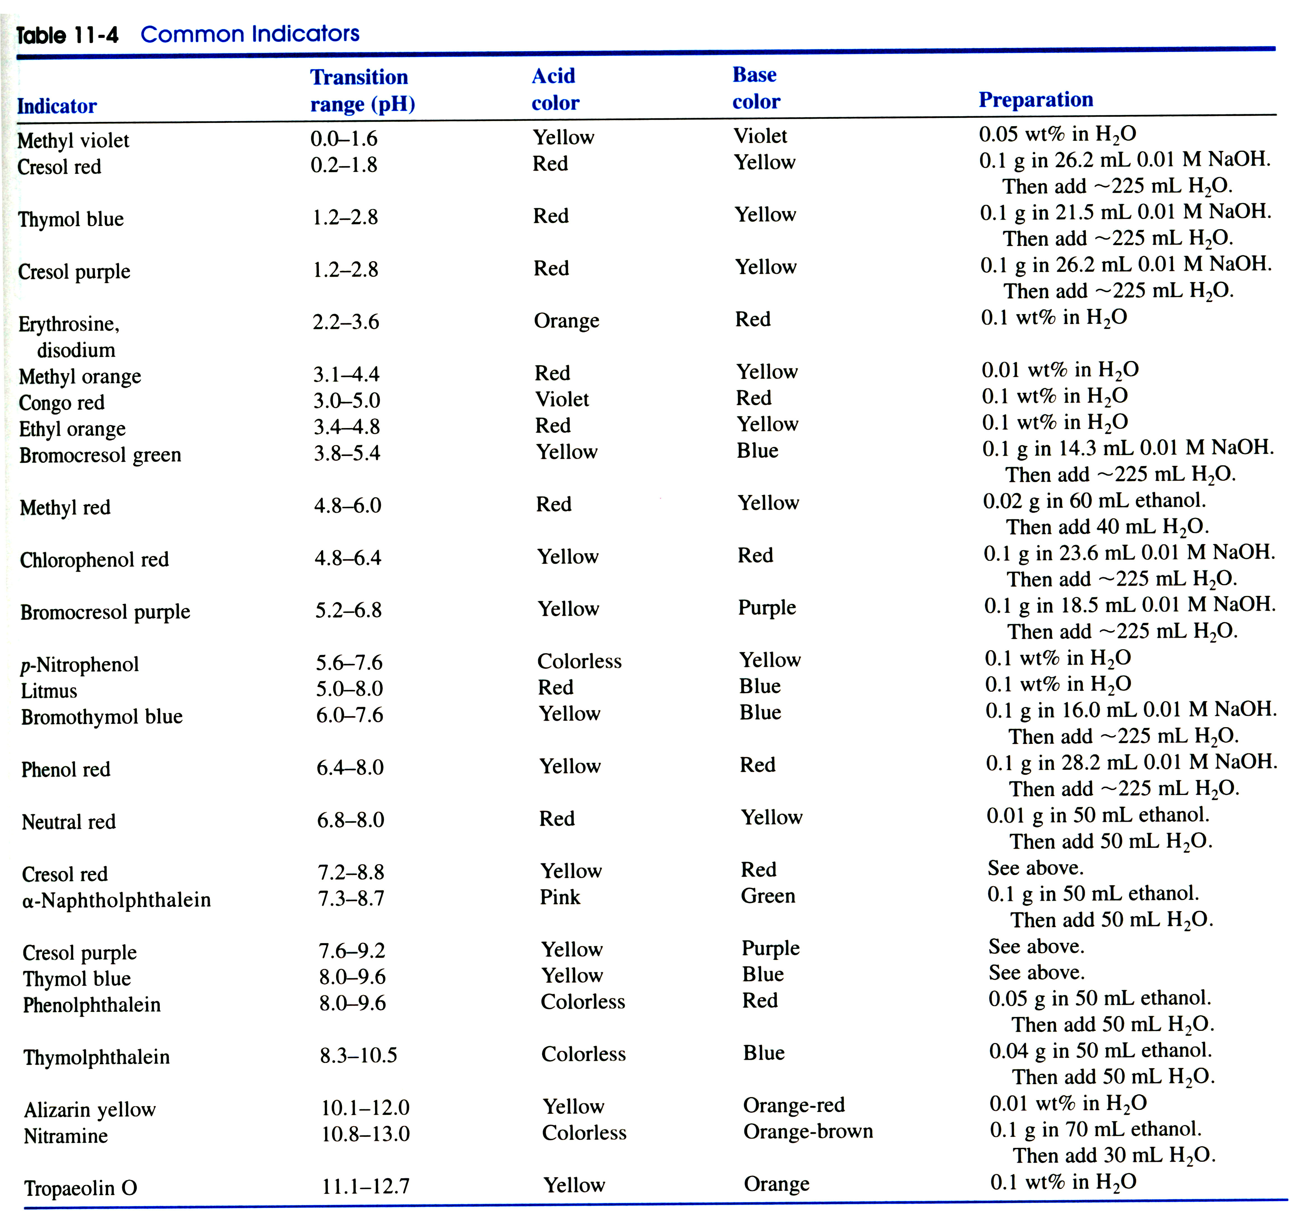

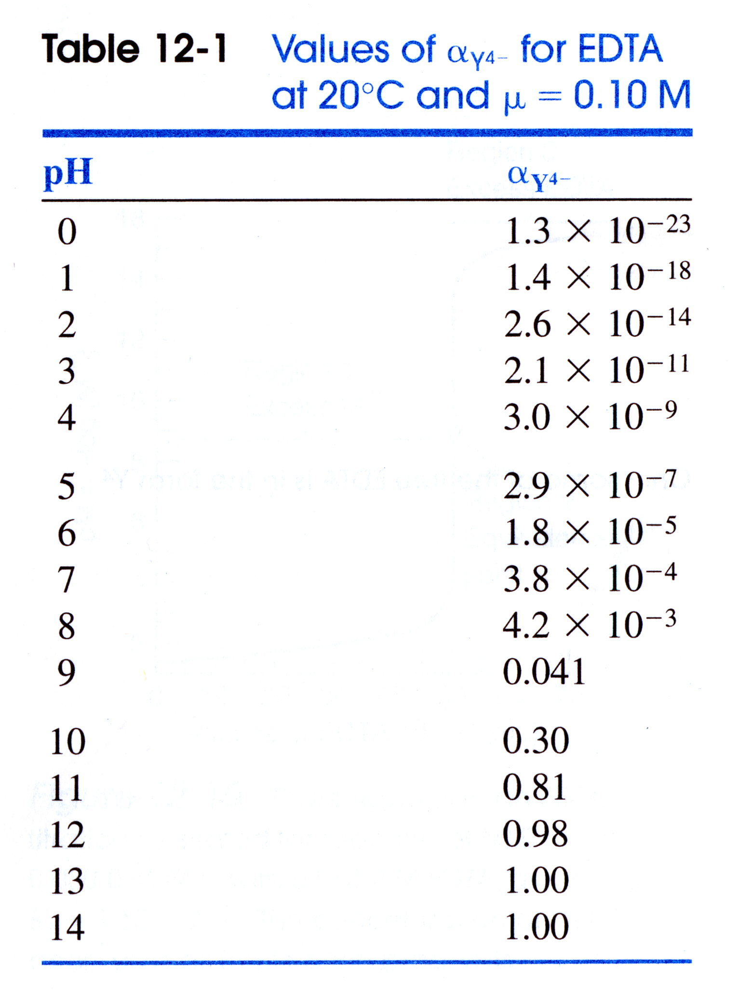

USEFUL EQUATIONS

Monoprotic Weak Acid: Diprotic Weak acid:

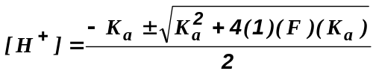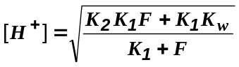

Isoionic point: Triprotic Weak acid:

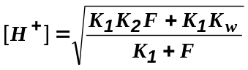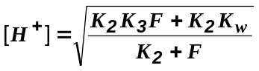

Debye-Hϋckel Equation: Gas Constant:

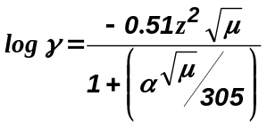 8.314472 J/K.mol

Faraday constant:

9.649x10⁴ C/mol

- (18 points) Given the following curve for the titration of a weak acid (HA) with a strong base (NaOH):

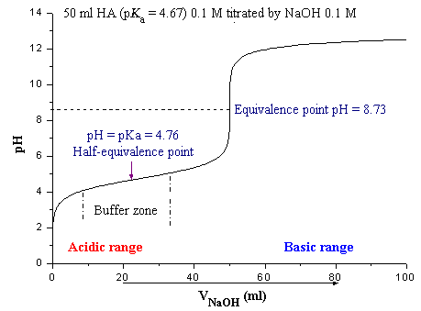

- (3 points) Indicate on the curve where the titration behaves as a buffer.

- (3 points) Estimate the pK_{a} of the weak acid.

- (3 points) Estimate the pH at the equivalence point.

- (3 points) Why is the pH at the equivalence point not 7.0?

- (3 points) What would be an appropriate indicator to use for this acid-base titration?

- (3 points) If the concentration of NaOH used for the titration was 0.1M, how many moles of the weak acid (HA) were present in the sample?

- (24 points) Given the following titration reaction:
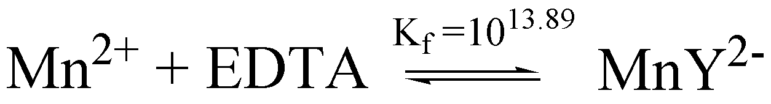

If 25.0 mL of 0.0100 M MnSO₄ solution buffered at a pH of 7.00 is titrated with 0.0200 M EDTA solution, calculate pMn²⁺ at the following volumes:

  - (6 points) 0 mL

  - (6 points) 5 mL

  - (6 points) 12.5 mL

  - (6 points) 13 mL

- (23 points) Given the following electrochemical cell and half-cell potentials:

Ni(s) | NiSO₄ (0.0020M) || CuCl₂ (0.0030M) | Cu(s)
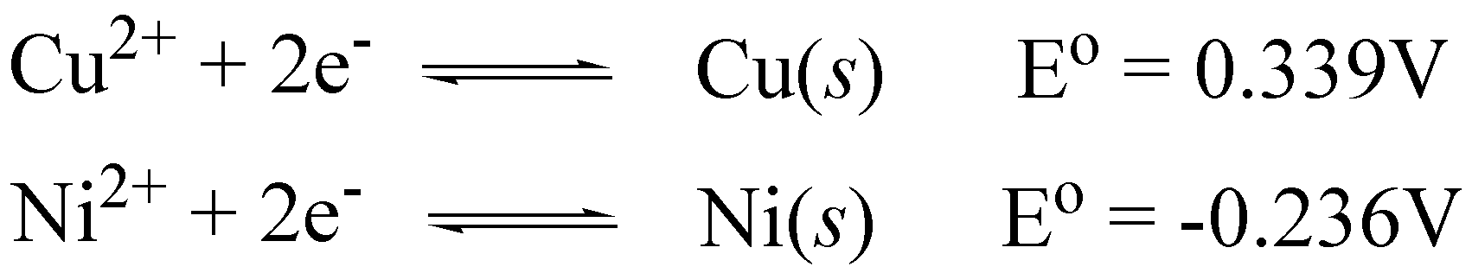

  - (3 points) Write a net or total cell reaction for the electrochemical cell.

  - (3 points) What is the standard reduction potential for the reaction?

  - (6 points) What is the equilibrium constant and free energy (ΔGº) for this reaction?

  - (3 points) Is this a Galvanic or electrolytic cell?

  - (8 points) What is the potential for this reaction under the given conditions?

- (25 points) Please explain the following:
  - (5 points) What is the source of the junction potential?

  - (5 points) What is a reference electrode?

  - (5 points) What is an indicator electrode?

  - (5 points) How can EDTA be used to differentiate between different metal ions during a titration?

  - (5 points) How a first derivative can be used to assist in the analysis of an acid-base titration curve?

- (10 points) Describe how a pH glass indicator electrode works.

