CHEMISTRY 221 - Dr. Powers Second Exam - FALL 2007

PRINT NAME ______________________________________________
(Last) (First) (MI)
ID# ___________________________

Signature ________________________________________

SECOND EXAM Lab Section______
October 18, 2007
BE SURE YOU HAVE 12 DIFFERENT PAGES OF THIS EXAM
**********WRITE YOUR NAME ON EVERY PAGE****************
SHOW ALL WORK - NO WORK - NO CREDIT

REPORT ALL ANSWERS WITH CORRECT LABELS AND SIGNIFICANT FIGURES

• All Cell phones must be turned off and cannot be used as a calculator.
• You may use a calculator, and an exam data sheet.
• Raise your hand if you have a question.
• Keep your eyes on your own paper.
• Several exam forms may be in use. It is a code violation if data from another exam form appears on your paper.
• Keep all REQUIRED exams as part of your records.

REQUEST FOR REGRADE _______________Date

EXAMS SUBMITTED FOR REGRADES SHOULD NOT LEAVE THE RESOURCE CENTER!

Please regrade question because___________________________________________ _________________________________________________________________________
_________________________________________________________________________
Please regrade question because __________________________________________
_________________________________________________________________________
_________________________________________________________________________
Please regrade question because __________________________________________
_________________________________________________________________________

______ Check here if there is a mistake in addition.
You must sign your regrade request, or it will not be considered a valid request.

I accept responsibility for all answers contained herein. ________________________________ Signature

When submitting regrade request, do not write on exam pages. Additional questions or comments are to be placed on a separate sheet of paper and turned in with your test. Sign these as well.

Question No. | Possible Points | Points Earned | TA Initials
1 | 25
2 | 5
3 | 14
4 | 16
5 | 18
6 | 22
Total | 100

Some Useful Information:

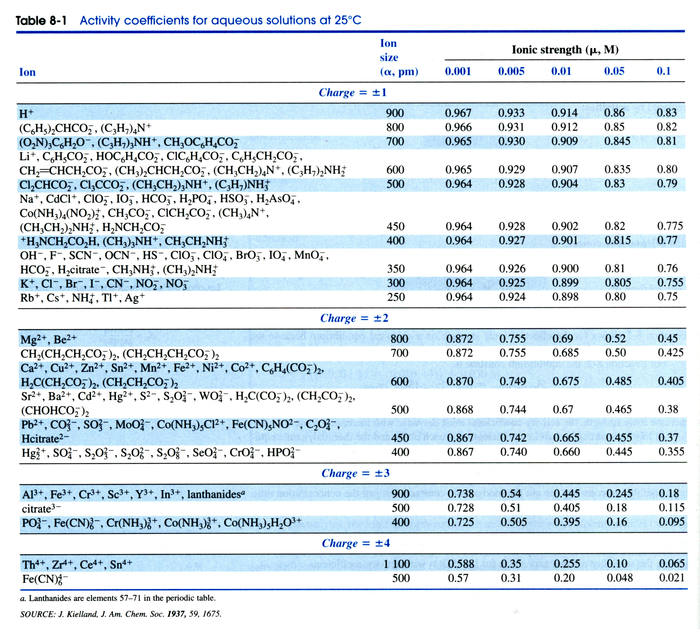

USEFUL EQUATIONS

Debye-Hϋckel Equation: Gas Constant:

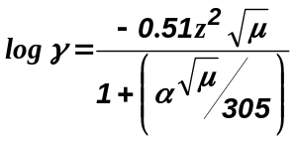 8.314472 J/K.mol

- (25 points) Given the following chemical reactions, identify how the reaction is expected to respond based on the listed changes to the equilibria (does the equilibrium move toward reactants, products or no change):

- (5 points) Photosynthesis is an endothermic chemical reaction. What happens if the temperature is decreased from 20º to 10º C

- (5 points) What happens if 1 g of solid CaF₂ is added to a saturated solution of CaF₂?
K_{sp} = 3.2x10⁻¹¹

- 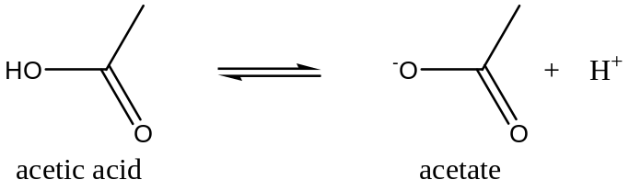(5 points) What happens if 10 mL of 1 mM NaOH is added to 10 mL of 100 mM of acetic acid?
K_{a} = 1.75x10⁻⁵

- (5 points) What happens if 0.01 M of NaCl is added to a solution of benzoic acid?
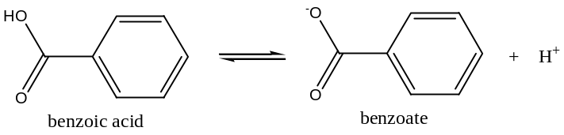
K_{a} = 6.28x10⁻⁵

- (5 points) What happens if 0.01 M of NaCl is added to a solution of TlCl?
K_{sp} = 1.8x10⁻⁴

- (5 points) What is the difference between a Lewis acid and a Brønsted-Lowry acid?

- (14 points) ΔG for photosynthesis was determined to be +502 kJ/mol at 25ºC.

  - (3 points) Is the reaction spontaneous?

  - (4 points) What is the equilibrium constant for this reaction?

  - (4 points) If the change in enthalpy was determined to be +469 kJ/mol, what is the change in entropy?

  - (3 points) What does the ΔG, enthalpy and entropy values listed above tell us about the rate of this reaction?

- (16 points) Given 10 mL of a 100 mM solution of benzoic acid in pure water
K_{a} = 6.28x10⁻⁵

  - (4 points) What is the pH of this solution?

  - (4 points) What is the pH if 0.01 M of NaCl is added to the solution?

\

  - (4 points) If the benzoic acid solution was titrated with a 25 mM solution of NaOH, what volume of NaOH would be required to reach an equivalence point?

  - (4 points) Would the pH at the endpoint for the titration in (c) be acidic, basic or neutral?

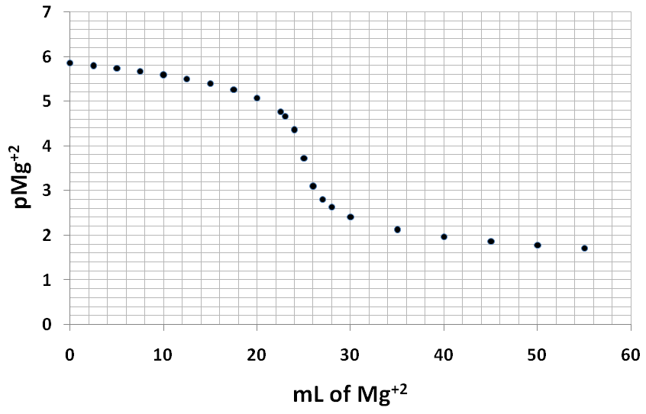
- (18 points) Given the following titration curve for the precipitation of MgCO₃ where Mg⁺² is the titrant:

  - (4 points) Using the graph, estimate the concentration of Mg⁺² at the equivalence point

  - (5 points) Based on your answer to (a), what is the K_{sp} of MgCO₃?

  - (5 points) Based on your answer to (b) and the graph, what was the original concentration of CO₃⁻²

  - (4 points) Roughly estimate and sketch on the graph what would happen to the titration curve if the K_{sp} of MgCO₃ increased by 100-fold (What would the curve look like if the K_{sp} is 100x the current value?).

- (22 points) Given the following equilibria:
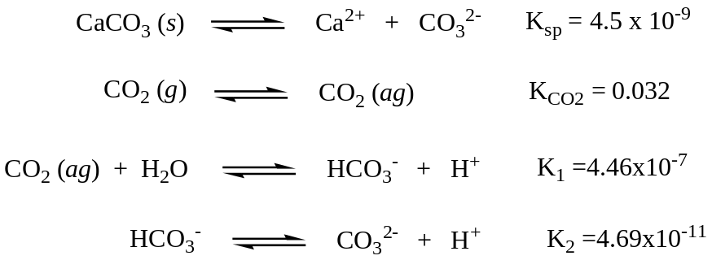
(1)

(2)

(3)

(4)

  - (4 points) Write a mass balance equation using chemical reaction 1.

  - (5 points) Write a charge balance equation using chemical reactions 1, 2, 3 & 4 (Make sure to use all the chemical reactions).

  - (5 points) Calculate the equilibrium constant for the following reaction:

- (8 points) Using your answer from (c) and the reactions from (c), 1, 2, 3 & 4, determine the pH of the solution if P_{CO2} = 3.8x10⁻⁴ bar and [Ca⁺] = 5.07x10⁻⁴ M (ignore activity coefficients).

